118TH ANNUAL REPORT
& FINANCIAL STATEMENTS
2022-2023 SEASON
FOUNDED 1905
Gordon District Cricket Club Inc.
This page left blank

Message from the President

Our season started with high expectations. While there were plenty of highlights, both at a team level and individually, the overall results were a little disappointing.
We continue to attract and develop excellent young players who are coming through the ranks of our grade club and will be the future of the club for many seasons ahead. Given the quality of players at the club, next season we should be aiming to improve on the last 2 seasons’ results and get back into the top 1/3 of the club championship.

Off the field the club made important strides in a number of key areas.
Michael Cant
- We have secured a new platinum sponsor in Chatswood RSL
- Our major lunch function is now a regular event on the calendar and has added significantly to our revenue
- We have forged closer relationships with Willoughby Council, which saw some modest improvements to our facilities, including improvements to Chatswood Oval change rooms, and new fencing around the Artarmon Reserve nets.
- The Past Players & Supporters’ Day was a big success, and really brough together the wider Gordon CC community.

Notwithstanding this progress, we have only touched the sides in addressing two big challenges we face in the years ahead.

- The quality of our facilities needs improvement. This is not an overnight fix and will require long term focus, planning and lobbying across a range of stakeholders - from council, local MPs and Cricket NSW.
- The costs of running a Premier Cricket club continues to rise. This is particularly the case for Gordon, where ground hire costs are amongst the highest in Sydney. We must increase our revenue, particularly sponsorships.

We are well placed to tackle these challenges but it will require effort and focus from the Executive and other club volunteers. I urge everyone involved at the club to do your bit to ensure Gordon thrives in the years ahead. I would also like to see Cricket NSW more involved in proactively helping premier clubs.

The Gordon Women’s Club faces the same challenges as we do, and we are increasingly working together on these things together. Our voice carries more weight together.

Playing Performances

Our results on the field were below expectations. We placed 12th (of 20) in the club championship. The highlight was making the 1st grade T20 conference final where we lost in a nail biter. Apart from an excellent result in the T20 competition, 1st grade had a disappointing season. Pleasingly we made semi-finals in 6 of the 10 competitions we contested, with 2nd grade, 4th grade and 6th grade all making the regular season finals. The performances of a young second grade team (4th) were a real standout.
We again had a good representation of Gordon players in NSW age representative teams. Congratulations to Luke Callanan (U19 Metro), Joey Gillard (U19 Country), Bryce Cook (U19 Country) and Sid Singh (U17 Metro). Axel Cahlin and Nick Toohey were also selected in SCA representative teams. Rory McLean was selected in the Green Shield Merit XII.

Axel Cahlin won the Player of the Year after an outstanding season with the bat. Axel was also one of the top 5 run scorers in the 1st grade competition which saw him selected in the SCA Merit XII. It was great to have Axel back at Gordon.

One thing that really impacted our playing performances last season was the poor availability of players. We cannot hope to achieve the results we want with so many players being out each week. We need to address this next season, and ultimately it comes down to the playing group making the necessary commitment to play Premier Cricket.

Coaching

As a club, we continue to invest in our players through coaching. Elliot Richtor was Head Coach, supported by Nick Miller and a range of other specialist coaches. Thanks to all our coaches for the job you do in running practice and improving the skills of our players.

I wanted to make a special mention of Matt Nicholson who was actively involved in coaching and working with our fast bowlers. Matt is one of the best coaches in NSW and we are very fortunate to have him involved at Gordon.

Off Field

The off-field highlight was undoubtedly the day we held at Chatswood Oval in conjunction with the T20 conference final. We had a big turnout of supporters, volunteers and past players along with a great representation from the playing group. It was also nice to host our sponsors and some local councillors and showcase our club. All in all, a very successful day (we just needed 2 more runs!)
There was a healthy social aspect to the season and a number of social events were held.

There was a core group of players who regularly helped out off field, whether that be social, covers or the myriad of other things that go into running a cricket club. Thanks to those that rolled up their sleeves and helped out. Being part of the club is more than just playing on a Saturday, and we need more players to get involved.

I wanted to acknowledge the contribution of the Club Captains (Matt Wright and Ryan Tullia). Last season was their 3rd as Club Captains, and they set a great example of the type of culture we aspire to have at Gordon.

Clubman Of the Year

The Clubman of the Year was Ben Woods. Ben is an active member of the Executive Committee where he has spent many hours working with Cricket NSW and councils to improve facilities, including securing grant funding. Ben also helped as a net co-ordinator at practice, as a match day manager and with the logistics for the presentation night. Halfway through the season we needed someone to take on the role of 6th Grade Captain. Ben was the one who put his hand up to help and led the young team superbly. Thanks Ben.

The Junior Clubman of the Year was awarded to James Loynes. James was always willing to help out when something needed to be done - whether that be covers, nets at training, or helping organize social events. He was a valuable member of the 6th grade (Colts) team and played every game which was a great refection on his commitment to the club. James, you are an outstanding clubman.
Another player who deserves special mention is Tym Crawford. Tym is not only the 1st Grade Captain, but does so many other things around the club. His contribution to our club is immense.

Sponsors, Donors and Fund Raising

It takes considerable financial resources to run a Premier Cricket club and we rely very heavily on sponsors and other fund-raising activity.

Last season it was great to welcome Chatswood RSL as a platinum sponsor. Chatswood RSL have been a long-term sponsor of the Gordon Women’s club, and it was great to have them extend their sponsorship to cover the whole Gordon District Cricket Club (men’s, women’s and juniors).

I wanted to thank all of our sponsors. Your support is very important and greatly appreciated.

Platinum Sponsor: Chatswood RSL
Gold Sponsor: Insurance Adviser Net, K Fibre
Silver Sponsors: Hickman & Ritchard, JB Advisory, DLK Construction,
Other Sponsors : JP Gavan, Olympic Hotel, Trumans

After the incredible success of the Underarm Lunch last season, we ran another major event with guest speakers Jeff Thomson and Kim Hughes. The day was another huge success. The lunch is now a regular on our calendar, and next season we will have Adam Gilchrist as the main attraction.

Congratulations to Glen Tullia for making the day happen. Thanks also to those people who donated items for auction prizes, in particular Wayne Lambert (Olympic Hotel), Nick Cutler and Ben Callanan.
After a few years hiatus we ran a Golf Day at Long Reef golf club. The day was an enjoyable social event and also raised funds for the club. Thanks to Dave Bezer for organizing this.

We again ran a fund-raising campaign through the Australian Sport Foundation, which provides a tax effective way for people to donate to the Club. To those who donated, I wanted to say a big thank you. Your generosity is greatly appreciated.

Grounds

The quality of wickets at each of our grounds was good most of the season. The practice wickets at Chatswood Oval were also good to train on. However, for a good part of the season the outfields at all 3 of our grounds were below the required standard. The switch from winter to summer sports and getting the outfield fields in good condition for cricket remains a perennial challenge.

Thanks to each of the groundsmen for all your work. We appreciate all the work you do and understand the challenges that are faced given multiple uses for all the grounds. I would also like to acknowledge the support of Willoughby and Ku-ring-gai Councils in preparing the grounds we use.

Given the shortage of green space in our area, grounds do present a challenge. We will continue to proactively work with councils to look to improve the condition of all our ovals.

Juniors

We continue to have a vibrant junior club catering for boys and girls (from ages 6-17). Pleasingly, we are also seeing more of the Gordon juniors progress through to our Green Shield and Academy Squads. I wanted to acknowledge the contribution of Dave Bezer who is stepping down as President of Gordon Juniors. Chris Rigg will be the new Juniors President and I look forward to working with Chris in the years ahead.

Volunteers

Running a Premier Cricket Club takes time and effort. There are so many things that need to get done. I wanted to acknowledge the following groups:

- Executive Committee - Andrew Falk, Mark Carmichael, Bob Thomas, Scott Hinton, Rob Carruthers, Glen Tullia, Geoff Hickman, Jim Wright, Geoff Keevers, Ben Woods
- Selectors - Geoff Hickman, Ed Howitt
- Match Day Management - Clive Fletcher, Prem Kumar, Mike Weaver and all the parents who helped during the season as part of the roster.
- Scorers - Andrew Falk, Andy Baldwin and Tony Kingsford Smith
- Covers - Scott Hinton and the players mid-week covers group
- Practice Net Roster - Ben Woods, Darpan Ranjan, Matt Patterson, Sam Buono
- Juniors - Dave Bezer, Chris Rigg, the Junior Club committee and all the parents involved in managing and coaching teams.
- Bala Subramanian for his help with the Supporters and Past Players Day, together with a range of other items behind the scenes.

While we have a good core group of volunteers, many of them have been involved in the club for many years. We need to supplement this with some new blood, to share the load and also bring some fresh energy.

MICHAEL CANT
PRESIDENT

Gordon District Cricket Club Major Sponsor

CHATSWOOD RSL IS THE PREMIER CLUB
ON THE NORTH SIDE

Contents
Message from the President 3
Contents 7
Gordon Women’s Cricket Club President’s Message 8
Gordon District Junior Cricket Club President’s Message 13
Notice of Meeting 16
Club Office Bearers, Life Members and Playing Members 17
Obituaries 19
Financial & Auditors Report 20
Executive Committee Report 36
Cricket Report 44
Awards 46
Operations Report 49
Communications Report 51
Grants and Infrastructure Report 52
First Grade Report 53
Second Grade Report 57
Third Grade Report 59
Fourth Grade Report 67
Fifth Grade Report 73
6th Grade (Metropolitan Cup) Report 77
Poidevin Gray Shield Report 82
A.W. Green Shield Report 85
Career Records of Current Players 92
Club Records 94
NSW Premier Cricket Sponsors 2022-2023 109

Gordon Women’s Cricket Club President’s Message

Season 2022-23 will be remembered as a watershed year for the Women’s game. The outstanding results in the WPL (Women’s Premier League) auction and the latest MoU between Cricket Australia and the ACA to significantly increase the salaries of contracted female players is a testament to the rapid growth and professionalism of the game here and abroad. These moves will further reinforce the importance of the NSW Women’s Premier Cricket competition as a pathway to professionalism including opportunities with the Breakers and / or WBBL franchises.
Beny Chun

We need a plan to address the increasing gap between the amateur and professionals. We can see a marked difference in the level of skills, athleticism, and strength required at the next level up. The plan will need to include broadening our talent pool across all grades, earlier skills acquisition, much more structured coaching, formalization of player development frameworks and mentoring to help our Players navigate the difficult journey towards professionalism. At the same time, we will not forego our mission of remaining a Club for all players across all abilities.

New Eligibility Criteria for Women’s’ Club

The SCA published an Eligibility Criteria for Women’s Premier Cricket clubs prior to the start of the season. Having continuity across a Club’s grade pathway was one of the key requirements. The SCA raised a concern about our ability to have an independent Second Grade side due to our joint venture with North Sydney the previous season.

After some intense lobbying and demonstrating we had the player numbers and depth, common-sense prevailed and approval was granted by the SCA Women Sub-committed to allow Gordon to have its own Second Grade team. The team responded in the best way possible by putting in some remarkable performances throughout the season and finishing in the top four. Whilst we did not win the trophy, it demonstrates the character of the team members. We are so proud of you and your determination to make your team and Club proud.

New leadership

Heidi Cheadle was appointed Club Captain. This recognition is long overdue. Heidi has tirelessly worked in developing our future talent pool as the head coach for both the U15 Talent Academy and Orange Development Tour. Plus, her unwavering generosity week in / week out in helping the development of our Grade Players. There is no better role model who inculcates OUR (Ownership, Unity, Respect) values.

Having started with the Club as a Brewer player, we are proud to have appointed Kinjal Kumari as First Grade Captain. Since an early age, Kinjal has displayed leadership qualities and communication skills beyond her years. It will be a journey of growth for Kinjal. There will be some challenges as we continue our rebuild. However, we know she is well equipped for the task. We have a great network who will provide the necessary support for success. We look forward to her leadership in nurturing the playing group and building on this year’s performance.

After several successful seasons as third grade Captain, Kristen Dorsch agreed to accept a new challenge to lead a very young and talented second grade side. With several new players to the Club in the team, Kristen’s has done a fabulous job in bringing the team together. With the team making semi-finals it has been one of the better performances in recent times.

With a diversity of experience and youth in the team, Katie O’Sullivan stepped up this season to be third grade captain. She has expertly managed the team through the season and getting the balance right between giving players opportunities and being competitive. Another year and another heart break with a tie in the semi-finals to Manly stopping progress to the finals.

It was a tough season for the Brewers and first time Captain, Elizabeth Cambridge. Whilst the team looked good during the trial matches, they had a challenging start and found themselves on the wrong end of several very close matches. The season ended well with the team winning their last two games. Special thanks to Jess Henry who stepped in as Team Mentor in the second half of the season.

Grass Roots and Talent Pool Development

Our change in focus to work in partnership with surrounding Junior cricket clubs is paying dividend. In addition to Lane Cove, we have expanded our reach to Lindfield, St Ives, West Pennant Hills & Junior Cricket Club this season. We had a good cross section of young talented female players from these Clubs representing Gordon at the Orange Carnival in January.

During the Carnival, the young Gordon team beat the more experienced Lane Cove team in the normal round, but unfortunately, the team lost to Lane Cove in the Final off the very last ball. I would like to thank Jess Henry (Tour Manager), Heidi Cheadle (Head Coach) and Emily Sidgreaves (Assistant Coach) for creating a positive environment and an enjoyable cricketing experience. And for many players and families, this is their first experience with Gordon.

Hence, it is not surprising that we had a record turnout for the Brewer Shield Trials for the 23/24 Season with more than 30+ girls registering for the trials many of whom participated in the Orange Tour or are members of the Club that we built relationship with. Reiterating the importance of Brewers, seven members of the current First Grade team including Captain Kinjal Kumari, came through our Brewer Shield system.

Coaching and Mentoring

After a short stint on the sidelines through retirement, Charlotte Anneveld has returned to the Reds as Head and First Grade Coach. She has a clear three year plan to: create a positive environment this season, consolidate and Build players skills next season, which will put us in a great position to get back to the upper echelon of the Club Championship the year after. Her passion for the Reds, experience and mentorship has been invaluable in developing, retaining, and attracting players to the Club.

With Charlotte’s assistance, we were able to form a formidable coaching and mentoring structure with Manu Bisht returning for his sixth season, this time as Second Grade coach. He is highly respected and has been successful in forming a unique bond especially those who were under his tutelage in their Brewer years.

Puru Rathore was responsible for Brewers and Jess Henry helped as Team Mentor in the second half of the season. A special thanks to Malcolm Freame for his contributions in coaching Third grade. With a wide range of cricketing skills and experience, we would like to acknowledge the challenges of this assignment and recognise that we need to provide better support next season.

Special thanks to our specialist coaches. Belinda Robertson once again was our batting guru, Phil Emery keeping, and Lisa Sthalekar & Alex Blackwell provided valuable mentoring to our leadership group.

We would also like to thank our Playing coaches. Special call out to Abi Pereira, Lexi Bull, Bea Ellis and Kinjal Kumari who were engaged as coaches for adjacent schools.
Performance update for Season 22-23
The quality of the First Grade competition was elevated this season with increased participation by Oversea and State players when not committed to WBBL or WNCL. We ourselves had two overseas players, Kristie Gordon, ex-England International and Bea Ellis from Gloucestershire. Overall we finished sixth on the Club championship which was a two place improvement from the previous season.

It is not often that you beat the top three teams and finish eighth on the ladder! The addition of Kirstie Gordon, star recruit, Ahilya Chandel and the coming of age of our bowlers certainly strengthened our bowling which statistically was exceptional and up there with the top teams. Other debutants include Sayali Abhyankar who joined us from Victorian Premier Cricket. Whilst it was our strength last year, our batting was inconsistent with no centuries and only five half centuries scored this season. We are confident under Kinjal Kumari’s leadership, they will continue to grow and become more consistent.

With several new recruits, injection of experienced players and the ongoing development of talented youngsters resulted in a well-balanced Second grade team. Captain, Kristen Dorsch did an amazing job bringing all the players together and quickly learning their respective strengths and weaknesses.
The top order was firing in the first half of the season and dominated the competition. Unfortunately, we could not maintain this performance in the second half of the season. It was a close loss to
Sydney, the eventual competition winner in the semi-finals. We look forward to bettering his performance next season.
Third Grade had a slow start to the season due to a combination of byes and wet weather. The team welcomed several new players and did very well to make into the semi-finals. Heart break once again for the team, with the semi-final finishing in a tie. Unfortunately, the team did not progress to the final as Manly was higher on the ladder. Surely luck of the team will turn around next season.
We had a very young Brewer Shield team with more than half being first time players. The transition from synthetic to turf is difficult, let alone with the added pressure of playing against bigger, stronger, and more experienced players. As the season progressed, mounting losses eroded the team’s confidence. I would like to thank Jess Henry for stepping in as Team Mentor in the second half of the season. She helped to bring it back to first principles, which was to ensure that the girls had fun, worked, and played as a team which resulted in a couple of wins in the back end of the season.
Thank You

Reflecting on the season, it has only reinforced the amazing work done by our amazing volunteers, supporters and the collaboration with the Men’s and Junior clubs. On behalf of the club, I would like to extend my personal thanks to:

- Executive Committee: Catherine Pittaway – our Deputy President, Stephanie Lum – our Secretary and Jessie Maclaine – our Treasurer: You have demonstrated, not only commitment, but care and compassion. It speaks volumes about your character. Thank you for your support and friendship in what has been a challenging season. I have learnt a lot from you and proud to be part of this group with you.
- Jess Henry – Orange Tour Manager, Brewer Team Mentor, My Mentor, and everything else that you do in the background for Players and the Club.
- Keith Martland – our transition to PlayHQ was relatively smooth thanks to all your hard work in attending the training, videos and making it easy for the rest of us.
- Heidi Cheadle – Our Club Captain, we cannot find a better role model for OUR values and what it means to be a part of this Club. There are so many players that look up to you. You have our outmost respect, and we are so very proud of you.
- Emily Sidgreaves – We love your social media posts and the new uniform designs.
- Craig and Madge Mitchell – for accommodating pre-season boot camp in Taree. Opening your home, hosting us, and introducing us to your local community and its members.
- A big shout out to all our Volunteers and Supporters: we are very fortunate to have such a large group. Thank you for all your help, from managing the players, providing coaching assistance mid-week and on game day. Likewise to all the other parents who scored, lifted wet muddy covers (repeatedly), put up fences, driving kids to the ground and contributed to us getting on the park. So many to thank but a special should out to Leonie Ridley, Ashutosh Bhanage, Stephen Callaghan, Bhola Kumar, the Brewers Parents, the 3rd Grade support crew.
- Lane Cove Junior Cricket and John O’Farrell – thank you for your ongoing commitment in developing girls’ cricket. We hope you will be back at Lane Cove next season and look forward to the next Gordon vs Lane Cove Chapter in Orange.
- Gordon District Cricket Club – Special thanks to President Michael Cant and Secretary Andy Falk, who tirelessly lobbies our Local Member, the Mayor, Willoughby and Kuringai Council and other bodies in the background to try and improve our facilities. A special thank you to Ben Woods, from the Men’s Club who worked tirelessly in the off-season in successfully applying for the ACIF grants and getting Willoughby City Council to co-fund the Chatswood oval facilities to be more “female friendly”.
- Gordon Junior Cricket Club – David Beezer, we are sad to see you retire, but no doubt we will continue to see you at the RSL. We look forward to continuing the relationship with your successor Chris Riggs.
- Scott Hinton – the expert in ground management. Thank for all your help in juggling grounds through the course of the season. No easy feat given the various facilities challenges that we have across the north shore.

Sponsors

Chatswood RSL Club – for your ongoing support of the Women’s Club over the past 30 years and expanding that support to include the Men’s Club this season. We are grateful to CEO Andrew Hoschke and the RSL's Board for their ongoing support and looking forward to deepening this relationship and giving back to the local community that we both serve.

2Reds – for helping us transition to new uniforms that has well received by Players and supporters. We look forward to refreshing the remainder of our playing gear next season.

The Future?

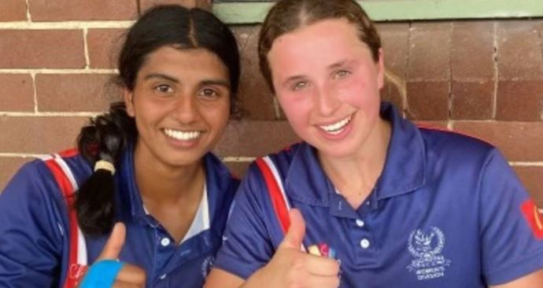
I am not one for navel gazing, but I suspect we will see an acceleration in the development and internationalisation of the Women’s game. We will have more oversea players playing in our competition which will help to further strengthen the competition. There will be an increasing gap between amateur and professionals and as a Club, we need to have a strategy on how we close the gap. Including more specialised training, coaching, and having the funds to support it. We may not have all the answers now, but the future certainly looks bright.
Asmi Bhanage and Olivia Callaghan - Record 466 run opening partnership

Go the Mighty Wonderful Reds!

BENY CHUN
PRESIDENT

Gordon Women’s Cricket Club Major Sponsor

YOUR ENTERTAINMENT DESTINATION
Whether it’s weeknight or weekend, Chatswood RSL has something
for you every night of the week!

Gordon District Junior Cricket Club President’s Message

What a great season we have just had – COVID free and great weather and to add to this - two premierships for Gordon Juniors. Congratulations to the Gordon U11 and Gordon U13 Green teams. Great performances by both sides in the final to take out the premiership.

In the U11’s, it was Gordon Green vs Gordon Silver - It was a close game with the Green side winning by 13 runs. Silver posted a reliable total thanks to a quick fire 24 from Angus Johnston. Green lost wickets early but steadied the ship and it wasn’t until the last partnership where Henry McNamara & James Boyd batted superbly to take the game away. Well done to both teams and the club spirit on the day was overflowing.
Dave Bezer

In the U13 final, it was Gordon Green playing archrivals Mosman. Mosman batted first and set a competitive 7/113 after their 30 overs. A brilliant bowling and fielding display by the Stags with honours shared by the entire side. Gordon set the platform with a strong opening partnership of 40 between Oliver Loader and Bob Barnett. Shaarav Jain added a handy 23 while Raveen Attanayake 16 n.o steered the team home to 5/115 with a few overs to spare. A great win, boys, and special thanks to Alex Cowdrey (Manager) and Danushka Attanayake (coach) who guided the team during the season.
Gordon Under 13 Green
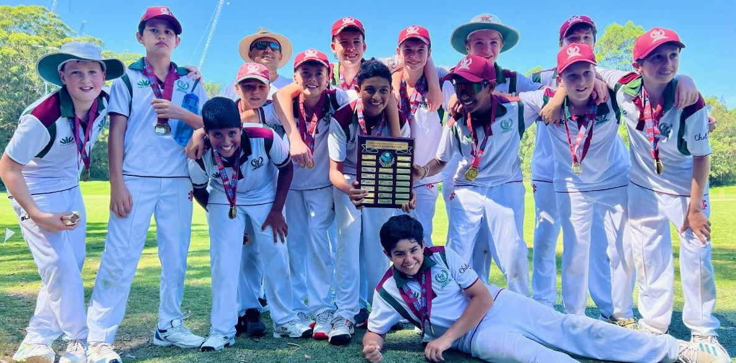
This season, we saw a reduction in the number of players registering for the juniors. The first decrease in ten seasons. This was disappointing, however the quality along with the enthusiasm of the players remained high. Starting with our Junior and Master Blaster squads and going through from under 9’s to under 17’s, the Gordon Juniors fielded teams in every age group of the North Shore Junior Cricket Association competitions. All of the teams performed well giving all players in the teams an equal opportunity to both bat and bowl. Team awards for the season are:

TEAM: BATTING BOWLING MOST IMPROVED
11GREEN James Boyd Shresth Sharma Hugo Stuart
11SILVER Max Zimmer Max McColl M.Mattar/H.Mcpherson
11RED Oscar Brophy Rayaan Rais Owen Wharton
12ORANGE Drew Rennie Ralph Hindmarsh Zac Robertson
12SILVER Bruce Kovacic Rui Ittner Ryan Spadafora
12RED Josh Nguyen Michael Archer Ben Free
12GREEN Harrison Koch Samson Clarke Liam Flattery
13GREEN Lachlan Boys Billy Smith Chris Healy
13RED Max Cawood Josh Cawood Henry Vanderfield
14GREEN Luke Francis Toby Maple-Brown Ben Stewart
14RED Nicholas Bruce Ahaan Marathe Angus Burton
15RED Josh Evans Sam Szudrich Noah Fontaine
17RED Naveen Jegendran Shaan Brar James Patselis

In addition to the foregoing awards, the following players also received an award for the best team contribution. These awards were decided by the recipient’s fellow team members and the award also doubles as a Player’s Player award. Henry McNamara, Angus Johnston, Abdul Rahmaan Jawaad, Charlie Finn, Thomas Hagger, Adam Twining, Harvey Ekas, Shaarav Jain, Angus Collins, Namay Kohli, Saras Pillai, Lucca Valtvies and Dev Patel.

Each season, Gordon Juniors have three major awards for players and volunteers’.
1, The Clyde Coltman Award for the best junior performances throughout the season. This season, Drew Rennie of the Gordon U12/13 side scored 276 runs at an average of 46 and took 12 wickets at an average of 8.4 from 33 overs. Congratulations to Drew on winning the Clyde Coltman award.
2. The Mal Hall Award for the Gordon Junior Cricket of the Year goes to Lachlan Boys from the Gordon U 13 green premiership winning side. Well done Lachlan.
3. President’s Award for great volunteer contributions is shared this year by Edwina Dorney (under 9s) and Alan Stapledon u10s) – two new committee members who did a remarkable job in coordinating their age groups.
Gordon Junior Cricket has a well-established pathway for players going on to play senior grade cricket and also be selected for the Gordon - AW Green Shield side which is a competition in which every team in the NSW Premier Cricket competition enters a side. Toby Robinson, Tom Fuzes and Justin Nielsen gained selection in this side. This a great acknowledgement of these junior players’ ability as over 300 players from throughout NSW registered to play in this side.

Gordon Juniors who played in the Gordon Grade sides were, James Patselis, Toby Robinson, Tiger Khunmuang, Justin Nielsen, Shaan Brar and Satvah Shah.

Each season, players from all North Shore junior clubs are invited to trial for the various age group representative teams which play in the NSW Youth Championships. The following players gained selection for the 2022/23 representative season: Adam Twining, Thomas Rigg, Angus Johnston, Harrison Koch, Samuel Kierse, Christopher Gower, Daniel Couper, Bob Barnett, Shaarav Jain, Satvah Shah, Alex Ruhfus, Luke Edgecombe and Archie Middleton. Well done to all of the above players on your representative selection.

Gordon Junior Cricket Club continues to follow the Junior cricket pathway as set down by Cricket Australia. This ensures both boys and girls get an equal opportunity to participate in all facets of the game in a safe and friendly environment.

I would thank all of our mums, dads, carers and volunteers who helped throughout the season in coaching, managing, scoring and umpiring the teams. Without your valued support we would not have this great family cricket club. Also it was great to see grandparents, siblings, family friends and the family pet supporting our players. In particular thank you to Edwina Dorney (under 9s) and Alan Stapledon (under10s) for your fantastic efforts in coordinating the younger players. Most importantly, thanks to all boys and girls from all teams who played the game in the true Gordon Spirit and showing great sportsmanship in all games played.

Lastly, the committee of Gordon Juniors along with the committees of the men’s and women’s senior clubs gave me fantastic support and I thank you sincerely for your assistance during the season.

DAVE BEZER
PRESIDENT
GDJCC

Insurance Advisernet was founded in 1996 with the aim of providing high quality risk management advice that business owners can trust. Today they are one of the largest and most respected General Insurance businesses in Australia and New Zealand, with an ever-growing network of over 180 insurance advisers across 140 locations. As part of the AUB Group, an ASX-listed company with over $2.5 billion in gross written premiums under management, their buying power spans major insurers in Australasia as well as access to major overseas insurers, including Lloyd’s of London.
For Gordon Cricket player or supporter enquiries contact Shaun Stanfield.

Shaun Standfield
Level 31, 100 Miller St,North Sydney NSW 2060
Phone: (02) 9964 7307
Mobile: 0417 215 009
Email: sstandfield@iaa.net.au

Notice of Meeting

GORDON DISTRICT CRICKET CLUB INC.
Notice is hereby given that the ONE HUNDRED AND EIGHTEENTH ANNUAL GENERAL MEETING of the GORDON DISTRICT CRICKET CLUB INC. will be held at the Killara Golf Club, 556 Pacific Highway, Killara, on MONDAY 24th JULY 2023, at 6.45 p.m.
You are cordially invited to be present.
BUSINESS
- To receive the Report of the General Committee and the Hon. Treasurer's Financial Statement.
- To receive and consider the Committee's Statement as required by the Association's Incorporation Act, 1984.
- To elect the Office Bearers and General Committee of the Club.
- To transact any other business brought forward in conformity with the Rules of the Club.

A.J. Falk P.O. Box 379
Hon Secretary Roseville NSW 2069
Ph: 0418 208532

NOMINATIONS
PATRONS
Mayor of Ku-ring-gai Mayor of Willoughby
Mr. Ian C. Carroll AM

PRESIDENT
M.A. Cant

HONORARY SECRETARY ASSISTANT HON. SECRETARY
A.J. Falk TBA

HONORARY TREASURER
G. Keevers

DELEGATES TO SYDNEY C.A. DELEGATE TO N.S.W.C.A. HONORARY AUDITOR
A.J. Falk & M. Carmichael A.J. Falk Trumans

GENERAL COMMITTEE
M. Carmichael, R. Carruthers, G. Hickman, S. Hinton, G. Tullia, B. Woods, J. Wright, M. Patterson.

Club Office Bearers, Life Members and Playing Members

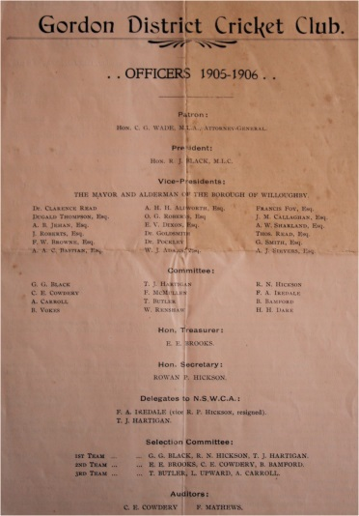
OFFICE BEARERS 2022-2023

PATRONS
Mayor of Ku-ring-gai Mayor of Willoughby
Mr. Ian C. Carroll AM

PRESIDENT
M.A. Cant

HONORARY SECRETARY ASSISTANT HON. SECRETARY
A.J. Falk -

HONORARY TREASURER
G. Keevers

DELEGATES TO S.C.A. DELEGATE TO N.S.W.C.A. A.J. Falk & M. Cant/M. Carmichael A.J. Falk

HONORARY AUDITOR
Trumans

GENERAL COMMITTEE
M. Carmichael, R. Carruthers, G. Hickman, S. Hinton, R. Thomas, G. Tullia, B. Woods, J. Wright,
B. Callanan (resigned Oct 22)

LIFE MEMBERS

* E.J. Baker | * C.A. Harris, OAM | * J.C. Morrison
* R. Barnes | * P.C. Harrison | * W.A. Murray
C. Berenger | * T.J. Hartigan | * W.A. Oldfield, MBE
* R.C.M. Boyce | G. Hickman | * J. Prowse
* D.A. Campbell | * A.H. Hinton | * W.R. Renshaw
M.A. Cant | S.A. Hinton | * G.A. Richardson
* S. Carroll | * E.W. Howitt Snr | M.F. Rosen, OAM
R.J.W. Cattlin | E.W. Howitt Jnr | * J.B. Shea
* C. Coltman | P. Horwitz | * B.C. Sheidow
* H. Crow | * F.A. Ireland | * C. Stevens
P. Davison | * W.E. Jackson | * S. Smith, CBE
* P.W. Dive | * C.E. Kelleway | P.G Stephenson
P.A. Emery | G.B.V. King | H.B. Taber
* D. Evans | * R. Lowing | * H.W. Tebbutt
A.J. Falk | * C.G. Macartney | R.J. Thomas
M.N. Falk | * K.D. McDonald | * S.E. Trumper
* R.H. Guy | * F. Matthews | A.N. Wilson

SENIOR PLAYING MEMBERS including A.W. Green Shield

Andreou, Nicholas  Archer, Lucas  Austin, Joel  Austin, Luke  Balaguruswamy, Nishanth  Bansal, Manas  Baruah, Anay  Bekis, Jamie  Bhabra, Louis  Bladen, Callum  Booth, Felix  Brar, Shaan  Brar, Taj  Bristow, Stephen  Bromley, Stuart  Brown, Mathew  Budroo, Nomaan  Burrows, Lachlan  Cahlin, Axel  Callanan, Luke  Carruthers, Tom  Clarke, Nam  Cook, Connor  Coventry-Searle, Tyler  Crawford, Tym  Cubbage, Adam  Deshpande, Shreyan  Doshi, Smit  Douglas, Jaeden  Farrell, Miles  Fedorow, Thomas  Fletcher, Michael  Foster, Bailey  Fuzes, Thomas  Gandhi, Vivaan  Gillard, Joseph  Gobinath, Arinath  Gohl, Tom  Gray, Jaiden  Gupta, Aryan  Hocking, Benjamin  Holland, Alex  James, Jack | Johnston, Jaylen  Jones, Matthew  Keevers, Matt  Kennedy, James  Kennedy, Trystan  Khunmuang, Tiger  Krishnan, Kieran  Lambert, Milan  Lole, Mitchell  Loong, Michael  Loynes, James  Madan, Aayush  Maini, Krrish  Manangam Premkumar, Ashwin  McKay, Dale  McKenzie, Lachie  McLean, Rory  Medford, Lucas  Medford, Tom  Mitchell, Charles  Monaghan, David  Murugappan, Ilankumaran  Naganayagam, Jayllen  Newton, James  Newton, Matthew  Nicholson, Taj  Nielsen, Justin  O'Brien, Scott  O'Farrell, Finn  Parsons, Benjamin  Patselis, James  Patterson, Oscar  Ranjan, Dylan  Read, Simon  Reicher, Thomas  Richards, Tim  Richtor, Elliot  Roberts, Nate  Robertson, Hayden  Robinson, Toby  Singh, Sidhant  Smith, Campbell | Saggers, Jackson  Schembri-Green, Samuel  Shah, Satva  Sharma, Apurv  Siede, Thomas  Stacy, Tom  Stanwell, Nick  Suresh Iyer, Prahlad  Sutton, William  Titterton, Quincy  Toohey, Nicholas  Toohey, Sam  Tullia, Ryan  Turner, Oscar  Voleti, Aditya  Watson, Rohan  Wilson, Fraser  Winslow, Zack  Woods, Ben  Woods, Jack  Woods, Nicholas  Woodward, Nicholas  Wright, Matthew

Obituaries

BRYAN CE DAWSON (30/6/1933 – 22/5/2023)

The club is saddened by the loss of Bryan “Smokie” Dawson at the age of 89.
Bryan played with Gordon 1960-66 before moving to the southern suburbs of Sydney. He opened the batting in 1st Grade for 5 years and was a most consistent performer, scoring 2 centuries and topping the batting aggregate several times. He formed a very strong opening partnership with Tony Steele. Comments like”…he impressed me greatly with his sure and perfect balance against the new ball. One has to play with Bryan to really assess his ability…” from skipper Sid Carroll are an indication of his talent with the bat. In those five seasons of 1st Grade, he scored 2042 runs at 26.18 with a highest score of 112.

Bryan moved south at the end of the 1965-66 season and the following season played in Sutherland’s 1st Grade side that lost the final. He played two more seasons in 1st Grade for a total of 890 runs at 29.67. He continued to play for them for another seven seasons, captaining a number of their lower grade sides successfully as well as winning a Premiership in 3rd Grade in 1975-76. In 2nd and 3rd Grades he scored 2,080 runs at 21.01.

He then retired from Grade cricket but in 1984 and having just passed the age of 50, he was asked to come back and captain the Gordon 5th Grade side and help nurture some young players through the grades. This lasted for three seasons and he did a great job. His stats were 420 runs at 19.09. He also served on the general committee for these years. Shortly after, he moved down the south coast where he remained until his death.

Bryan was a cheerful, effervescent character and proved to be popular in whichever team he played. He was a great clubman, always willing to pitch in and help when needed. He had a keen cricket brain and loved a chat about the game.

His later years were a struggle health-wise which was very sad for such an enthusiastic and passionate man. The club passes on its most sincere condolences to his wife and family.

ROBERT ROSEN (1943 – 2023)
Bob Rosen, middle brother to Ellis and Marshall, passed away suddenly 16th April, 2023. Bob started playing for Gordon in under age teams then graduated to play five seasons in 4th and 3rd Grades 1960-65 scoring a total of 614 runs at 20.47 for 35 innings. He was a popular player and a good team man who enjoyed his cricket with the Club.

Financial & Auditors Report

On behalf of the Management Committee of Gordon District Cricket Club Inc (GDCC) I am pleased to report on the financial position of GDCC as at 31 May 2023 and the financial performance of its operations for the year then ended.

For the financial year GDCC reported a statutory profit of $2,063 (2022 $5,939).

The Junior Club is funded by player playing fees. The Junior Club is proud of its Community Club status and is extremely conscious of the need to ensure that it remains affordable and inclusive. This season players enjoyed a full season with a traditional late September/October start. It was disappointing that Junior registrations were down by 20% compared to the 2021-22 season where the start was delayed due to Covid 19.
Geoff Keevers

To keep the Grade playing fees affordable for a largely student playing cohort means that GDCC is heavily reliant on grants from Cricket NSW, sponsorship and fundraising. The decision by Chatswood RSL Club to award GDCC a significant grant under their 2022 Club Grants program was most welcome. I am delighted to advise that Chatswood RSL Club has included GDCC and Gordon Women’s Clubs jointly in their 2023 Club Grants program at the maximum grant allowable for the coming 2023-24 season. GDCC continued the arrangement with the Australian Sports Foundation to permit tax-deductible donations to be made to the Club. This arrangement raised in excess of $17,000, which is testimony to the generosity and the importance of the Club to the community.

The Cricket Legends lunch was held in October. A memorable lunch was attended by over 370 people. The lunch successfully raised the profile of your Club and returned a surplus exceeding $36,000.

The increase in the inflation rate over the past year means that the cost pressures on the club will only worsen. Both Willoughby and Ku-ring-gai Councils have indicated that ground hire charges will increase by more than 7% in the coming year and longer term they are looking to increase fees and charges in excess of inflation to compensate for rate pegging.

Your Club remains in a strong financial position with member’s funds of $130,074 (2022 $128,011) and a significant cash reserve.

On behalf of the Management Committee, I would like to acknowledge and thank Cricket NSW, Chatswood RSL Club, the Club’s sponsors, supporters who made donations and all those involved in the Cricket Legends function for their support of the Club. It would be remiss not to acknowledge those people who chose to support the Club through their involvement in match day management, coaching and operations.

GEOFF KEEVERS
GDCC TREASURER

Gordon District Cricket Club Inc.
ABN 90 442 412 153

Special Purpose Financial Report
For the Year Ended
31 May 2023

CONTENTS

Statement of Profit or loss and Other Comprehensive Income 22

Statement of financial position 23

Statement of Changes in Equity 24

Statement of Cash Flows 25

Notes to the Financial Statements 26

Statement by Members of the Committee 34

Independent Audit report 35

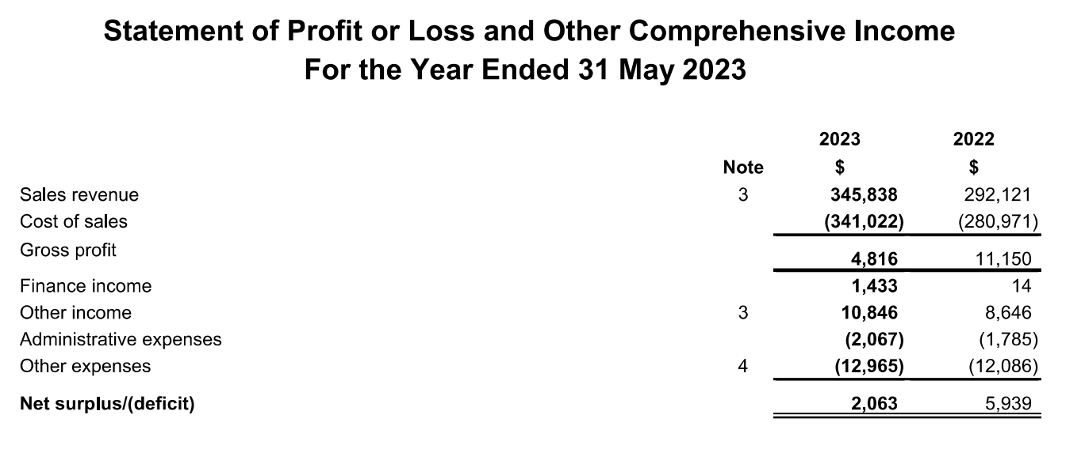

The accompanying notes form part of these financial statements

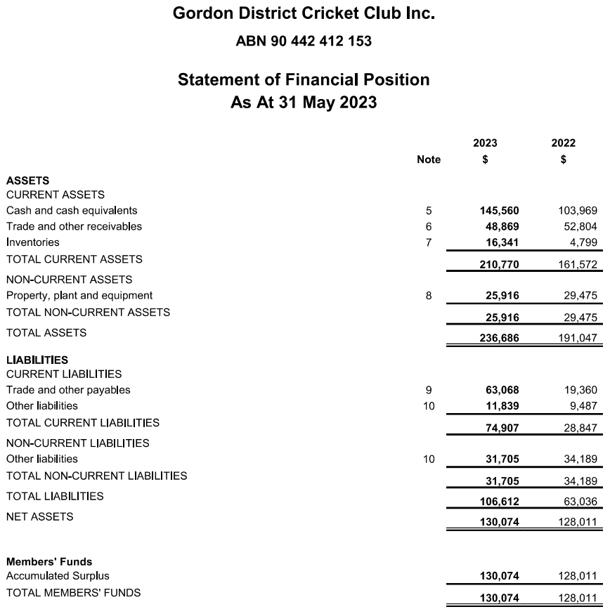

The accompanying notes form part of these financial statements
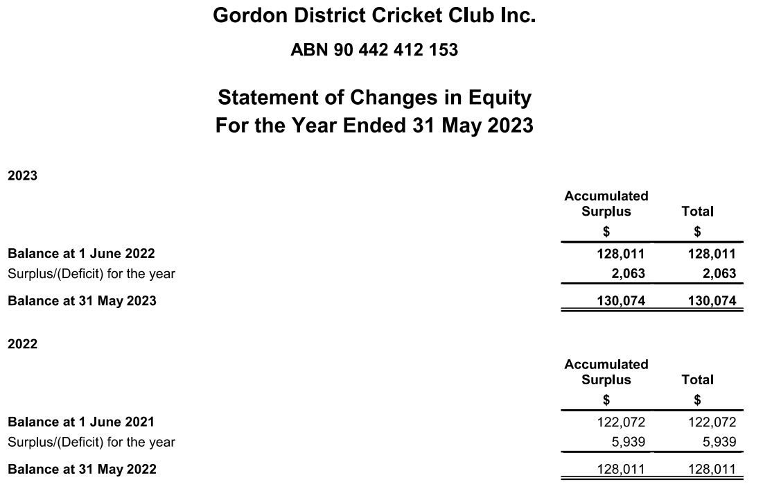

The accompanying notes form part of these financial statements

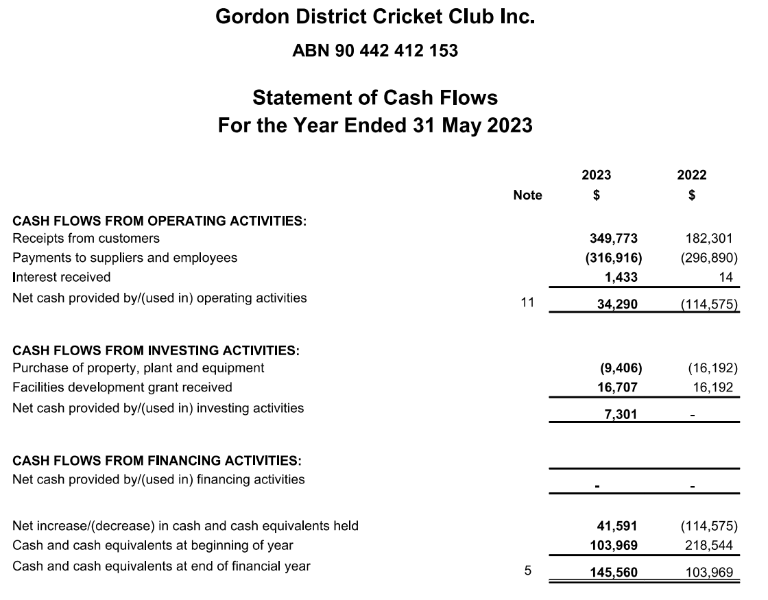

The accompanying notes form part of these financial statements
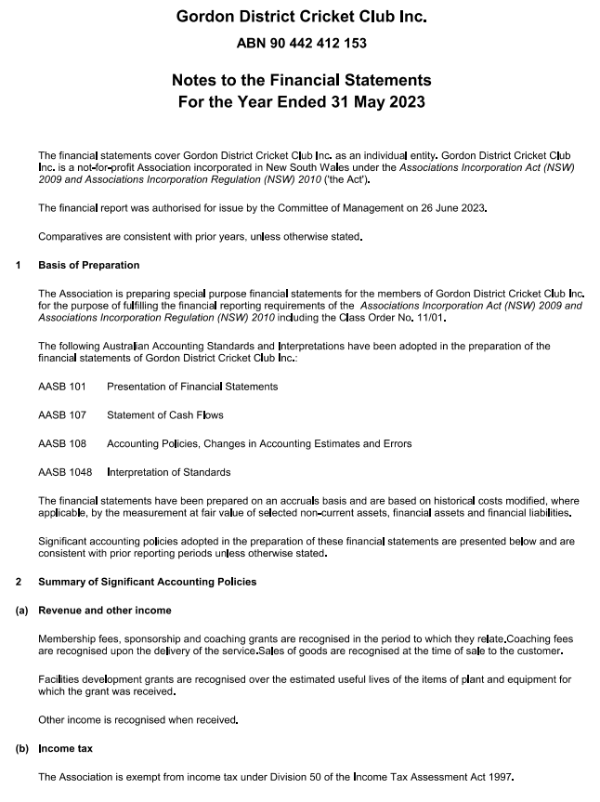

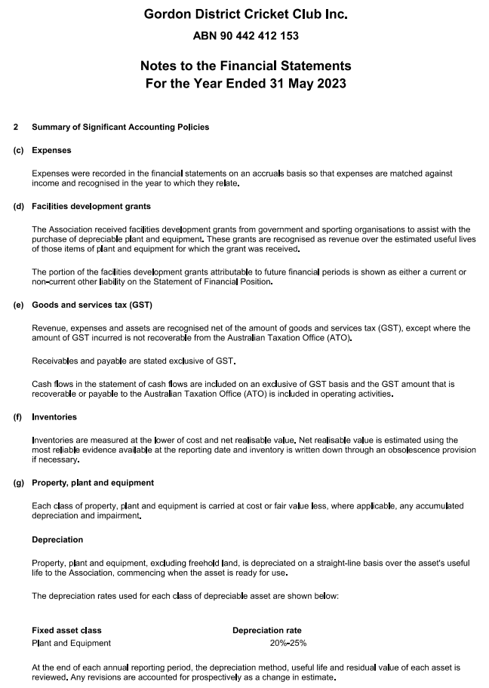

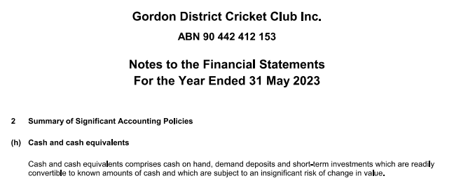

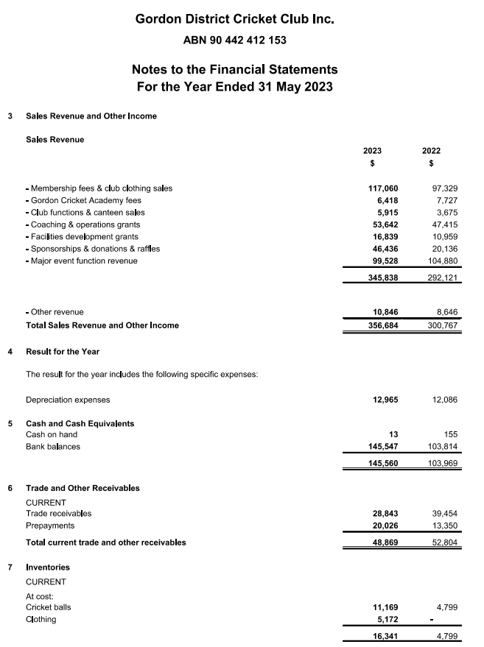

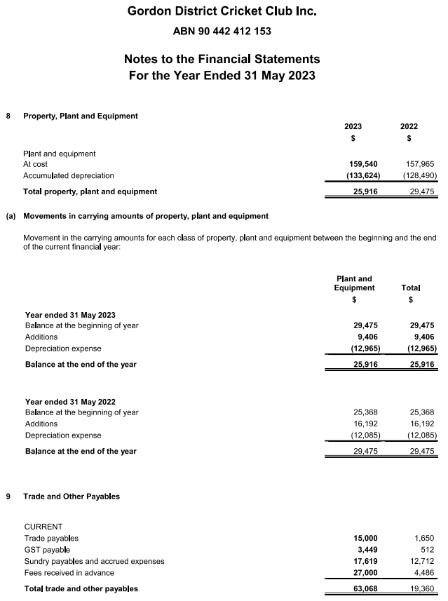

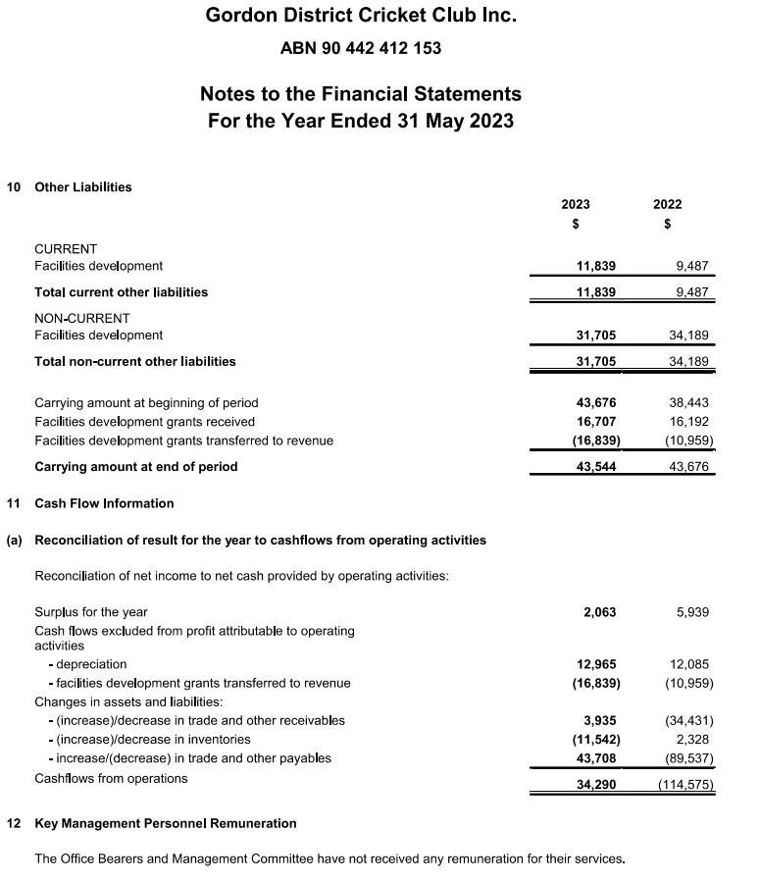

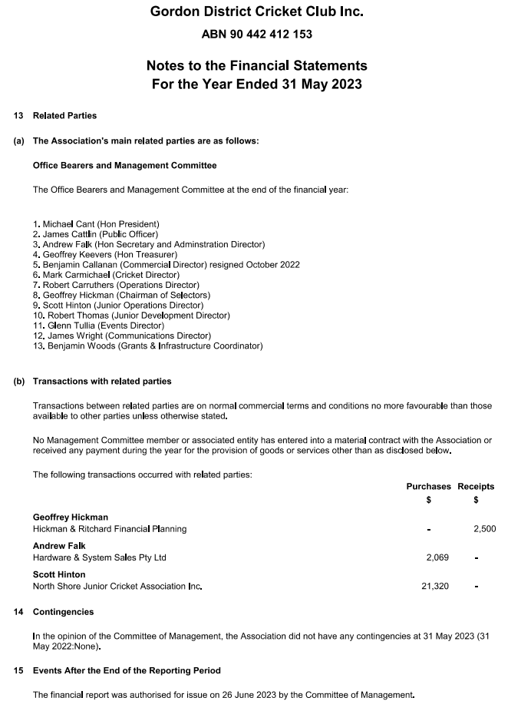

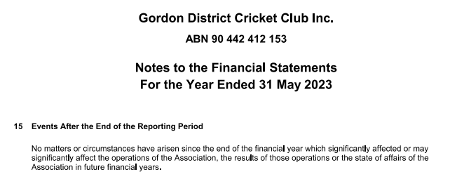

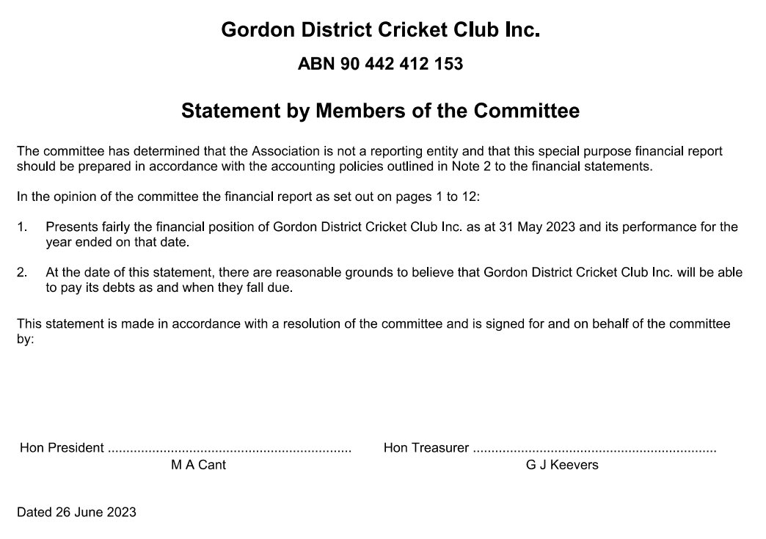

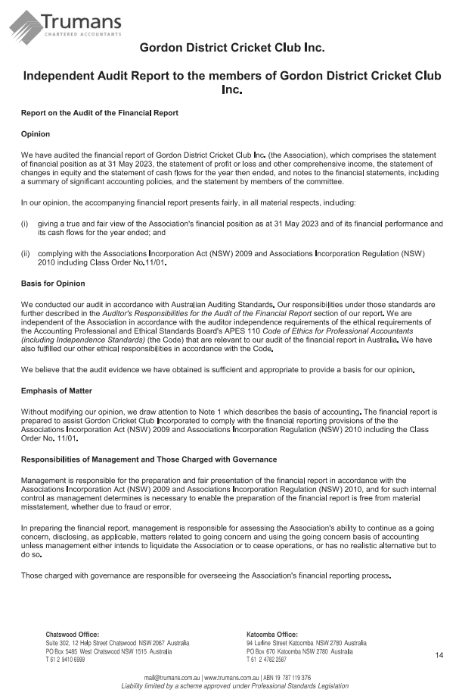

Executive Committee Report

The Executive Committee has much pleasure in submitting for the members' consideration and adoption, the One Hundred and Eighteenth Annual Report and Balance Sheet. This report is in the format that various sub-committees report to the Executive Committee.

GENERAL - ADMINISTRATION

After the previous season when the two main features of NSW Premier Cricket were COVID and rain, we were able to “resume normal programming” during the 2022-23 season. There was still some rain around, and several wash-outs resulted, but it was good to return to two-day cricket.
Andrew Falk

After reaching Finals Series in the Kingsgrove Sports T20, 2nd Grade, 4th Grade, Green Shield, Poidevin Gray and Colts/Metro Cup competitions, the Club’s season has been described by some as being “successful”. However, despite some outstanding individual and team performances, our inability to progress to the “decider” (and, perish the thought, bring home some silverware!) in any Premier competition for several years reflects on our inconsistency in performances, a worrying trend of players missing matches for minor reasons and our mental toughness.

In my opinion, the Gordon 1st Grade squad this season “on paper” was the strongest we had fielded in several years. Unfortunately, as the classic expression goes, “the game was played on grass”. Injuries, drop-outs, suspensions and inconsistent performances throughout the 1st Grade season impacted considerably on the enjoyment factor of those close to the team. In addition, the new PlayHQ administration and live-scoring system was inflicted upon all clubs by CA/CNSW and it became a difficult season for club administrators, scorers and selectors.

On the positive side, as long as they aren’t poached by other clubs, we have a crop of highly talented young players coming through who will hopefully form the nucleus of our top two sides for several seasons to come.

It’s a pretty obvious statement but, volunteering in the 21st century isn’t what it used to be. Life is busier, communication is instantaneous, work is more demanding, local and overseas travel is fast and relatively inexpensive and there are, probably, too many “life” options available to fill in a person’s day. Gone are the days when a 1st or 2nd Grade cricketer continued to play lower grade cricket as a captain or mentor well into their 30’s, and sometimes beyond.

As a consequence, the concept of volunteering to assist at an amateur sporting club on a regular basis has gone by the wayside. Due to additional obligations towards local councils and our affiliated associations (Cricket NSW and the Sydney Cricket Association) added to the expectation of always utilising the latest technology and most Premier Clubs in Sydney are on a downwards spiral in regards to having real workers “on the ground”. There are too few people available to carry the ever-increasing burden of off-field work. The Club has always provided a high standard of hospitality to visiting players, umpires, parents and officials at our home venues but this has dropped off over recent seasons, partly due to COVID and partly because the concept of volunteering is foreign to most people in the relevant age and cultural demographic in which the Club operates. The enjoyment of all participants in community sport is vital to the perpetuation of the sport. If all the work is carried out by only a few people, their enjoyment factor dissipates quickly and, when they are gone, who will be there to pick up the slack?

Off the field, there were several outstanding successes. Following on the success of the “Underarm Luncheon” in March 2022, the follow-up luncheon later in the year was equally enjoyable and successfully financial. A most-welcomed renewal of a sponsorship arrangement with the Chatswood RSL Club (after a hiatus of only about 25 years!!) added to funds raised from the luncheon, the annual Golf Day at Long Reef in March and some generous donors and another solid financial result was ensured.

Again, this year’s End-of-Season Awards function was held as a relatively-informal sit-down dinner at the Greengate Hotel in Killara in mid-April. Ed Howitt Jnr did much to organise the various trophies and awards for this function, Paul Stephenson kindly arranged photographs and Lachie McKenzie again acted as MC.

Mark Carmichael again chaired the Club’s Cricket Committee with responsibility for recruitment and retention of players, selections, coaching and training. The Selection Committee, headed by Geoff Hickman (with Ed Howitt, Club Coach, Elliot Richtor, and the team captains) had an easier job in regards to COVID withdrawals and wet weather this season but were plagued with what looked from the outside like a lack of commitment from many players. Gone are the times when a player put their name down to play a season of Grade cricket and only withdrew from a match through severe injury or death!

The Club’s Junior Development and Country Program, run by Director Bob Thomas, was again a highlight this season. Good, young cricketers are selected into this program from across Sydney and regional NSW and the better ones develop via our Green Shield and Poidevin Gray squads into top Premier Cricket grades. The Green Shield and Poidevin Gray teams both reached their respective quarter finals and, as time goes on, more and more of our young players are achieving recognition through selection in Cricket NSW’s Under-Age/”Pathways” Representative and Development Squads.

Despite the mediocre season for 1st Grade, 2nd and 4th Grades made the playoff’s in March and both teams progressed beyond Preliminary Finals into Semi-finals. Given a little bit of luck, 2nd Grade could easily have beaten a very strong Manly team in their semi at Allan Border Oval while 4th Grade, after an excellent effort in the field, were let down by their batting against Parramatta at Bankstown Oval.

I ran out of superlatives some years ago to describe the exceptional job that G. (“Genius”) Keevers Esq does to manage the finances of the Club.

Jim Wright, as Director of Communications, has completed the revitalization of the Club’s website and social media platforms. Jim and Tony Wilson regularly provide high quality photos for the Club’s Facebook and Instagram pages while TeamApp provides an excellent tool for disseminating information to the Gordon Community promptly. “Frogbox” is used by most Men’s and Women’s Premier Clubs to provide live-streaming services across the various competitions – our Country families appreciate these services while players, coaches and umpires can view their “errors” at the end of a game.

Ben Woods, as Director of Facilities, is starting to get some traction in regards to improving our facilities through closer links with Local and State Governments. Chatswood Oval is well-overdue for a significant upgrade to the off-field facilities (the Trumper Pavilion reaches its Centenary next year!) while synthetic and wet-weather practice facilities in our LGA are either in disrepair or non-existent. Ben also took on the added responsibility of captaining our Metro Cup (“Colts”) team during the second half of the season. His team made it through to the Preliminary Finals and then, to celebrate, Ben put his hand up to be the Club’s liaison to the Metro Cup Competition. (Incidentally, after more than ten years being “privately” administered, this Competition will be run out of Cricket NSW’s Community Cricket Department from next season. This should make ground and umpire allocation considerably more efficient.)

Scott Hinton continued as a Director on the Executive Committee. Scott did a massive amount behind the scenes to assist with mid-week liaison with Councils and groundstaff and with emergency mid-week pitch covering during wet weather. He also extended his long-term involvement with the North Shore District Cricket Association as well as with the Gordon Junior Cricket Club. Huge thanks again go to Scott and also to Dave Bezer, the President of the Junior Club, for their assistance and support throughout the season.

Finally, my thanks go to (former Secretary) Jim Cattlin and (former Comms Director) Paul Stephenson for their considerable work in collating this Annual Report.

The Executive Committee met on 9 occasions (to 30th June 2023) and attendances were as follows:

Name | Committee Responsibility | Attendances  (max 9)
Michael Cant | Chairman of Committee, Club President | 9
Andrew Falk | Director – Administration, Hon Secretary | 9
Geoff Keevers | Director – Finance, Hon. Treasurer | 9
Geoff Hickman | Director (Chairman of Selections) | 6
Mark Carmichael | Director - Cricket | 5
Rob Carruthers | Director – Operations | 5
Glenn Tullia | Director – Major Functions | 7
Bob Thomas | Director – Junior Dev & Country Liaison | 6
Ben Callanan | Director – Commercial (Resigned Oct 22) | 1
Ben Woods | Director - Facilities | 7
Scott Hinton | Junior Coordinator | 8
Jim Wright | Director - Communications | 6

Club Captains, Ryan Tullia and Matt Wright, and Junior Club President & Golf Day Coordinator, David Bezer, also attended meetings as Guests during the year.

ANDREW FALK
ADMINISTRATION DIRECTOR

SYDNEY CRICKET ASSOCIATION & CRICKET NSW

NSW MEN’S PREMIER CRICKET

Cricket NSW now has a new, and permanent, home at Silverwater in the heart of the Sydney basin.
The now-complete Stage 1 includes a remarkable indoor centre, gyms, pools, work areas, meeting rooms, café, library and a beautiful First Class playing field. Turf practice nets are in the process of completion while Stage 2 will see a second “junior” playing field, outdoor synthetic practice nets and team facilities at the main ground. Sadly lacking are spectator facilities but hopefully these won’t be too far away.

Gordon and Cricket NSW Life Member, Marshall Rosen, remains involved in the top echelons of cricket in the State, sitting on several CNSW Board Subcommittees including Cricket, Life Membership and the above-mentioned Wilson Park Development. Marshall was recently awarded an OAM for his services to cricket.

Andrew Falk fills the role as the Club’s Delegate to Cricket NSW and also as one of the Delegates to the Sydney Cricket Association where he has now completed 21 years on the SCA’s Committee of Management. Mark Carmichael replaced Michael Cant during the season as the Club’s other Delegate to the SCA.

The Australian Cricketers’ Association (ACA) continues to provide generous financial support for every Male and Female Premier Club across Australia by funding an ACA Member to coach and/or play for that club. Mark O’Neill provides specialist batting coaching for the Club and is currently the recipient of this funding.

While COVID remained in the community during the season, it had significantly less influence over the Grade Competition than it had over the previous two seasons and a relatively “normal” cricket season was possible. La Nina caused loss of play on some days, especially early and late in the season, but it was a pleasure to return to two-day cricket (and the corresponding afternoon teas!!).

The introduction by Cricket Australia via Cricket NSW of a new competition administration and management system called PlayHQ to replace the, albeit aging, myCricket system was nothing short of a disaster. The new product was promised to be an “upgrade” on the previous offering but, in reality, many features were missing and others simply didn’t work. Not one aspect of the new system made a club administrator’s life “easier” than it had been before. Whether it was player registrations, team selections, live-scoring, connection to the Frogbox live-streaming, player statistics or manual scorecard entry, there was nothing where users could confidently say they were now better off. PlayHQ is used in several other sports around Australia. It might be fine for “community” sport but significant work is required for it to provide the necessities of Premier Cricket – the total lack of player statistics and Club Championship tables caused staff at Cricket NSW massive amounts of extra work this season and, unfortunately, there doesn’t appear to be any light at the end of the tunnel.

Finally, Premier Clubs continue to be greatly appreciative of the significant funding that is provided by long-term sponsors McDonalds, Kookaburra and Kingsgrove Sports and, for a second season, we enjoyed a generous sponsorship arrangement with Gage Roads Brewing.

Men’s Club Championship (Points and positions after Preliminary Rounds)

Grade | Position  2022-23 | Position  2021-22 | Points Contrib’d 2022-23 | Points Contrib’d  2021-22
1st Grade | 19th | 15th | 90 | 168
1st Grade T20 | 1st (Sixers conf) | 10th (Sixers conf) | 90 | 3
2nd Grade | 4th | 6th | 280 | 295
3rd Grade | 12th | 11th | 156 | 156
4th Grade | 3rd | 8th | 171 | 138
5th Grade | 13th | 4th | 66 | 106
Poidevin Gray | 4th (Sixers conf) | 10th (Sixers conf) | 60 | 2
Green Shield | 5th | 4th | 75 | 114
Club Championship | 12th | 11th | 988 | 982

Congratulations to the following clubs on their Premiership honours in SCA competitions in 2022/2023: -

McDonald’s NSW Premier Cricket

Club Championship Manly-Warringah
First Grade Parramatta
First Grade Limited Overs Northern District
Second Grade Manly-Warringah
Third Grade Parramatta
Fourth Grade Manly-Warringah
Fifth Grade Northern District
Poidevin Gray Shield Randwick-Petersham
A W Green Shield Parramatta
Kingsgrove Sports T20 Cup Sydney
KST20 Sixers Conf Sydney
KST20 Thunder Conf Sydney University
Spirit of Cricket St George

McDonald’s Sydney Shires Cricket

Club Championship Burwood Briars
First Grade Strathfield
Second Grade Burwood Briars
Third Grade Burwood Briars
Fourth Grade Warringah
Fifth Grade Pennant Hills
Frank Gray Shield Epping

NSW WOMEN’S PREMIER CRICKET

Legend of the GDCC Women’s Division, Jessica Henry, again served on the Cricket NSW Board’s Cricket Sub-Committee. Having stepped down from her SCA responsibilities a couple of seasons ago, she obviously had some spare time on her hands as she is now on the Veterans Cricket Australia Board and the Organising Committee of Veterans Cricket NSW. And, of course, she continues to take the field for Gordon’s “Mighty Reds” each weekend.

Following on from two years at the helm by John Biviano, Craig Hambleton chaired the SCA Women’s Competition Sub-committee this year. Craig is an experienced club administrator and, through his involvement on the SCA Committee of Management for more than 15 years, he has seen first-hand the issues in the advancement of women’s cricket in Sydney and across NSW. His greatest challenge remains the fact that there is some outstanding talent in the women’s game “at the top” while there are a “million” young females in the entry-level phases but the path in between is largely undefined.

Congratulations to the following Women’s clubs on their Premiership honours in SCA competitions in 2022-2023: -
WOMEN'S COMPETITION
McDonald’s NSW Women’s Premier Cricket
Club Championship Sydney
First Grade Penrith
First Grade T20 Sydney
Second Grade Sydney
Third Grade St-George Sutherland
Brewer Shield Sydney

ANDREW FALK
ADMINISTRATION DIRECTOR

Kfibre is a natural, complex, raw un-purified prebiotic dietary fibre for gut health management and microbiome support containing active phytonutrients & antioxidants and that equals raw prebiotic power for all stages of life and diets, this includes children on solids to our Great-Grandparents. And everyone in between. It’s that good we do not need to hide behind flavours and additives! That’s not what Kfibre is about! So, if you need help with maintaining your intestinal health from dietary bloating, irregularity, normalising dietary indigestion, FODMAPs, or food intolerances (Kfibre has no known allergens) and that keeps you from optimal healthy digestion then Kfibre is for you.

www.kfibre.com

MEN’S COMPETITION TABLES – 2022/2023

CLUB CHAMPIONSHIP (SYDNEY SMITH CUP):

Manly Warringah 1,566 Parramatta 1,391 St George 1,297 Northern District 1,237 Bankstown 1,228 UTS North Sydney 1,198 Randwick Petersham 1,168 Sydney University 1,074 Eastern Suburbs 1,069 Penrith 1,061 Mosman 1,015 Gordon 988 Western Suburbs 967 Sydney 959 UNSW 817 Sutherland 751 Fairfield-Liverpool 72 Blacktown Mounties 655 Hawkesbury 520 Campbelltown Camden 492.

FIRST GRADE: (BELVIDERE CUP):

Sydney University 66 Manly Warringah 61.9 Parramatta 60 St George 59 Northern District 56 Randwick Petersham 54 Penrith 53 UNSW 53 Bankstown 52 Sydney 51 Western Suburbs 40 Fairfield-Liverpool 37 Mosman 37 Blacktown 33 UTS North Sydney 32 Campbelltown Camden 29 Eastern Suburbs 28 Sutherland 20 Gordon 15 Hawkesbury 14.

FIRST GRADE LIMITED-OVERS:

St George 26 UNSW 25 Campbelltown Camden 22 Penrith 20 Sydney 20 Northern District 19 Blacktown Mounties 19 Sydney University 19 Bankstown 18 Mosman 18 Parramatta 13 Manly Warringah 13 Sutherland 12 Randwick Petersham 12 UTS North Sydney 12 Western Suburbs 12 Fairfield-Liverpool 11 Eastern Suburbs 7 Gordon 2 Hawkesbury 0.

KINGSGROVE SPORTS T20 CUP:

Sydney Sixers Conference:

Gordon 15 St George 15 Sydney 12 Randwick Petersham 12 Manly Warringah 12 Mosman 6 Sutherland 6 Eastern Suburbs 6 UNSW 3 UTS North Sydney 3.

Sydney Thunder Conference:

Bankstown 15 Sydney University 15 Penrith 15 Blacktown Mounties 12 Northern District 9 Parramatta 6.5 Western Suburbs 6 Fairfield-Liverpool 3.5 Campbelltown Camden 3.5 Hawkesbury 0.5.

SECOND GRADE (ALBERT CUP):

Manly Warringah 64 Northern District 60 Mosman 57 Gordon 56 Bankstown 55 St George 54 Eastern Suburbs 53 UTS North Sydney 52 Sydney University 51 Sydney 46 Parramatta 43 Western Suburbs 39 Penrith 37 Campbelltown Camden 32 Randwick Petersham 31 Hawkesbury 26 UNSW 25 Fairfield-Liverpool 21 Sutherland 20.9 Blacktown Mounties 13.

THIRD GRADE (MITCHELL CUP):

Randwick Petersham 71 Parramatta 71 Manly Warringah 68 UTS North Sydney 63 St George 60 Penrith 58 Eastern Suburbs 57 Bankstown 56 Western Suburbs 49 Sutherland 44 UNSW 40 Gordon 39 Northern District 35 Fairfield-Liverpool 34 Mosman 33 Sydney University 26 Blacktown Mounties 21 Hawkesbury 20 Sydney 10 Campbelltown Camden 4.

FOURTH GRADE (REID CUP):

Manly Warringah 76 Parramatta 64 Gordon 57 UTS North Sydney 56 Eastern Suburbs 53 Sydney 52 Bankstown 52 St George 46 Northern District 46 Fairfield-Liverpool 45 Western Suburbs 45 Randwick Petersham 38 UNSW 34 Sutherland 34 Mosman 28 Penrith 26 Sydney University 26 Blacktown Mounties 21 Hawkesbury 17 Campbelltown Camden 1.

FIFTH GRADE (DAVID SHERWOOD CUP):

Manly Warringah 70 UTS North Sydney 70 Northern District 65 St George 59 Parramatta 53 Eastern Suburbs 51 Sutherland 51 Mosman 44 Sydney University 44 Randwick Petersham 42 Penrith 40 Blacktown Mounties 40 Gordon 33 Bankstown 33 Fairfield-Liverpool 33 UNSW 32 Hawkesbury 31 Western Suburbs 30 Sydney 14 Campbelltown Camden 11.

POIDEVIN-GRAY SHIELD:

Sydney Sixers Conference:

UTS North Sydney 24 Manly Warringah 22 Randwick Petersham 15 Gordon 15 Sydney 13 Mosman 12 Eastern Suburbs 9 St George 6 Sutherland 3 UNSW 3.

Sydney Thunder Conference:

Northern District 25 Campbelltown Camden 19.5 Parramatta 19.5 Western Suburbs 12 Bankstown 12 Blacktown Mounties 9 Fairfield-Liverpool 6.5 Sydney University 6 Penrith 6 Hawkesbury 3.5.

AW GREEN SHIELD:

Mosman 40 Parramatta 39 Sutherland 33 Hawkesbury 32 Gordon 25 Manly Warringah 25 Eastern Suburbs 25 Randwick Petersham 25 Sydney 25 UTS North Sydney 24 St George 21 Bankstown 19 Blacktown Mounties 19 Western Suburbs 19 Penrith 18 Northern District 13 Sydney University 13 Campbelltown Camden 6 Fairfield-Liverpool 6 UNSW 6.

Premiers denoted in bold.

Cricket Report

Introduction
Season 2022/23 was in many respects a return to the cricket we had known pre Covid 19. The season consisted of a combination of two and one day matches, a T20 competition in First Grade and a continuation of the Poidevin-Gray and A W Green Shield competitions.

Grades:
The on field results were mixed with consistency or the lack of being evident. It was very pleasing that both 2nd grade and 4th grade qualified for the finals series, with both progressing to the semi final stage. The Colts team also made it the semi-finals which was another very positive aspect of the season.
Mark Carmichael

First Grade: While playing some very bright and attractive cricket at times, the team overall had a disappointing season. A highlight was finishing top of the Sixers Conference in the T20 competition. During the season a number of younger players were given the opportunity to play First grade, and it is to be hoped that this will be the beginning of a resurgence in our top team.

Second Grade: once again the 2nd grade team had an excellent season finishing fourth on the ladder and playing out a tremendous semi-final. Captain Jamie Bekis led the team with a calm demeanor, and it is to be hoped that the younger players who contributed so much during the year will continue to improve.

Third Grade: Former first grader James Kennedy made a welcome return to play for the club this season and did an excellent job captaining and leading he third grade team. The team finished the season on a high, and it may well have been a year of missed opportunities, with a 12th place finish not necessarily reflecting the overall performance of the team.

Fourth Grade: 4’s finished third on the table and were deserved finalists, winning the qualifying final only to go down in the semi-final. Captain Apurv Sharma led the team very well, and the team are to be congratulated on a good and successful season.

Fifth Grade: Finished 13th and it was a season of near misses. Unfortunately unavailability’s in higher grades impacted severely on 5’s which made things more difficult. Captain Steve Bristow did a good job coping well with the regular team changes and giving players the opportunity to shine.

Metropolitan Cup: Our Colts team made the semi-finals, finishing 4th in the regular season. Captain Ben Woods did a wonderful job captaining this very young squad, and it is hoped that a number will progress into the grade teams in the years ahead.

Poidevin-Gray : This competition was a mix of 50 over and T20 games which presents both opportunities and challenges for the players. The team had a strong season, finishing 4th. The side was well captained by Connor Cook and with a number of players eligible again next season it is hoped the team will build on its successful year.

A W Green Shield: The team finished 5th on the table and performed very well during the season. Importantly they played as a team and it is hoped that a number will progress into the grade teams in the years ahead.

Gordon finished 12th out of 20 in the Club Championship, finishing short of our target of a top 10 finish. Ideally this will be improved upon next season

Final Positions
1st grade – 19th
1s grade T20 – 1st – Sixers Conference
2nd grade – 4th
3rd grade – 12th
4th grade – 3rd
5th grade – 13th
Colts – 4th
Poidevin-Gray Shield Under 21’s – 4th
A W Green Shield Under 16’s – 5th
Club Championship – 12th

Coaching
Elliot Richtor was again Head Coach of the Club as well as Poidevin-Gray coach, and did an excellent. He was well supported by Nick Miller and a number of specialist coaches namely, Mark O’Neill (batting) Matt Nicholson (fast bowling) Brett Hunter (spin bowling) and Brett Rosen (wicket keeping). The club places great emphasis on the coaching made available to the players and a sincere thank you to all of these people for their contributions.

Nick Miller and Matt Wright were once again the A W Green Shield coaches and did a wonderful job shaping this young group of players.

Captains: Being the captain of grade cricket team is a time consuming and demanding role, and I thank all of those who captained teams this season. A sincere thank you to the following for their contributions as captains, Tym Crawford and Dale McKay, Jamie Bekis, James Kennedy, Apurv Sharma and Steve Bristow in grade and Ben Woods in Colts.

Selectors: Geoff Hickman, Ed Howitt and the team captains formed he selection panel for the season and thank you to all for your contribution during the year. Player availability in particular in lower grades made the job of selecting teams even more difficult during the season. Ideally this situation will be rectified next year.

Representative selections:
Congratulations to the following players selected in a range of representative and merit teams during the season:

Under 19’s
Luke Callanan – NSW Metro
Joey Gillard – NSW Country
Bryce Cook – NSW Country
Karan Katli – NSW Country

Under 17’s
Sidhant Singh – NSW Metro

AW Green Shield Merit XI
Rory McLean

Junior academy
The Junior Academy continues to play a vital role in the club, helping prepare younger players for the higher levels of cricket. A special thank you to Bob Thomas, Ed Howitt, Nick Miller and Matt Wright for their ongoing work in this area.

Awards
The winners of the various awards are summarized below. Congratulations to all of these players and officials on excellent seasons.

AWARD DESCRIPTION WINNER

Victor Trumper Player of the Year Axel Cahlin
Charles Macartney 1st Grade Performances Axel Cahlin
Ed (Junior) Howitt 2nd Grade Performances Smit Doshi
Graham King 3rd Grade Performances Tom Siede
Phil Bovey 4th Grade Performances Charlie Gwynn
Rob Lowing 5th Grade Performances Steve Bristow
Charles Harris Colts Performances Jack Woods
Dick Guy Under 21 Performances Smit Doshi
Phil Emery Green Shield Performances Rory McLean
Brian Taber All Round Performances Jamie Bekis
Ed (Senior) Howitt Clubman of the Year Ben Woods
Bert Oldfield Award Junior Clubman of the year James Loynes

*Dave Monaghan reached 3,000 runs and 250 wickets for the club in his 12th season
*Tym Crawford reached 5,000 runs in first grade
*Axel Cahlin reached 5,000 runs in all grades
*Louis Bhabra (157) and Tom Siede (106) created a new 3rd grade record partnership of 261 (unbeaten) for the 2nd wicket. (10th highest partnership in history of club)

MARK CARMICHAEL
CRICKET DIRECTOR

Zoono Group are leading experts in antimicrobial protection, listed on the Australian Stock Exchange (ASX:ZNO). Zoono specialises in the development, manufacture and global distribution of a unique range of long-lasting and environmentally friendly antimicrobial solutions. Over the past 5 years, Zoono has developed a suite of proven products that enable our customer’s partners and distributors to realise and maximise both revenue producing and commercial opportunities. Zoono Group has developed, and owns, a wealth of intellectual property based around the ‘Zoono Molecule’. A unique, antimicrobial technology that bonds to any surface and kills pathogens including bacteria, viruses, algae, fungi and mould. It has proven efficacy and longevity, it does not leach and cannot diminish in strength. Today, Zoono Group has established a global network of customers and distributors that are spread across 42 countries and territories. As the market leader in its field, Zoono Group continues to develop new products and industry applications via a strong base of scientific, technical and training support.
Website: www.zoono.com.au

GDCC Silver Sponsor

Now in its centenary year, continuously providing a full range of accounting services, Trumans is the right size to give you the personal and partner-level service you want and large enough to provide the experience and support you need to confidently manage and grow your business. Trumans is a respected firm of Chartered Accountants providing direct access to experienced professionals who are only interested in achieving the best outcomes for our clients. Services include auditing and assurance, business services and tax planning and management.
Suite 302 / 12 Help St, Chatswood NSW
02 9410 6999
mail@trumans.com.au
trumans.com.au

Hickman & Ritchard Financial Planning (HRFP) have more than 30 years collective experience in the financial services industry, in excess of $100 million in funds under management, and the backing of big name brand MLC – an organisation that’s been around for more than 120 years.

This second-generation financial planning business was founded by Geoff and Shaun's fathers, Jim Hickman and Peter Trimnell-Ritchard, who were well-known and highly regarded members of the financial planning industry.

MLC stands behind the advice we provide and provides the technical and investment research that we use for our clients (although we are not tied to using their investment and insurance products). MLC audit us annually to ensure we are meeting our obligations to our clients by providing sound, appropriate advice.

Telephone: (02) 9876 0177
Level 2, 16-18 Cambridge Street
EPPING NSW 2121

Operations Report

Operations ran as smoothly as can be expected this year, thanks to contributions from throughout the executive, administrative, and playing ranks of the club.

A significant portion of which, ground bookings and cover roster, was once again handled with great aplomb by Scott Hinton. Covers coordinated by the players with Scott’s guidance worked well, with only one miss- reading of the metrological conditions resulting in a game being impacted at Killara.
Rob Carruthers

There were some important operational investments made this year:
- New covers for Beauchamp and Killara.
- New hessians.
- New black covers for sight screen at Beauchamp.
- New sopper for Chatswood.

Next season we may well need at least one new sopper, with the one at Killara having been repaired many times over many years.

Grounds
Chatswood

Despite construction work around the ground, and new drainage, it was another “typical” Chatswood year, with the ground once again only looking perfect in the final weeks of the season.
Also “typical”, storage remains an issue. Council are still not able to provide any assistance whatsoever, which ultimately resulted in a loss of memorabilia (photos), and club assets (new balls), due to inadequate storage.

Beauchamp

The square played well, and through consistent communication with council, the outfield was eventually kept at an acceptable level.
Whilst Beauchamp is an off leash dog park, this did not present significant issues to playing or preparations.

Killara

The playing conditions improved at Killara, helped by some helpful focus from the council groundsman.

Unfortunately, Killara remains neither a quality sports facility, nor off leash dog oval. Neither user communities have satisfactory use of the park.

ROB CARRUTHERS
FACILITIES DIRECTOR

GDCC Silver Sponsor
JP Gavan Cricket is owned and operated by Josh Gavan. Beginning in 2012 as a high school student selling Indian-made bats mainly to friends, Josh now works with many professional cricketers to supply and repair custom made bats. Josh’s goal is to help you score as many runs as possible with a more ideal cricket bat for you. JPGavan customises each bat from the Sydney, Australia workshop to perfectly suit your game. You can view the range of cricket bats customised for you on the website. Make an appointment and watch as your next cricket bat is made while you wait and watch! Or fill out the easy-to-use online form and have your bat delivered to your door worldwide.
Josh Gavan
Josh@JPGavan.com
jpgavan.com.au

GDCC Silver Sponsor

A family owned business providing interior design for residential home builds and renovations.
Dave Kennedy
0427 810 114

Communications Report

Communication for the 2022-23 season was dominated by the decision by Cricket NSW to adopt PlayHQ for scores and statistics. Promising to introduce several exciting new features, PlayHQ failed to live up to the promise and instead caused a great deal of angst among the cricket community. For much of the season live scores were inaccurate and player stats were unavailable.

Having found the FrogBox Lillypad to be a convenient tool for quickly creating highlight videos in the latter half of the 2021-22 season, your webmaster was very disappointed to find that FrogBox is incompatible with PlayHQ. I could only manage to produce highlight videos from a few T20 games due to the significant increase in time required to edit the available footage. It is hoped that the two systems will become compatible before the 2023-24 season gets underway.
Jim Wright

Our social media footprint has continued to grow over the 2022-23 season. We have just reached 2,000 followers on Instagram and have over 2,300 Facebook followers. This represents an increase from last season of around 10% on each platform.

We send out our digital newsletter, Stag Roundup, to around 500 subscribers.

Tony Wilson and I got around the grounds to photograph our players and made the photos available to players and supporters. A selection of our best photos is available on our website by choosing ‘Player Photo Collection’ from the ‘Links’ menu. My thanks to Tiddles for many years of service to the club with his camera. Looking forward to the 2023-24 season, the club would welcome one or two more photographers, so that more of our players may be regularly seen in action. Happy to hear from anyone who would like to help.

David James and Nicole Lenoir-Jourdan kindly agreed to assist with communications for the 2022-23 season. They helped with the communication of results from each round and organised the publication of two articles in the Village Observer. My thanks to them for joining the team.

JIM WRIGHT
COMMUNICATIONS DIRECTOR

Grants and Infrastructure Report
It’s been a mixed year for the Club in the grants & infrastructure space.

The grant application (in the order of $7,500) for improvements to the change rooms at both Chatswood Oval was successful and in conjunction with matched funding from Willoughby Council, works were carried out and completed ahead of the season commencement. The works included the addition of doors to the shower cubicles and improved ventilation in the Trumper Stand and Harrison Pavilion change rooms. The Club has been advised that further minor improvements to the bathrooms in the change rooms will occur in the near future.
Ben Woods

Whilst we successful in securing a $15,000 grant towards the site screen at Beauchamp Oval, this project has proved challenging in terms of securing the appropriate expertise to develop the design. Once we can finalise the design, we can then proceed to procuring quotes and apply for further grant funding.

The Club was also successful in lobbying Willoughby Council to undertake improvements to the net structure at Artarmon Reserve. These improvements included construction of a longer side fence and rear fence to help protect park users whilst the nets are in use. We are now seeking further improvements inclusive of extending the run ups to make them a hard surface and new synthetic grass across the entire area within the net structure. These improvements will require additional grant funding to assist with progressing the works.

The Club continues to work closely with Gordon Rugby Club and Willoughby City Council to develop plans for significant improvements to Chatswood Oval, inclusive of a new grand stand, new change facilities, function space, indoor training spaces and a renovation of the Trumper Stand. This is a longer-term project that will require the support of all levels of government and peak sporting bodies such as Cricket NSW and Rugby NSW, in order to progress from a concept to reality.

In October 2022, Willoughby Council sought Expressions of Interest (EOI) for the area known as the Western Precinct. The EOI sought to create a space that could be better used by the community, so we were very disappointed when Council supported the retention of the Chatswood Croquet Club and its existing use, over our proposal which sought to provide an outcome that offered a solution to allow cricket, rugby, croquet and the broader community to better utilise the site.

We have recently developed a long-term plan for improvements at all the facilities we use and will continue to seek the appropriate support in order to bring these plans to fruition.

Yours in cricket,

BEN WOODS
GRANTS & INFRASTRUCTURE COORDINATOR

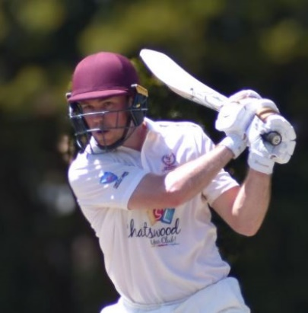
First Grade Report

The 2022/23 season was filled with optimism, with lots of hard work on fitness and skills in the preseason. We also worked hard on recruitment in the off-season and added many new faces to the First Grade Squad. Four of these players made their debut to start the season. Our additions included; Dale McKay, a top order batsman, James Newton, a wicket-keeper and middle order batsman, Jack James, an opening batsman and off-spin bowler and Smit Doshi, a middle order batsman and leg spin bowler. Axel Cahlin also returned to the club as a top order batsman.
Tym Crawford

Unfortunately, we did not get the opportunity to complete our first two matches due to wet weather, but when we got on the park at home, we chased down Sutherland’s 298 quite easily. Sadly, this positive start was not capitalised on in the first half of the season and we were met with many, ‘What could have been’ moments, where we fell agonisingly short of victory after being in control of the match. It could have been a vastly different season had we won these matches. The ruthlessness of First Grade cricket requires consistent application for extended periods, and this was a key learning for the team.

The highlight of the season was our T20 campaign. We finished top of the Sixers Conference after many dominant displays. Our bowlers were outstanding throughout the competition. Ben Parsons, Callum Bladen, Nick Toohey, Quincy Titterton & Matt Wright often took wickets in the early overs, putting the opposition on the back foot. They were also very economical, which is a challenging task in the first six overs, with only two fielders allowed outside the 30 metre circle. Through the middle overs Connor Cook, Jack James and Smit Doshi were effective and at times destructive with their spin, blowing away the middle order. Our most prevalent batters were Dale McKay, Tym Crawford and Smit Doshi who often finished an innings with flashing cover drives or flicks over square leg for six. Dale scored 316 runs which was the most in the Sixers Conference. He played a valuable role at number 3, anchoring the innings on many occasions. His highlight was 99* vs Randwick-Petersham at Coogee, where he put on a match winning partnership of 144 with Tym (89).

Unfortunately, we could not replicate this form in the Conference Final, where we were defeated by only two runs. Apart from the result, it was an excellent day for the club with 600 spectators in attendance at Chatswood Oval with support from current players, ex-players, family and friends and junior stags. The support we received from the players at our T20 matches is unrivalled in the competition and if you have not attended a home T20 match, I encourage you to do so.

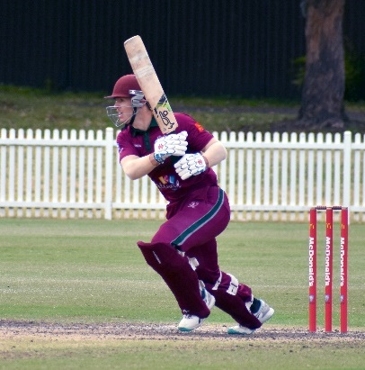
Axel Cahlin produced an excellent display of batting throughout the season. His impact was outstanding, scoring 736 runs in the Belvidere Cup and 176 in the T20 competition, totalling 912 runs for the season. He scored two centuries and five fifties and was a rock for our batting line up. Axel was rewarded with selection in a Combined First Grade team which played against an U20 NSW Premier Cricket Team (including Nick Toohey). He was also selected in NSW Premier Cricket Team of the season. Well done, Axel.

I would like to congratulate fast bowlers, Nick Toohey and Luke Callanan who made their First Grade debut this season. Both have come through our Green Shield side and progressed through the grades. Nick and Luke displayed their potential in the back end of the season with their speed and movement off the pitch. They have a great bowling partnership with Callum Bladen, who was our most consistent fast bowler this season, taking 20 wickets. Callum is a fantastic example of loyalty and his consistent hard work and ‘team first’ mentality has made him a reliable asset.
Axel Cahlin

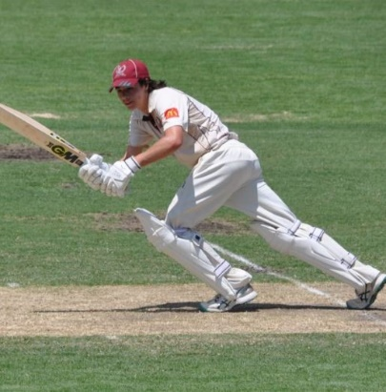
Midway through the season we had another debutant, Trystan Kennedy. Trystan forced his way into the side after scoring multiple centuries in Second grade. He is an excellent example of a clubman, who has displayed loyalty from a 12 year-old, coming through our ranks, starting in the Junior Academy, progressing to captain the Green Shield team, opening the batting in Poidevin-Gray and now playing First Grade. Trystan held his own in the middle order, showing his class scoring 70 against Campbelltown at Chatswood Oval. He has a bright future and we are looking forward to watching him progress his cricket in the coming years.
Trystan Kennedy
The current squad of First Grade players ranges from 18-30 and the younger players gained valuable experience last season. There were signs of progression with many players making valuable contributions and learning how to play at a high level for extended periods. This provides me and the club optimism for a more successful 2023/24 season.

I thank our volunteers who were a fantastic support to the team this season. Firstly, Andrew Falk, our stalwart scorer, who did not make any mistakes this season. Like a fine wine, he is getting better with age. Secondly, Prem Kumar, who managed our side, ensuring the players could focus on the game. The importance of these volunteers is underestimated, and we are most grateful for your contribution.

Lastly, a thank you to our coach Elliot Richtor who demonstrated outstanding commitment throughout the season. Being the Head Coach of a club and coaching First Grade is a big task, however Elliot was organised and ensured training and match days were run effectively. His guidance and support of me and the players was substantial. I was waiting for an old-fashioned blow up at one point during the season, but Elliot’s calm approach meant that did not happen. Els, thank you for your hard work and passion you displayed for our team and we hope to repay you with better results next season.

TYM CRAWFORD
FIRST GRADE CAPTAIN

 |  |  | GORDON DCC PLAYER AVERAGES
 |  |  | SEASON 2022/23
 |  |  | 1ST GRADE & T20 (Combined)
Batting Averages
Player |  |  |  |  | Matches |  |  | Innings |  |  | Not Outs |  |  | H.S. |  |  | Runs |  |  |  | Average
AMA Cahlin |  |  |  |  | 21 |  |  | 23 |  |  | 0 |  |  | 140 |  |  | 912 |  |  |  | 39.65
JN James |  |  |  |  | 19 |  |  | 21 |  |  | 5 |  |  | 141* |  |  | 575 |  |  |  | 35.94
TA Crawford |  |  |  |  | 18 |  |  | 19 |  |  | 0 |  |  | 144 |  |  | 640 |  |  |  | 33.68
DJ Mckay |  |  |  |  | 20 |  |  | 22 |  |  | 1 |  |  | 99* |  |  | 609 |  |  |  | 29.00
T Brar |  |  |  |  | 12 |  |  | 16 |  |  | 2 |  |  | 58 |  |  | 365 |  |  |  | 26.07
J Newton |  |  |  |  | 20 |  |  | 19 |  |  | 2 |  |  | 67 |  |  | 424 |  |  |  | 24.94
L Callanan |  |  |  |  | 3 |  |  | 5 |  |  | 2 |  |  | 35* |  |  | 67 |  |  |  | 22.33
S Doshi |  |  |  |  | 13 |  |  | 13 |  |  | 2 |  |  | 67* |  |  | 235 |  |  |  | 21.36
T Kennedy |  |  |  |  | 7 |  |  | 8 |  |  | 0 |  |  | 70 |  |  | 163 |  |  |  | 20.38
C Cook |  |  |  |  | 20 |  |  | 19 |  |  | 3 |  |  | 42* |  |  | 278 |  |  |  | 17.38
M Wright |  |  |  |  | 20 |  |  | 20 |  |  | 1 |  |  | 38 |  |  | 278 |  |  |  | 14.63
NV Toohey |  |  |  |  | 10 |  |  | 9 |  |  | 5 |  |  | 24* |  |  | 54 |  |  |  | 13.50
C Bladen |  |  |  |  | 18 |  |  | 13 |  |  | 8 |  |  | 14* |  |  | 53 |  |  |  | 10.60
QL Titterton |  |  |  |  | 17 |  |  | 12 |  |  | 5 |  |  | 12 |  |  | 37 |  |  |  | 5.29
Also Batted
J Bekis |  |  |  |  | 1 |  |  | 1 |  |  | 0 |  |  | 15 |  |  | 15 |  |  |  | 15.00
AM Premkumar |  |  |  |  | 1 |  |  | 1 |  |  | 0 |  |  | 12 |  |  | 12 |  |  |  | 12.00
B Parsons |  |  |  |  | 6 |  |  | 4 |  |  | 2 |  |  | 15* |  |  | 15 |  |  |  | 7.50
M Keevers |  |  |  |  | 2 |  |  | 2 |  |  | 0 |  |  | 8 |  |  | 8 |  |  |  | 4.00
C Mitchell |  |  |  |  | 2 |  |  | 2 |  |  | 0 |  |  | 6 |  |  | 7 |  |  |  | 3.50
Best Batting Performances
Player |  |  |  |  |  | Score |  |  | Round |  |  | Opponent
TA Crawford |  |  |  |  |  | 144 |  |  | 6 |  |  | Eastern Suburbs
JN James |  |  |  |  |  | 141 |  |  | 3 |  |  | Sutherland
AMA Cahlin |  |  |  |  |  | 140 |  |  | 4 |  |  | UTS North Sydney
JN James |  |  |  |  |  | 134 |  |  | 6 |  |  | Eastern Suburbs
AMA Cahlin |  |  |  |  |  | 118 |  |  | 3 |  |  | Sutherland
Best Partnerships
Batsmen |  |  |  |  |  | Runs |  |  | Wkt |  |  | Opponent
JN James - TA Crawford |  |  |  |  |  | 223 |  |  | 3rd |  |  | Eastern Suburbs
JN James - AMA Cahlin |  |  |  |  |  | 189 |  |  | 4th |  |  | Sutherland
TA Crawford - DJ McKay |  |  |  |  |  | 144 |  |  | 2nd |  |  | Randwick-Petersham (T20)
AMA Cahlin - J Newton |  |  |  |  |  | 132 |  |  | 5th |  |  | UTS North Sydney
JN James - S Doshi |  |  |  |  |  | 112 |  |  | 5th |  |  | Sydney (T20)
AMA Cahlin - J Newton |  |  |  |  |  | 111 |  |  | 5th |  |  | Blacktown Mounties
AMA Cahlin - T Crawford |  |  |  |  |  | 111 |  |  | 4th |  |  | Campbelltown Camden
JN James - T Brar |  |  |  |  |  | 109* |  |  | 1st |  |  | Penrith
Batsmen |  |  |  |  |  | Runs |  |  | Wkt |  |  | Opponent
T Kennedy - J Newton |  |  |  |  |  | 109 |  |  | 6th |  |  | Campbelltown Camden
T Brar - DJ McKay |  |  |  |  |  | 100 |  |  | 2nd |  |  | Sydney University
Bowling Averages
Player | Overs |  |  | Mdns |  |  | Runs |  |  | Wkts |  |  | Average |  |  | Best |  |  |  | R/O
B Parsons | 29.2 |  |  | 2 |  |  | 187 |  |  | 15 |  |  | 12.47 |  |  | 4-23 |  |  |  | 6.40
L Callanan | 34.3 |  |  | 4 |  |  | 163 |  |  | 9 |  |  | 18.11 |  |  | 4-51 |  |  |  | 4.75
C Bladen | 167 |  |  | 30 |  |  | 653 |  |  | 30 |  |  | 21.77 |  |  | 5-54 |  |  |  | 3.91
NV Toohey | 107 |  |  | 14 |  |  | 478 |  |  | 17 |  |  | 28.12 |  |  | 4-30 |  |  |  | 4.47
JN James | 61.3 |  |  | 3 |  |  | 357 |  |  | 11 |  |  | 32.45 |  |  | 2-18 |  |  |  | 5.82
M Wright | 157.3 |  |  | 22 |  |  | 705 |  |  | 21 |  |  | 33.57 |  |  | 3-15 |  |  |  | 4.48
QL Titterton | 134.1 |  |  | 12 |  |  | 705 |  |  | 21 |  |  | 33.57 |  |  | 5-44 |  |  |  | 5.26
C Cook | 128 |  |  | 10 |  |  | 632 |  |  | 17 |  |  | 37.18 |  |  | 3-25 |  |  |  | 4.94
TA Crawford | 62.2 |  |  | 6 |  |  | 338 |  |  | 7 |  |  | 48.29 |  |  | 5-55 |  |  |  | 5.43
Also Bowled
S Doshi | 33.5 |  |  | 1 |  |  | 166 |  |  | 2 |  |  | 83.00 |  |  | 1-20 |  |  |  | 4.96
M Keevers | 20 |  |  | 2 |  |  | 97 |  |  | 1 |  |  | 97.00 |  |  | 1-51 |  |  |  | 4.85
DJ Mckay | 1 |  |  | 0 |  |  | 6 |  |  | 0 |  |  | n/a |  |  | 0-6 |  |  |  | 6.00
J Saggers | 8 |  |  | 0 |  |  | 55 |  |  | 0 |  |  | n/a |  |  | 0-55 |  |  |  | 6.88
Best Bowling Performances
Player |  |  | Overs |  |  | Runs |  |  | Wkts |  |  | Round |  |  | Opponent
QL Titterton |  |  | 17 |  |  | 44 |  |  | 5 |  |  | 3 |  |  | Sutherland
C Bladen |  |  | 21 |  |  | 54 |  |  | 5 |  |  | 12 |  |  | Campbelltown Camden
TA Crawford |  |  | 20 |  |  | 55 |  |  | 5 |  |  | 5 |  |  | Sydney University
QL Titterton |  |  | 4 |  |  | 20 |  |  | 4 |  |  | 1 |  |  | UTS North Sydney (T20)
B Parsons |  |  | 4 |  |  | 23 |  |  | 4 |  |  | SF |  |  | Randwick Petersham (T20)
B Parsons |  |  | 3.2 |  |  | 24 |  |  | 4 |  |  | 4 |  |  | Eastern Suburbs (T20)
NV Toohey |  |  | 7 |  |  | 30 |  |  | 4 |  |  | 13 |  |  | University of NSW
L Callanan |  |  | 13 |  |  | 51 |  |  | 4 |  |  | 14 |  |  | Sydney

Second Grade Report
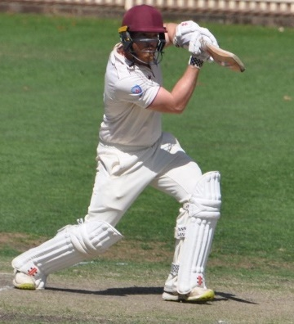
In the previous season (2021-22), Gordon’s Second Grade side fought their way into the finals thanks to a post-Christmas winning spree. Unfortunately, the Preliminary Final was washed out with Gordon the lower-placed side against the Minor Premiers, Mosman, meaning they would take no further part in that season. Mosman went on to win the Premiership that year, leaving our Second Grade boys in 6th place on the table and feeling robbed of an opportunity to bring the Second Grade flag home. Not only did this give the team a strong belief but also a strong confidence leading into the 2022/2023 season.
Jamie Bekis

With the new season just around the corner the First/Second Grade squad was revitalised with a number of new and returning members to the Club including Louis Bhabra (UK), Smit Doshi, Tom Siede, James Newton, Jack James, Dale McKay and the return of 1st Grade Captain, Tym Crawford from injury and Stags “Golden Boy”, Axel Cahlin, after a two-year sojourn with our northern neighbours. There was also a group of young pace bowlers who had come through Green Shield and Poidevin Gray that was keen to show their wares in the higher grades.

Preseason was led with plenty of fitness and skills sessions, uninterrupted by COVID regulations or bad weather. The boys were fit and raring to start the season, keeping in mind the opportunity that we felt had been taken away from us at the end of the previous season.

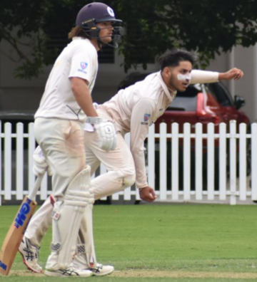
Before reviewing the overall team performance during the season, there were numerous stand-out individual performances and achievements that need recognition.

- Smit Doshi (Second Grade Player of the Season) 28 Wickets @18.82 with the ball (with 2x 5-wicket hauls) plus 217 runs at 27.13
- Luke Callanan 16 wickets @ 25.75
- Charles Mitchell 475 runs @ 43.18
- Trystan Kennedy 393 runs @ 65.5, including 3x 100’s
- Jamie Bekis 534 Runs @ 38.14 with 1x 100 and 29 dismissals as wicketkeeper with 27 catches and 2 stumpings
Smit Doshi

Looking into the season closer as a team, the strongly experienced Second Grade side had some ups and downs but managed to push our way into 4th spot at the end of the Preliminary Rounds with 9 wins and 6 losses. Once again, we showed the importance of how to win close games of cricket.

Round 1 of the Finals Series is a game most of us would like to forget about, being comprehensively defeated by the defending Premiers Mosman at Allan Border Oval. However, as the best-placed loser after the Preliminary Finals, we progressed into the Semi Finals of the Albert Cup, facing off against a strong Manly side, again at Allan Border Oval.

Winning the toss, Captain Jamie Bekis elected to bowl on what looked like a bowling-friendly deck. After some excellent bowling and fielding interspersed with some close umpiring decisions, eventually Manly was bowled out for a lower than expected 206. In reply, Gordon couldn’t capitalise on a smaller than usual run chase, falling an agonising 35 runs short of victory and a crack at the flag.

Massive thanks to everyone involved around the club and the playing group, Andy Baldwin and Glenn Tullia for scoring, Mike Weaver for assisting around Chatswood Oval home games and to all the volunteers and selectors.

JAMIE BEKIS
CAPTAIN

GDCC Silver Sponsor

Recent renovations to the Olympic Hotel have brought a welcome facelift to an iconic Sydney pub. Featuring a bar and bistro, the Olympic Hotel is a great place to gather for a few drinks and a meal, including options for the kids. Patrons enjoy live music and weekly trivia. Contact publican Wayne Lambert for bookings.

308 Moore Park Road, Sydney.
wayne@wamhotels.net

 | GORDON DCC PLAYER AVERAGES
 | SEASON 2022/23
 | 2ND GRADE
Batting Averages
Player |  |  |  |  | Matches |  | Innings |  |  | Not Outs |  |  |  | H.S. |  |  |  | Runs |  |  |  |  |  | Average
T Kennedy |  |  |  |  | 6 |  | 6 |  |  | 0 |  |  |  | 127 |  |  |  | 393 |  |  |  |  |  | 65.50
C Mitchell |  |  |  |  | 13 |  | 14 |  |  | 3 |  |  |  | 88* |  |  |  | 475 |  |  |  |  |  | 43.18
J Bekis |  |  |  |  | 15 |  | 16 |  |  | 2 |  |  |  | 115* |  |  |  | 534 |  |  |  |  |  | 38.14
SG O'Brien |  |  |  |  | 9 |  | 7 |  |  | 3 |  |  |  | 47 |  |  |  | 139 |  |  |  |  |  | 34.75
L Bhabra |  |  |  |  | 12 |  | 12 |  |  | 1 |  |  |  | 85 |  |  |  | 340 |  |  |  |  |  | 30.91
S Doshi |  |  |  |  | 10 |  | 10 |  |  | 2 |  |  |  | 63 |  |  |  | 217 |  |  |  |  |  | 27.13
R Tullia |  |  |  |  | 14 |  | 15 |  |  | 2 |  |  |  | 87* |  |  |  | 349 |  |  |  |  |  | 26.85
MA Lole |  |  |  |  | 5 |  | 5 |  |  | 1 |  |  |  | 33 |  |  |  | 104 |  |  |  |  |  | 26.00
M Keevers |  |  |  |  | 13 |  | 8 |  |  | 3 |  |  |  | 54* |  |  |  | 116 |  |  |  |  |  | 23.20
M Fletcher |  |  |  |  | 6 |  | 5 |  |  | 0 |  |  |  | 66 |  |  |  | 110 |  |  |  |  |  | 22.00
B Parsons |  |  |  |  | 8 |  | 7 |  |  | 2 |  |  |  | 46 |  |  |  | 104 |  |  |  |  |  | 20.80
FE Booth |  |  |  |  | 7 |  | 7 |  |  | 0 |  |  |  | 52 |  |  |  | 134 |  |  |  |  |  | 19.14
T Stacy |  |  |  |  | 7 |  | 5 |  |  | 2 |  |  |  | 12* |  |  |  | 31 |  |  |  |  |  | 10.33
Also Batted
S Singh |  |  |  |  | 4 |  | 4 |  |  | 0 |  |  |  | 51 |  |  |  | 134 |  |  |  |  |  | 33.50
QL Titterton |  |  |  |  | 4 |  | 2 |  |  | 0 |  |  |  | 41 |  |  |  | 62 |  |  |  |  |  | 31.00
J Naganayagam |  |  |  |  | 4 |  | 4 |  |  | 0 |  |  |  | 70 |  |  |  | 118 |  |  |  |  |  | 29.50
T Brar |  |  |  |  | 1 |  | 1 |  |  | 0 |  |  |  | 25 |  |  |  | 25 |  |  |  |  |  | 25.00
A Baruah |  |  |  |  | 1 |  | 1 |  |  | 0 |  |  |  | 20 |  |  |  | 20 |  |  |  |  |  | 20.00
D Ranjan |  |  |  |  | 4 |  | 3 |  |  | 1 |  |  |  | 17* |  |  |  | 26 |  |  |  |  |  | 13.00
T Siede |  |  |  |  | 2 |  | 2 |  |  | 0 |  |  |  | 21 |  |  |  | 26 |  |  |  |  |  | 13.00
C Bladen |  |  |  |  | 2 |  | 1 |  |  | 0 |  |  |  | 9 |  |  |  | 9 |  |  |  |  |  | 9.00
J Saggers |  |  |  |  | 6 |  | 3 |  |  | 1 |  |  |  | 3 |  |  |  | 5 |  |  |  |  |  | 2.50
L Burrows |  |  |  |  | 3 |  | 2 |  |  | 1 |  |  |  | 1* |  |  |  | 1 |  |  |  |  |  | 1.00
L Callanan |  |  |  |  | 8 |  | 4 |  |  | 4 |  |  |  | 6* |  |  |  | 13 |  |  |  |  |  | n/a
JA Kennedy |  |  |  |  | 1 |  | 0 |  |  | 0 |  |  |  | 0 |  |  |  | 0 |  |  |  |  |  | n/a
S Read |  |  |  |  | 3 |  | 0 |  |  | 0 |  |  |  | 0 |  |  |  | 0 |  |  |  |  |  | n/a
S Schembri-Green |  |  |  |  | 1 |  | 0 |  |  | 0 |  |  |  | 0 |  |  |  | 0 |  |  |  |  |  | n/a
Best Batting Performances
Player |  |  |  |  | Score |  | Round |  |  | Opponent
T Kennedy |  |  |  |  | 127 |  | 3 |  |  | Sutherland
J Bekis |  |  |  |  | 115* |  | 5 |  |  | Sydney University
T Kennedy |  |  |  |  | 111 |  | 6 |  |  | Eastern Suburbs
T Kennedy |  |  |  |  | 111 |  | 11 |  |  | Penrith
Best Partnerships
Batsmen |  |  |  |  | Runs |  | Wkt |  |  | Opponent
T Kennedy - L Bhabra |  |  |  | 174 |  |  |  | 5th |  |  | Eastern Suburbs
T Kennedy - FE Booth |  |  |  |  | 116 |  | 5th |  |  | Sutherland
C Mitchell - J Bekis |  |  |  |  | 106 |  | 2nd |  |  | Campbelltown Camden
M Keevers - QL Titterton |  |  |  |  | 101 |  | 9th |  |  | Sydney
Bowling Averages
Player | Overs |  |  |  | Mdns |  | Runs |  |  | Wkts |  |  | Average |  |  |  | Best |  |  |  |  |  | R/O
S Doshi | 177.5 |  |  |  | 32 |  | 527 |  |  | 28 |  |  | 18.82 |  |  |  | 6-99 |  |  |  |  |  | 2.96
L Callanan | 113.4 |  |  |  | 22 |  | 412 |  |  | 16 |  |  | 25.75 |  |  |  | 5-81 |  |  |  |  |  | 3.62
J Saggers | 62 |  |  |  | 8 |  | 213 |  |  | 7 |  |  | 30.43 |  |  |  | 3-48 |  |  |  |  |  | 3.44
T Stacy | 83 |  |  |  | 9 |  | 290 |  |  | 9 |  |  | 32.22 |  |  |  | 4-68 |  |  |  |  |  | 3.49
QL Titterton | 53 |  |  |  | 9 |  | 166 |  |  | 5 |  |  | 33.20 |  |  |  | 3-42 |  |  |  |  |  | 3.13
M Keevers | 126.3 |  |  |  | 15 |  | 473 |  |  | 14 |  |  | 33.79 |  |  |  | 4-64 |  |  |  |  |  | 3.74
MA Lole | 69.5 |  |  |  | 11 |  | 208 |  |  | 6 |  |  | 34.67 |  |  |  | 4-49 |  |  |  |  |  | 2.98
B Parsons | 77 |  |  |  | 24 |  | 218 |  |  | 6 |  |  | 36.33 |  |  |  | 2-27 |  |  |  |  |  | 2.83
SG O'Brien | 121.2 |  |  |  | 11 |  | 408 |  |  | 10 |  |  | 40.80 |  |  |  | 2-44 |  |  |  |  |  | 3.36
D Ranjan | 60 |  |  |  | 7 |  | 256 |  |  | 5 |  |  | 51.20 |  |  |  | 2-67 |  |  |  |  |  | 4.27
Also Bowled
NV Toohey | 10 |  |  |  | 1 |  | 36 |  |  | 3 |  |  | 12.00 |  |  |  | 3-36 |  |  |  |  |  | 3.60
JA Kennedy | 11 |  |  |  | 3 |  | 15 |  |  | 1 |  |  | 15.00 |  |  |  | 1-15 |  |  |  |  |  | 1.36
C Mitchell | 4.1 |  |  |  | 0 |  | 17 |  |  | 1 |  |  | 17.00 |  |  |  | 1-13 |  |  |  |  |  | 4.08
S Read | 25.2 |  |  |  | 2 |  | 119 |  |  | 4 |  |  | 29.75 |  |  |  | 2-44 |  |  |  |  |  | 4.70
T Kennedy | 13 |  |  |  | 1 |  | 65 |  |  | 2 |  |  | 32.50 |  |  |  | 2-63 |  |  |  |  |  | 5.00
L Bhabra | 8 |  |  |  | 1 |  | 34 |  |  | 1 |  |  | 34.00 |  |  |  | 1-6 |  |  |  |  |  | 4.25
S Singh | 14 |  |  |  | 0 |  | 76 |  |  | 2 |  |  | 38.00 |  |  |  | 2-30 |  |  |  |  |  | 5.43
L Burrows | 18.1 |  |  |  | 1 |  | 68 |  |  | 1 |  |  | 68.00 |  |  |  | 1-32 |  |  |  |  |  | 3.74
C Bladen | 26 |  |  |  | 2 |  | 109 |  |  | 0 |  |  | n/a |  |  |  | 0-48 |  |  |  |  |  | 4.19
J Naganayagam | 11 |  |  |  | 0 |  | 46 |  |  | 0 |  |  | n/a |  |  |  | 0-11 |  |  |  |  |  | 4.18
T Siede | 5 |  |  |  | 0 |  | 20 |  |  | 0 |  |  | n/a |  |  |  | 0-20 |  |  |  |  |  | 4.00
A Baruah | 3 |  |  |  | 0 |  | 16 |  |  | 0 |  |  | n/a |  |  |  | 0-16 |  |  |  |  |  | 5.33
S Schembri-Green | 3 |  |  |  | 0 |  | 13 |  |  | 0 |  |  | n/a |  |  |  | 0-13 |  |  |  |  |  | 4.33
R Tullia | 1 |  |  |  | 0 |  | 3 |  |  | 0 |  |  | n/a |  |  |  | 0-3 |  |  |  |  |  | 3.00
Best Bowling Performances
Player | Overs |  |  |  | Runs |  | Wkts |  |  | Round |  |  |  | Opponent
S Doshi | 36 |  |  |  | 99 |  | 6 |  |  | 6 |  |  |  | Eastern Suburbs
S Doshi | 11.1 |  |  |  | 33 |  | 5 |  |  | 12 |  |  |  | Campbelltown Camden
L Callanan | 21.4 |  |  |  | 81 |  | 5 |  |  | 3 |  |  |  | Sutherland
MA Lole | 17 |  |  |  | 49 |  | 4 |  |  | SF |  |  |  | Manly Warringah
M Keevers | 9.2 |  |  |  | 64 |  | 4 |  |  | 7 |  |  |  | Blacktown Mounties
T Stacy | 18 |  |  |  | 68 |  | 4 |  |  | SF |  |  |  | Manly Warringah
S Doshi | 22 |  |  |  | 77 |  | 4 |  |  | 11 |  |  |  | Penrith

Third Grade Report
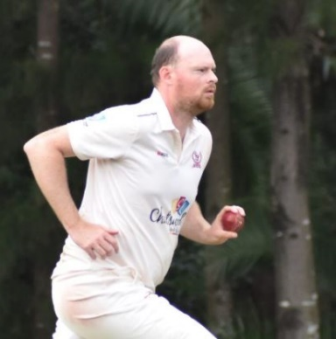
A highly anticipated start to the season awaited the Gordon Third Grade Side. A returning veteran, a lot of promising talent, an Englishman with a point to prove and a team that wanted to take that next step and play finals cricket.
However, our first encounter did not live up to the hype or the expectation with a promising Manly outfit (eventual grand finalists) winning the toss and putting us under immediate pressure away from home. 4-16 in the first 10 overs of a one day game ensured a low total of 112 was to be accumulated. One shining light was a pleasing all round performance by young leg spinner Anay Baruah (23 and 2/22 off 6).
James Kennedy
Round 2, saw the Stags have their first home game of the season at Beauchamp Park. Five of the top 7 made starts but failed to convert their opportunity with Matt Newton top scoring with 42. 220 on a fast outfield proved to not be enough despite tight, sustained, and at times relentless, bowling by Read, Kennedy and Lole. Sutherland passed our total five down and an hour to spare.
Another home game awaited Gordon for their Round 3 fixture against the local rivals North Sydney. The Stags were given their first opportunity to start the game in the field however the Bears were in control for most of the first day being 2-230 after 62 overs. A late run of wickets slowed the scoring rate, restricting the Bears to 297 at the end of the day's play. The Bears did not feel that this was enough of a total to defend and batted on for an extra 8 overs the following week. It was their demise in the end with our bats once again getting a start but not completing their innings. Gordon lost late wickets to be 9 down with 7 overs remaining in the day. The Stags held on for a highly contested and at times heated draw.
Gordon were back on the road and this time to the picturesque Sydney Uni. It is not every day that our overseas player has intelligence on away venues but on this occasion he was the groundsman for this upcoming clash. Sydney Uni had the choice to use his pitch first and decided to bat. Wickets fell at convenient moments throughout the day and some loose shots provided Lachlan Burrows with a handy 4 for 58 off 19 overs. Jackson Saggers made a guest appearance and bowled the classic first grade length and line that not many Third graders can hit. A modest total of 286, with a short boundary in play, made for a confusing yet attacking declaration. It definitely wasn’t enough as our number 2 Tom Siede (106*) and number 3 Louis Bhabra (157*) put on an unbeaten 261 run second wicket partnership. Remember that groundsman I mentioned, way to use your facilities Louis!
A tale of many starts was the theme for the home fixture versus Easts and the away fixture to Blacktown which saw the Third graders battle out low scoring affairs and come away with a win and a loss. The emergence of Baruah’s strike rate with the bat, Siede’s all-round capabilities and Tom Stacy finding form with the ball were the highlights of Round 6 and 7.
With a midweek change of venue the selected team were pleasantly surprised and thrilled to play the away game against St George at Hurstville Oval, an experience that would make any lower grader jealous. Christmas came early for Matthew Newton, the Vice Captain, as he withstood the early fluorescent green grass to compile a well-made 93, which was very much deserving of a hundred. 232 seems to be a low one day score at Hurstville but soon to be a competitive one. The in-form man Stacy (4/29 off 10) and Sam Schembri-Green (2/22 off 8) ripped the middle order apart with the old ball. For the second week in a row the young stags defended a low total in a one day fixture. Three wins, three losses and a draw kept the Stags in the hunt at the halfway point of the season.
The next two games are the hardest two rounds of our season to discuss. After another frustrating washout which saw half the competition play and the other half abandon their games the upcoming fixtures were very important for finals hopes. An all-round bowling performance from our newest recruit Nick Woods (3/19 off 10 overs), Stacy (2/17 off 5), Siede (3/20 off 8) and Schembri-Green (2/11 off 5) looked to secure the points against Randwick-Petersham (98). At 2-59, the Stags thought that another one day win was already written into the table standings. Some poor shot selections, running between the wickets and nerves got the best of the young middle order which saw us lose eight wickets for 25 runs. A loss that hopefully was character building for the weeks to come. We were going to need it!
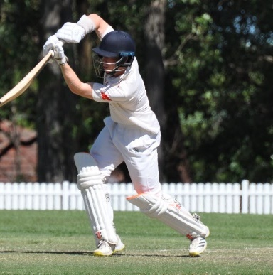
This part of the season was the chapter of dropped / missed chances. That contagious element of cricket that comes about when the team has so many changes and players being out of position. Penrith should have been bowled out for under 200 but instead 232 on a long, thick outfield was a very competitive total. Credit has to go to Jayllen Naganayagam for bowling 17 overs, two maidens, 5 for 59; his first five wicket haul in Premier Cricket. We got heartbreakingly close, too close, losing by 6 runs with an over to go. Anay Baruah, coming off an outstanding hundred the previous week in fourth grade almost found a way to win it for the Stags with a flamboyant 66. However, losing two wickets in the last two overs, crushed our chances of pulling off an unlikely victory.
Tom Siede
A deflated, yet frustrated Stags side came out with purpose the following Round, desperately needing a win to stay in touch of the top six. Naganayagam (97), more known for his devastating striking of the ball, showed everyone what he is capable of. Jay only scored one single in his first 50 runs. Siede (92) soon became the other bash brother, scoring at an unprecedented strike rate. In the first 27 overs of a two day game the Stags were 0/147. Unfortunately for both Jay and Tom the score became 2/222 and their demise came about by going for one too many over the top which to their credit led to so much success throughout the day. At the 51st over, the bash brothers were gone but Kieran Krishnan, 21 not out, must have been inspired by the Mighty Ducks sequel and unexpectedly became the third bash brother. Kieran amassed a further 137 runs in 21 overs to finish on 158 not out and the score declared 5/401. What a performance of clean hitting from our top three batsmen! Something that has been too few and far apart. The bowlers did not want to be shown up in this game either and created numerous chances throughout the innings. Saggers (5/35 off 19 overs) making another cameo appearance was too quick for the top order whereas Siede (5/42 off 16 overs) bamboozled the middle to lower order when he changed from left arm orthodox to wrist spin late in the day. The Stags secured victory in the dying overs which was a reward for the attacking brand of cricket that was played throughout the game.
Round 13 was another one day game that should have been at least six points for the Stags. On a more clinical day, UNSW would have scored well under 200 making the chase just that little bit easier to secure bonus points. Burrows (4/31 off 7), with another reliable performance, was the pick of the bowlers. Naganayagam (65) and the top order found life easy going at first, making it to 115 with the loss of only one wicket by the 20 over mark. However, chasing the elusive 30 over bonus point to put the side in the best position going into the last two rounds placed too much pressure on the lower order to complete the win.
The final two rounds meant that results out of our control had to start going our way in order to have any chance of making the finals. The Stags were once again given the first chance to bat on an under prepared, rain impacted pitch, but credit to Fraser Wilson (65) and Newton (70) for battling through a tough first 10 overs and score 135 before the loss of our second wicket. It was then up to the middle and lower order to consolidate the start, with Baruah (52), Jaiden Gray (36), Burrows (19), Stacy (24), Kennedy (45) and Woods (19) taking the score to an impressive 351. Over the last two home games at Killara Park the third grade side had scored 752 runs off 151 overs. This is a side that could shake up the finals if consistent performances and catching had allowed it. Another 20 chances were created, another game going right to the wire (10/316 off 78 overs) and a clutch 5 for 61 off 19 overs securing Stacy’s second grade call up for the rest of the season.
We come to the final game of the season, with Western Suburbs needing a victory to keep their finals hopes alive. For Gordon, this was out of reach. However, this did not stop Mitchell Lole from showing his batting strength blasting an impressive 153 not out with 7 sixes. He was well supported by Wilson (42), Felix Booth (41) and a few late innings strikes by Gray (23*) taking us to a well compiled 295 runs. Lole, albeit exhausted, wanted to remind everyone about his all- round abilities before the second grade finals campaign, taking 3 for 36 off 8 overs. Thanks to club legend Adam Cubbage (1/12 off 2) and a few late call ups, the Stags were able to field a victorious side to finish off the season.
After 15 rounds with two washouts and a draw, Gordon finished 12th on the ladder. With both Second grade and Fourth grade having finals campaigns, 34 players were used throughout the season to field what we hoped would be a competitive team. A more consistent side, especially in the field, may have seen a top 6 result. However, I am proud of the four players who started the season in third grade and finished the season in a second grade semi-final. That is what third grade cricket is about.
So the talent proved a point (at times), the unrecognized confident Englishman was more than handy and the returning veteran enjoyed the challenge. The question now is, will they be back seeking further glory for the Stags? Time will tell …
JAMES KENNEDY
THIRD GRADE CAPTAIN

JB Advisory Partners is an Australian independent provider of corporate advisory services. JB Advisory Partners continue to develop and maintain long term client relationships built on trust through their dedication and expertise. JB Advisory Partners has strong relationships with both clients and advisors located domestically and overseas. Since inception, JB Advisory has been involved in numerous capital raisings, both pre IPO, IPO and listed placements. JB Advisory has also advised on company structures and assisted in the formation and introduction of high class Board members to multiple businesses.

Ben Callanan is a principal and Director at JB Advisory Partners Pty Ltd. Ben has over 25 years’ experience in investment banking. Prior to JB Advisory Partners, Ben’s career background included long term positions at BT Australia Limited and Macquarie Bank.

 |  | GORDON DCC PLAYER AVERAGES
 |  | SEASON 2022/23
 |  | 3RD GRADE
Batting Averages
Player |  | Matches |  | Innings |  | Not Outs |  | H.S. | Runs |  | Average
MA Lole |  | 5 |  | 5 |  | 1 |  | 153* | 211 |  | 52.75
T Siede |  | 10 |  | 10 |  | 1 |  | 106* | 318 |  | 35.33
M Newton |  | 10 |  | 9 |  | 0 |  | 93 | 303 |  | 33.67
L Burrows |  | 8 |  | 5 |  | 2 |  | 35* | 100 |  | 33.33
A Baruah |  | 9 |  | 8 |  | 0 |  | 66 | 252 |  | 31.50
J Naganayagam |  | 11 |  | 11 |  | 0 |  | 97 | 298 |  | 27.09
F Wilson |  | 11 |  | 10 |  | 0 |  | 65 | 259 |  | 25.90
J Gray |  | 9 |  | 8 |  | 1 |  | 36 | 150 |  | 21.43
JA Kennedy |  | 10 |  | 8 |  | 2 |  | 45 | 123 |  | 20.50
FE Booth |  | 6 |  | 6 |  | 0 |  | 41 | 120 |  | 20.00
S Deshpande |  | 6 |  | 5 |  | 1 |  | 41 | 59 |  | 14.75
T Stacy |  | 7 |  | 7 |  | 2 |  | 24 | 37 |  | 7.40
Also Batted
L Bhabra |  | 4 |  | 4 |  | 1 |  | 157* | 240 |  | 80.00
S Read |  | 2 |  | 2 |  | 1 |  | 13 | 25 |  | 25.00
T Robinson |  | 1 |  | 1 |  | 0 |  | 25 | 25 |  | 25.00
S Schembri-Green |  | 3 |  | 3 |  | 1 |  | 24* | 47 |  | 23.50
M Fletcher |  | 2 |  | 2 |  | 0 |  | 22 | 43 |  | 21.50
A Madan |  | 1 |  | 1 |  | 0 |  | 12 | 12 |  | 12.00
S Singh |  | 1 |  | 1 |  | 0 |  | 10 | 10 |  | 10.00
SG O'Brien |  | 2 |  | 2 |  | 0 |  | 8 | 13 |  | 6.50
N Woods |  | 3 |  | 3 |  | 0 |  | 19 | 19 |  | 6.33
L McKenzie |  | 5 |  | 4 |  | 0 |  | 10 | 25 |  | 6.25
J Austin |  | 2 |  | 2 |  | 0 |  | 5 | 5 |  | 2.50
D Ranjan |  | 3 |  | 3 |  | 0 |  | 2 | 3 |  | 1.00
PS Iyer |  | 2 |  | 2 |  | 1 |  | 1* | 1 |  | 1.00
HM Robertson |  | 2 |  | 1 |  | 0 |  | 1 | 1 |  | 1.00
K Krishnan |  | 1 |  | 1 |  | 1 |  | 158* | 158 |  | n/a
AM Premkumar |  | 1 |  | 1 |  | 1 |  | 12* | 12 |  | n/a
N Clarke |  | 1 |  | 0 |  | 0 |  | 0 | 0 |  | n/a
A Cubbage |  | 1 |  | 0 |  | 0 |  | 0 | 0 |  | n/a
T Fedorow |  | 1 |  | 0 |  | 0 |  | 0 | 0 |  | n/a
J Saggers |  | 2 |  | 0 |  | 0 |  | 0 | 0 |  | n/a
S Toohey |  | 2 |  | 1 |  | 1 |  | 0* | 0 |  | n/a

Best Batting Performances
Player |  |  |  | Score |  |  | Round |  |  | Opponent
K Krishnan |  |  |  | 158* |  |  | 12 |  |  | Campbelltown Camden
L Bhabra |  |  |  | 157* |  |  | 5 |  |  | Sydney University
MA Lole |  |  |  | 153* |  |  | 15 |  |  | Western Suburbs
T Siede |  |  |  | 106* |  |  | 5 |  |  | Sydney University
Best Partnerships
Batsmen |  |  |  |  | Runs |  |  | Wkt |  |  | Opponent
T Siede - L Bhabra |  |  |  |  | 261* |  |  | 2nd |  |  | Sydney University
J Naganayagam - T. Siede |  |  |  |  | 147 |  |  | 1st |  |  | Campbelltown Camden
Bowling Averages
Player | Overs |  | Mdns |  |  | Runs |  |  | Wkts |  |  | Average | Best |  |  | R/O
T Stacy | 67 |  | 1 |  |  | 246 |  |  | 15 |  |  | 16.40 | 5-61 |  |  | 3.67
L Burrows | 79 |  | 12 |  |  | 260 |  |  | 14 |  |  | 18.57 | 4-31 |  |  | 3.29
J Saggers | 36 |  | 8 |  |  | 94 |  |  | 5 |  |  | 18.80 | 5-35 |  |  | 2.61
T Siede | 85 |  | 9 |  |  | 301 |  |  | 16 |  |  | 18.81 | 5-42 |  |  | 3.54
MA Lole | 52 |  | 7 |  |  | 179 |  |  | 8 |  |  | 22.38 | 4-36 |  |  | 3.44
L McKenzie | 50.2 |  | 4 |  |  | 176 |  |  | 5 |  |  | 35.20 | 3-82 |  |  | 3.50
J Naganayagam | 51.3 |  | 4 |  |  | 193 |  |  | 5 |  |  | 38.60 | 5-59 |  |  | 3.75
JA Kennedy | 72.1 |  | 9 |  |  | 205 |  |  | 5 |  |  | 41.00 | 2-35 |  |  | 2.84
A Baruah | 78.2 |  | 3 |  |  | 341 |  |  | 8 |  |  | 42.63 | 2-21 |  |  | 4.35
Also Bowled
S Schembri-Green | 13 |  | 1 |  |  | 33 |  |  | 4 |  |  | 8.25 | 2-11 |  |  | 2.54
A Cubbage | 2 |  | 0 |  |  | 12 |  |  | 1 |  |  | 12.00 | 1-12 |  |  | 6.00
S Read | 28 |  | 7 |  |  | 79 |  |  | 3 |  |  | 26.33 | 3-38 |  |  | 2.82
HM Robertson | 17 |  | 0 |  |  | 54 |  |  | 2 |  |  | 27.00 | 2-34 |  |  | 3.18
N Woods | 34.2 |  | 2 |  |  | 102 |  |  | 3 |  |  | 34.00 | 3-21 |  |  | 2.97
SG O'Brien | 51 |  | 0 |  |  | 155 |  |  | 4 |  |  | 38.75 | 3-91 |  |  | 3.04
S Deshpande | 35 |  | 1 |  |  | 142 |  |  | 3 |  |  | 47.33 | 3-34 |  |  | 4.06
D Ranjan | 8 |  | 0 |  |  | 53 |  |  | 1 |  |  | 53.00 | 1-18 |  |  | 6.63
PS Iyer | 11 |  | 1 |  |  | 56 |  |  | 1 |  |  | 56.00 | 1-39 |  |  | 5.09
S Toohey | 9 |  | 0 |  |  | 69 |  |  | 0 |  |  | n/a | 0-20 |  |  | 7.67
AM Premkumar | 4 |  | 1 |  |  | 22 |  |  | 0 |  |  | n/a | 0-22 |  |  | 5.50

Best Bowling Performances
Player | Overs | Runs | Wkts | Round | Opponent
J Saggers | 19 | 35 | 5 | 12 | Campbelltown Camden
T Siede | 16 | 42 | 5 | 12 | Campbelltown Camden
J Naganayagam | 16.3 | 59 | 5 | 11 | Penrith
T Stacy | 19 | 61 | 5 | 13 | Sydney
T Stacy | 10 | 29 | 4 | 8 | St George
L Burrows | 7 | 31 | 4 | 13 | University of NSW
MA Lole | 19 | 36 | 4 | 3 | Sutherland
L Burrows | 19 | 58 | 4 | 5 | Sydney University

PLASMAIDE is an epigenetic supplement that increases physical and mental performance by promoting ENDURANCE and supporting fast and efficient RECOVERY. #YourSecondWind

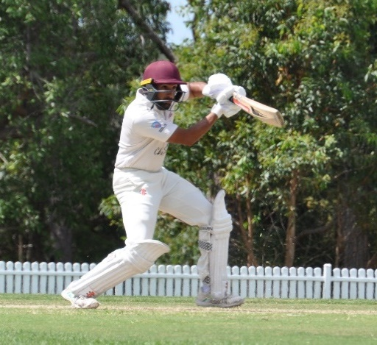
Fourth Grade Report

With the return of a regular full cricket season in a ‘post-covid’ world, the mighty 4th Grade Stags ended up having an outstanding year with some great individual and team performances throughout the season. A couple trial matches were held during preseason to help dust of the cobwebs and an opportunity for selectors, coaches & captains to see some of the new talent that had joined the club. It’s an exciting time with returning players reconnecting and new players being welcomed to Gordon. Everybody had a great run around and an opportunity to showcase their ability before the first-round versus defending premiers, Manly.
Apurv Sharma

The 2022/23 season kicked off on a slow note for the 4th Grade team with a Round 1 loss on Duckworth Lewis-Stern vs Manly (eventual premiers), a Round 2 washout vs Northern Districts and a Round 3 loss vs Sutherland (which featured an ex-Australian Test cricketer Stuart Clark, who made 91 for the opposition). Round 3 proved to be a lesson for the team with the return of 2-day cricket, requiring players to adjust quite quickly to a longer format that was not played in over 2 years, given the Covid impacted seasons with one-dayers only.

Round 4 saw a strong result vs UTS North Sydney on the back of an inspired performance by a club-favourite Hayden Robertson who starred with the ball taking 6/36 of 18 overs. North Sydney’s openers started of nicely but soon enough the ‘Dos’ show began, firstly, through a deflection on Hayden’s follow-through resulting in a run-out of the batsmen in good touch at the non-striker’s end. From here on in, Hayden persisted with consistent line & lengths and lured the opposition batters into false strokes and was ably supported by the veteran David Monaghan’s lethal swinging deliveries. UTS North Sydney were bowled out for 76 of 38 overs on Day 1. From there, the batters responded positively with Jaiden Gray (72*) and David Monaghan (57) lead the charge with the 76 total crossed overnight securing points on Day 1. Day 2 saw a push to the run rate supercharged by Tom Carruthers (31) which took Gordon to 4/199dec. Captain Apurv Sharma and his team had every intention to push for the outright and declared with 55 overs left in the day. Nishant Balaguruswamy (3/29) and David Monaghan (3/13) led the wickets in the 2nd innings as North Sydney reached 7/112 at stumps with the Stags just three wickets short!

Round 5 vs Sydney University was an epic low scoring encounter where the Stags defended 174 on home turf at Beauchamp Park. Matt Jones as opener scored an impressive 57 of 108 balls but the rest of the order struggled on a slow & low wicket. Prahlad Iyer provided a late flurry of runs and finished on 31*. Day 2 saw a disciplined performance from the Stags with Shreyan Deshpande leading the wickets with 3/16 of 9 overs, Samuel Schembri-Green with 3/44 of 13 overs and Prahlad Iyer taking 2/26 overs 8 overs including the 10th wicket to get the Stags a 12-run win in a close encounter.

Round’s 6-8 in the lead up to Christmas saw a mixed bag of results with a close loss to Eastern Suburbs away (Round 6). Then followed a dominant bonus point win vs Blacktown at Killara Oval (Round 7) with Nishant Balaguruswamy leading the wickets (3/26 of 8 overs) and Apurv Sharma (2/15 of 4 overs) keeping Blacktown to 138 all out. Openers Apurv Sharma (65) and Kieran Krishan (23) put on a 100-run partnership and the Stags made light-work of the run-chase reaching the score in the 29th over (3/139 of 28.5 overs). Round 8 we welcomed Charlie Gwynn, our UK-overseas player, who opened the bowling with Hayden Robertson, both bowled 10 tight overs each upfront putting St George on the back foot. St George recovered well and eventually posted 9/223 off their 50 overs. In reply Gordon fell agonisingly short with a 21-run defeat; Apurv Sharma top scored with 92 but lacked support around him with no other batsmen crossing the 20-run mark. This mixed start to the season left the 4th Grade side placed at 11th on the ladder at Christmas with a mountain to climb and requiring a real hard effort from the boys to turn their fortunes around in the New Year.
2023 was nearly scripted to perfection for the mighty 4’s. After a Round 9 washout, the boys started to build some momentum and got on a winning roll with strong individual performances and convincing team wins across Round 10-Round 13. Anay Baruah starred with the bat in Round 10 vs Randwick- Petersham scoring a 101* helping Gordon post an above par score 8/227 off 50 overs. They then kept RP to 9/139 of 50 overs, with wickets shared all around and a comfortable 88-run win for the team. Round 11 vs Penrith at Killara Oval involved the 4’s chasing down 240 with ease only four wickets down, Tom Federow (68), Matt Jones (42), Dylan Ranjan (59) and Charlie Gwynn (39) ensured the Stags got the points with ease! Matt Jones also 5/54 in the first innings to help restrict Penrith to 239.

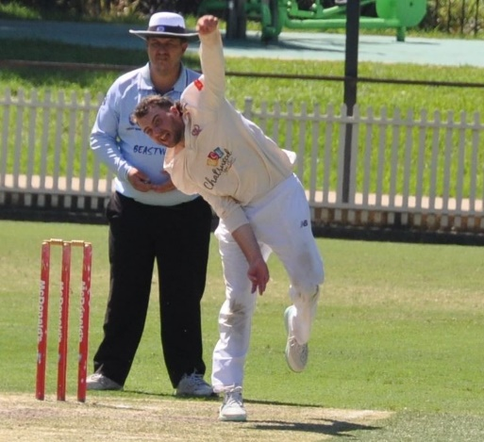
Round 12 vs bottom of the table Campbelltown-Camden out at Raby Sports Complex, meant that the 4s were on the hunt for some points, and if an opportunity arose for an outright, they would push for one. Captain Apurv Sharma’s wish came true when they had the opportunity to bowl first and restrict Campbelltown to a low total. Charlie Gwynn was the catalyst for keeping Campbelltown to 96 in the first innings taking 5/35 of his 22 overs. Gordon in reply chased down the runs quickly and finished with 131, in the bid for quick runs, giving a lead of 35 runs. What happened next could not have been scripted any better for the Stags; Gordon bowled out Campbelltown for 40 off 37 overs in the second innings (that’s correct, 40!), leaving Gordon 6 runs for an outright win and a crucial 10 points. Charlie Gwynn was again amongst the wickets with 4/13 of 14 overs but the real hero was Nishant Balaguruswamy with figures of 4/1 of 5.3 overs.
Charlie Gwynn

Round 13 vs UNSW at Killara Park was another bonus point one-day win for the Stags with UNSW bowled out for 116, in response Gordon chased the runs in 20 overs with Apurv Sharma (60*) and Dylan Ranjan (38*) getting the job done comfortably.

This meant that the boys were well and truly in contention to play finals cricket. A win in one of the last 2-games would secure a spot in the top six. However, Round 14 vs Sydney gave the team a bit of a reality check when we fell 44 runs short chasing 160. This meant that the 4s had a must-win encounter in the final one-day game vs Western Suburbs at Killara Park. We had built a bit of a fortress at Killara Park and were confident heading into this game. Apurv Sharma won the toss and chose to bowl first; he gave the golden arm and the man in form Charlie Gwynn the new rock and he struck straight away knocking back their in-form opener. At the other end, Simon Read was placing it on a dime, and swinging it religiously, making it very difficult for the Wests batsmen. Simon struck not once, not twice but thrice in three balls giving himself a hat trick and the boys were up-and-about leaving Wests in trouble at 5/20. They finished 90 all out off 24 overs with Simon Read 5/34 off 7 overs (inc. hat trick) and Charlie Gwynn 3/16 off 8 overs. Gordon in reply made light work of the chase with Apurv Sharma (55) again in the runs steering Gordon to a win, a 3rd place finish on the ladder and a home qualifying final at Chatswood Oval vs UTS North Sydney.

Finals is an exciting time for the club, the teams involved, all the players and anyone part of the experience. Gordon 4th Grade from 11th on the ladder at Christmas had climbed the mountain and finished 3rd on the ladder with five strong wins post Xmas (inclusive of bonus points & an outright win). The team had the consistency in personnel and there was clarity of player’s roles within the team. Off the field, the team was gelling nicely and there was a real ‘culture’ developed within the side. Heading into the QF vs UTS North Sydney the boys were pumped and excited to be part of a home final at Chatswood Oval. There were nerves throughout the game, but the team put in a strong disciplined performance by keeping North Sydney to 136 all out of 81 overs with wickets shared all around. In reply Gordon chased down the score 8/139 of 52 overs; Shreyan Deshpande (41) gave the team a strong start, with other contributors Apurv Sharma (23), David Monaghan (20) and an important 9* from Steve Bristow helped get us across the line. Gordon played Parramatta in the Semi Final at Bankstown Oval and kept them to 132. Unfortunately, Gordon were bowled out for 89 in response losing the Semi Final by 43 runs ending the season.

All in all, the Gordon 4’s had an awesome year on and off the field and have made the Club proud of their efforts. There is great potential for this group of young men to continue to play a lot of cricket together in future years and aspire to bring home some silverware. Below some key highlights from across the season:

Some key team highlights:
- Most successful Gordon team across all men’s grades (1-6)
- 4th Grade made finals for the first time since 2018/19
- 4th Grade finished 3rd on the ladder during the home & away season
- 4th Grade won three bonus point L/O games vs Blacktown, UNSW & Western Suburbs
- 4th Grade won outright vs Campbelltown Camden
Some key player highlights:
- Anay Baruah scored the only 100 for the team in Round 10 vs Randwick Petersham
- Simon Read took a hat trick vs Western Suburbs in his 5/34
- Captain Apurv Sharma lead the runs with 370 runs at 30.83 with four half centuries (HS of 92 vs St George)
- UK-overseas player Charlie Gwynn lead the wickets with 24 at 9.42 with 5/35 vs Campbelltown Camden

To finish, it has been a great privilege captaining the 4th Grade side this year and I thank everyone on the Gordon committee for the opportunity. I also would personally like to thank the club president Michael Cant for his ongoing support throughout the season to not only me personally but everyone involved at the club. To Geoff Hickman, thank you for your constant commitment to the 4th Grade selections throughout the year. We had several phone calls throughout the week with unavailable and injured players so I thank you for your time, effort, and patience with this process. To our coach, Nick Miller, thank you so much for your time and support, ensuring players were game-ready across all skill sets. Finally, to all the parents, family members, volunteers (special mention to Andy Falk), and committee members; thank you for your contributions and support.

APURV SHARMA
FOURTH GRADE CAPTAIN

 | GORDON DCC PLAYER AVERAGES
 | SEASON 2022/23
 | 4TH GRADE
Batting Averages
Player |  | Matches |  |  |  |  | Innings |  | Not Outs |  |  |  | H.S. |  | Runs |  |  | Average
D Ranjan |  | 5 |  |  | 5 |  |  |  | 2 |  |  |  | 59 |  | 163 |  |  | 54.33
D Monaghan |  | 8 |  |  | 7 |  |  |  | 2 |  |  |  | 57 |  | 159 |  |  | 31.80
A Sharma |  | 14 |  |  | 13 |  |  |  | 1 |  |  |  | 92 |  | 370 |  |  | 30.83
K Krishnan |  | 13 |  |  | 13 |  |  |  | 0 |  |  |  | 49 |  | 226 |  |  | 17.38
S Schembri-Green |  | 6 |  |  | 5 |  |  |  | 0 |  |  |  | 30 |  | 84 |  |  | 16.80
MR Jones |  | 11 |  |  | 10 |  |  |  | 0 |  |  |  | 57 |  | 167 |  |  | 16.70
T Carruthers |  | 6 |  |  | 5 |  |  |  | 0 |  |  |  | 31 |  | 76 |  |  | 15.20
C Gwynn |  | 9 |  |  | 7 |  |  |  | 1 |  |  |  | 39* |  | 79 |  |  | 13.17
S Deshpande |  | 9 |  |  | 6 |  |  |  | 0 |  |  |  | 41 |  | 79 |  |  | 13.17
I Murugappan |  | 5 |  |  | 5 |  |  |  | 1 |  |  |  | 17 |  | 51 |  |  | 12.75
PS Iyer |  | 5 |  |  | 5 |  |  |  | 1 |  |  |  | 31* |  | 47 |  |  | 11.75
N Balaguruswamy |  | 12 |  |  | 5 |  |  |  | 3 |  |  |  | 12 |  | 15 |  |  | 7.50
T Coventry-Searle |  | 5 |  |  | 6 |  |  |  | 1 |  |  |  | 14 |  | 21 |  |  | 4.20
Also Batted
J Gray |  | 4 |  |  | 4 |  |  |  | 1 |  |  |  | 72* |  | 110 |  |  | 36.67
T Fedorow |  | 2 |  |  | 2 |  |  |  | 0 |  |  |  | 68 |  | 69 |  |  | 34.50
S Bromley |  | 4 |  |  | 3 |  |  |  | 1 |  |  |  | 40 |  | 43 |  |  | 21.50
T Reicher |  | 4 |  |  | 2 |  |  |  | 0 |  |  |  | 19 |  | 36 |  |  | 18.00
K Katli |  | 1 |  |  | 1 |  |  |  | 0 |  |  |  | 17 |  | 17 |  |  | 17.00
O Patterson |  | 3 |  |  | 2 |  |  |  | 0 |  |  |  | 18 |  | 20 |  |  | 10.00
A Madan |  | 1 |  |  | 1 |  |  |  | 0 |  |  |  | 10 |  | 10 |  |  | 10.00
J Douglas |  | 3 |  |  | 4 |  |  |  | 1 |  |  |  | 14 |  | 29 |  |  | 9.67
HM Robertson |  | 6 |  |  | 4 |  |  |  | 1 |  |  |  | 18 |  | 26 |  |  | 8.67
N Clarke |  | 7 |  |  | 4 |  |  |  | 0 |  |  |  | 13 |  | 33 |  |  | 8.25
T Robinson |  | 1 |  |  | 1 |  |  |  | 0 |  |  |  | 5 |  | 5 |  |  | 5.00
S Read |  | 6 |  |  | 4 |  |  |  | 1 |  |  |  | 9 |  | 13 |  |  | 4.33
M Brown |  | 3 |  |  | 2 |  |  |  | 1 |  |  |  | 2* |  | 4 |  |  | 4.00
NS Budroo |  | 2 |  |  | 2 |  |  |  | 0 |  |  |  | 4 |  | 4 |  |  | 2.00
L Burrows |  | 1 |  |  | 1 |  |  |  | 0 |  |  |  | 1 |  | 1 |  |  | 1.00
O Turner |  | 1 |  |  | 1 |  |  |  | 0 |  |  |  | 0 |  | 0 |  |  | 0.00
A Baruah |  | 1 |  |  | 1 |  |  |  | 1 |  |  |  | 101* |  | 101 |  |  | n/a
T Siede |  | 1 |  |  | 1 |  |  |  | 1 |  |  |  | 78* |  | 78 |  |  | n/a
S Bristow |  | 3 |  |  | 1 |  |  |  | 1 |  |  |  | 9* |  | 9 |  |  | n/a
R Watson |  | 3 |  |  | 2 |  |  |  | 2 |  |  |  | 0* |  | 0 |  |  | n/a
S Toohey |  | 1 |  |  | 0 |  |  |  | 0 |  |  |  | 0 |  | 0 |  |  | n/a

Best Batting Performances
Player |  |  |  | Score |  | Round |  | Opponent
A Baruah |  |  |  | 101* |  | 10 |  | Randwick Petersham
Best Partnerships
Batsmen |  |  |  | Runs |  | Wkt |  | Opponent
K Krishnan - A Sharma |  |  | 100 |  | 1st |  | Blacktown Mounties
Bowling Averages
Player | Overs |  |  | Mdns |  | Runs |  | Wkts | Average |  | Best |  |  | R/O
C Gwynn | 128.4 |  |  | 44 |  | 226 |  | 24 | 9.42 |  | 5-35 |  |  | 1.76
S Deshpande | 67.3 |  |  | 10 |  | 184 |  | 14 | 13.14 |  | 4-58 |  |  | 2.73
S Read | 72 |  |  | 22 |  | 188 |  | 14 | 13.43 |  | 5-34 |  |  | 2.61
MR Jones | 66.2 |  |  | 14 |  | 159 |  | 11 | 14.45 |  | 5-54 |  |  | 2.40
A Sharma | 66 |  |  | 15 |  | 172 |  | 11 | 15.64 |  | 2-4 |  |  | 2.61
PS Iyer | 48.2 |  |  | 12 |  | 127 |  | 8 | 15.88 |  | 3-34 |  |  | 2.63
N Balaguruswamy | 131.1 |  |  | 33 |  | 326 |  | 20 | 16.30 |  | 4-1 |  |  | 2.49
D Monaghan | 91 |  |  | 27 |  | 196 |  | 12 | 16.33 |  | 3-13 |  |  | 2.15
HM Robertson | 74 |  |  | 11 |  | 219 |  | 12 | 18.25 |  | 6-36 |  |  | 2.96
S Schembri-Green | 60.3 |  |  | 12 |  | 149 |  | 8 | 18.63 |  | 3-44 |  |  | 2.46
Also Bowled
O Turner | 5 |  |  | 2 |  | 12 |  | 1 | 12.00 |  | 1-12 |  |  | 2.40
S Toohey | 4 |  |  | 0 |  | 12 |  | 1 | 12.00 |  | 1-12 |  |  | 3.00
I Murugappan | 7 |  |  | 0 |  | 38 |  | 2 | 19.00 |  | 2-26 |  |  | 5.43
S Bristow | 26 |  |  | 9 |  | 40 |  | 2 | 20.00 |  | 2-23 |  |  | 1.54
O Patterson | 14 |  |  | 3 |  | 41 |  | 2 | 20.50 |  | 2-30 |  |  | 2.93
T Reicher | 18 |  |  | 2 |  | 86 |  | 2 | 43.00 |  | 1-22 |  |  | 4.78
D Ranjan | 19 |  |  | 1 |  | 44 |  | 1 | 44.00 |  | 1-19 |  |  | 2.32
R Watson | 20 |  |  | 0 |  | 96 |  | 2 | 48.00 |  | 1-24 |  |  | 4.80
A Baruah | 8 |  |  | 1 |  | 20 |  | 0 | n/a |  | 0-20 |  |  | 2.50
L Burrows | 5 |  |  | 1 |  | 17 |  | 0 | n/a |  | 0-17 |  |  | 3.40
K Katli | 2 |  |  | 0 |  | 10 |  | 0 | n/a |  | 0-10 |  |  | 5.00
T Siede | 1.2 |  |  | 0 |  | 3 |  | 0 | n/a |  | 0-3 |  |  | 2.25

Best Bowling Performances
Player | Overs | Runs | Wkts | Round | Opponent
HM Robertson | 18 | 36 | 6 | 4 | UTS North Sydney
S Read | 7 | 34 | 5 | 15 | Western Suburbs
C Gwynn | 22 | 35 | 5 | 12 | Campbelltown Camden
S Read | 23 | 39 | 5 | SF | Parramatta
MR Jones | 12.2 | 54 | 5 | 11 | Penrith
N Balaguruswamy | 5.3 | 1 | 4 | 12 | Campbelltown Camden
C Gwynn | 14 | 13 | 4 | 12 | Campbelltown Camden
S Deshpande | 16.3 | 58 | 4 | 3 | Sutherland

Fifth Grade Report
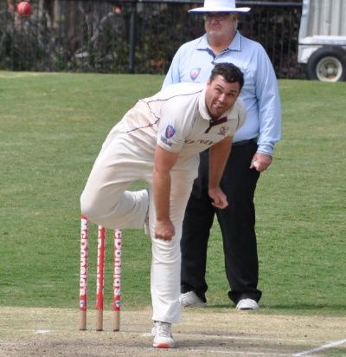
This was a season that got away from the mighty 5s, not making the finals for the first time in the past 2 seasons. It was a frustrating year in many ways, a lot of the games early in the year we should have won, and then the back half of the year was frustrating as we could never get the same bunch of 11 guys on the park week in week out.

A message for anyone committing to a grade season, it is a summer long commitment. You might think that missing one or two games a season is not going to impact the side, but it does, especially if its happening across the grades. Unfortunately, this year it seemed we had a consistent 20 players out a round, which impacts 5s more than any other team.
Stephen Bristow
I have no doubt if we can field our strongest teams week in week out then our lower grade sides can start to really challenge for flags at the end of the year (case in point the 2 seasons prior and 4s this year).

There were some strong performances by the guys that ran out for 5s week in week out. Nate Roberts was probably the find of the season, he was enthusiastic and always chipped away with wickets for us.

Oscar Patterson, before he got injured had a good year, especially with the bat, given a chance in the middle order he always contributed.

Sam Toohey is another guy that week in week outperformed for us, and hopefully we see him back in the stags colours again if he comes back for another tour from his home in the UK.

The club has plenty of players that I’m sure will find their way up the grades if they stay committed and take each game as they come. 5th Grade is a grade where players learn what grade cricket is like, and I’m glad a lot of the younger guys got the opportunity to do so this year, especially some of our under 17s guys who filled in toward the end of the year when players were especially hard to find.

There were some memorable games, early on against Sutherland, we were able to win by over 150, and I was lucky enough to reach triple figures, something I hadn’t done in a while.

There was also the demolition job of Sydney where Tom Reicher, Matt Brown got amongst the runs and Michel Loong filling in got amongst the wickets.

Again, I was lucky enough to have some older fellas help me out with the team. David Monaghan, the greatest ever 5th grader , Stu Bromley and Nick Andreou, always helping me out with ideas on and off the field. Having these guys around the club is essential and thanks you blokes!

We go around again next year, in the hope that we don’t have issues with selections and can build on the year that was. The mighty 5s are never too far out of finals contention and it would be good to see another 5s flag for the Stags!

STEPHEN BRISTOW
CAPTAIN

 | GORDON DCC PLAYER AVERAGES
 | SEASON 2022/23
 | 5TH GRADE
Batting Averages
Player |  | Matches |  |  |  | Innings |  |  |  | Not Outs |  |  |  | H.S. |  |  |  | Runs |  |  |  | Average
S Bristow |  | 10 |  |  |  | 9 |  |  |  | 2 |  |  |  | 100* |  |  |  | 282 |  |  |  | 40.29
I Murugappan |  | 6 |  |  |  | 6 |  |  |  | 0 |  |  |  | 80 |  |  |  | 162 |  |  |  | 27.00
M Brown |  | 6 |  |  |  | 6 |  |  |  | 0 |  |  |  | 77 |  |  |  | 159 |  |  |  | 26.50
O Patterson |  | 6 |  |  |  | 5 |  |  |  | 0 |  |  |  | 43 |  |  |  | 118 |  |  |  | 23.60
T Richards |  | 6 |  |  |  | 6 |  |  |  | 2 |  |  |  | 26 |  |  |  | 91 |  |  |  | 22.75
D Monaghan |  | 7 |  |  |  | 6 |  |  |  | 0 |  |  |  | 52 |  |  |  | 115 |  |  |  | 19.17
B Foster |  | 11 |  |  |  | 10 |  |  |  | 0 |  |  |  | 38 |  |  |  | 186 |  |  |  | 18.60
T Coventry-Searle |  | 6 |  |  |  | 6 |  |  |  | 1 |  |  |  | 46* |  |  |  | 92 |  |  |  | 18.40
S Toohey |  | 10 |  |  |  | 9 |  |  |  | 4 |  |  |  | 36 |  |  |  | 83 |  |  |  | 16.60
T Reicher |  | 8 |  |  |  | 7 |  |  |  | 0 |  |  |  | 54 |  |  |  | 114 |  |  |  | 16.29
N Andreou |  | 11 |  |  |  | 10 |  |  |  | 1 |  |  |  | 33 |  |  |  | 138 |  |  |  | 15.33
J Woods |  | 5 |  |  |  | 5 |  |  |  | 0 |  |  |  | 18 |  |  |  | 69 |  |  |  | 13.80
N Roberts |  | 10 |  |  |  | 6 |  |  |  | 3 |  |  |  | 5* |  |  |  | 8 |  |  |  | 2.67
Also Batted
A Madan |  | 1 |  |  |  | 1 |  |  |  | 0 |  |  |  | 59 |  |  |  | 59 |  |  |  | 59.00
T Robinson |  | 1 |  |  |  | 1 |  |  |  | 0 |  |  |  | 40 |  |  |  | 40 |  |  |  | 40.00
A Gupta |  | 2 |  |  |  | 1 |  |  |  | 0 |  |  |  | 29 |  |  |  | 29 |  |  |  | 29.00
M Farrell |  | 3 |  |  |  | 3 |  |  |  | 0 |  |  |  | 14 |  |  |  | 41 |  |  |  | 13.67
J Nielsen |  | 2 |  |  |  | 1 |  |  |  | 0 |  |  |  | 13 |  |  |  | 13 |  |  |  | 13.00
L Archer |  | 1 |  |  |  | 1 |  |  |  | 0 |  |  |  | 10 |  |  |  | 10 |  |  |  | 10.00
A Gobinath |  | 1 |  |  |  | 1 |  |  |  | 0 |  |  |  | 8 |  |  |  | 8 |  |  |  | 8.00
MR Jones |  | 1 |  |  |  | 1 |  |  |  | 0 |  |  |  | 7 |  |  |  | 7 |  |  |  | 7.00
S Shah |  | 1 |  |  |  | 1 |  |  |  | 0 |  |  |  | 6 |  |  |  | 6 |  |  |  | 6.00
S Brar |  | 1 |  |  |  | 1 |  |  |  | 0 |  |  |  | 5 |  |  |  | 5 |  |  |  | 5.00
R Watson |  | 5 |  |  |  | 3 |  |  |  | 0 |  |  |  | 6 |  |  |  | 9 |  |  |  | 3.00
PS Iyer |  | 1 |  |  |  | 1 |  |  |  | 0 |  |  |  | 3 |  |  |  | 3 |  |  |  | 3.00
O Turner |  | 3 |  |  |  | 1 |  |  |  | 0 |  |  |  | 3 |  |  |  | 3 |  |  |  | 3.00
S Bromley |  | 2 |  |  |  | 2 |  |  |  | 0 |  |  |  | 4 |  |  |  | 4 |  |  |  | 2.00
A Voleti |  | 4 |  |  |  | 3 |  |  |  | 0 |  |  |  | 3 |  |  |  | 5 |  |  |  | 1.67
J Patselis |  | 2 |  |  |  | 1 |  |  |  | 0 |  |  |  | 0 |  |  |  | 0 |  |  |  | 0.00
HM Robertson |  | 2 |  |  |  | 1 |  |  |  | 0 |  |  |  | 0 |  |  |  | 0 |  |  |  | 0.00
T Fedorow |  | 1 |  |  |  | 1 |  |  |  | 1 |  |  |  | 72* |  |  |  | 72 |  |  |  | n/a
N Balaguruswamy |  | 2 |  |  |  | 0 |  |  |  | 0 |  |  |  | 6 |  |  |  | 6 |  |  |  | n/a
N Clarke |  | 2 |  |  |  | 2 |  |  |  | 2 |  |  |  | 3* |  |  |  | 6 |  |  |  | n/a
A Holland |  | 1 |  |  |  | 1 |  |  |  | 1 |  |  |  | 4* |  |  |  | 4 |  |  |  | n/a
M Loong |  | 1 |  |  |  | 0 |  |  |  | 0 |  |  |  | 0 |  |  |  | 0 |  |  |  | n/a
N Stanwell |  | 2 |  |  |  | 0 |  |  |  | 0 |  |  |  | 0 |  |  |  | 0 |  |  |  | n/a
Best Batting Performances
Player |  |  |  | Score |  |  |  | Round |  |  |  | Opponent
S Bristow |  |  |  | 100* |  |  |  | 3 |  |  |  | Sutherland
Best Partnerships
Batsmen |  |  |  | Runs |  |  |  | Wkt |  |  |  | Opponent
S Bristow - M Brown |  |  |  | 112 |  |  |  | 5th |  |  |  | Sydney
S Bristow - O Patterson |  |  |  | 100 |  |  |  | 7th |  |  |  | Sutherland
Bowling Averages
Player | Overs |  |  | Mdns |  |  | Runs |  |  |  | Wkts |  |  |  | Average |  |  |  | Best |  |  |  | R/O
O Turner | 29.4 |  |  | 5 |  |  | 61 |  |  |  | 7 |  |  |  | 8.71 |  |  |  | 3-13 |  |  |  | 2.06
N Roberts | 69.2 |  |  | 13 |  |  | 172 |  |  |  | 15 |  |  |  | 11.47 |  |  |  | 4-28 |  |  |  | 2.48
T Reicher | 38 |  |  | 8 |  |  | 106 |  |  |  | 6 |  |  |  | 17.67 |  |  |  | 2-16 |  |  |  | 2.79
S Toohey | 96.4 |  |  | 25 |  |  | 285 |  |  |  | 15 |  |  |  | 19.00 |  |  |  | 4-25 |  |  |  | 2.95
R Watson | 47.5 |  |  | 8 |  |  | 204 |  |  |  | 10 |  |  |  | 20.40 |  |  |  | 5-73 |  |  |  | 4.26
S Bristow | 103.3 |  |  | 37 |  |  | 236 |  |  |  | 11 |  |  |  | 21.45 |  |  |  | 3-8 |  |  |  | 2.28
D Monaghan | 74 |  |  | 23 |  |  | 228 |  |  |  | 6 |  |  |  | 38.00 |  |  |  | 4-26 |  |  |  | 3.08
Also Bowled
N Andreou | 2 |  |  | 1 |  |  | 2 |  |  |  | 1 |  |  |  | 2.00 |  |  |  | 1-0 |  |  |  | 1.00
M Brown | 3 |  |  | 0 |  |  | 5 |  |  |  | 1 |  |  |  | 5.00 |  |  |  | 1-2 |  |  |  | 1.67
T Fedorow | 4 |  |  | 1 |  |  | 3 |  |  |  | 1 |  |  |  | 3.00 |  |  |  | 1-3 |  |  |  | 0.75
M Loong | 7 |  |  | 0 |  |  | 10 |  |  |  | 2 |  |  |  | 5.00 |  |  |  | 2-10 |  |  |  | 1.43
A Holland | 8 |  |  | 1 |  |  | 16 |  |  |  | 3 |  |  |  | 5.33 |  |  |  | 3-16 |  |  |  | 2.00
J Patselis | 8 |  |  | 2 |  |  | 17 |  |  |  | 2 |  |  |  | 8.50 |  |  |  | 1-6 |  |  |  | 2.13
MR Jones | 10 |  |  | 1 |  |  | 45 |  |  |  | 4 |  |  |  | 11.25 |  |  |  | 4-45 |  |  |  | 4.50
N Balaguruswamy | 27 |  |  | 11 |  |  | 55 |  |  |  | 4 |  |  |  | 13.75 |  |  |  | 4-43 |  |  |  | 2.04
HM Robertson | 12 |  |  | 2 |  |  | 51 |  |  |  | 3 |  |  |  | 17.00 |  |  |  | 3-21 |  |  |  | 4.25
J Nielsen | 16 |  |  | 4 |  |  | 40 |  |  |  | 2 |  |  |  | 20.00 |  |  |  | 2-16 |  |  |  | 2.50
PS Iyer | 9 |  |  | 2 |  |  | 22 |  |  |  | 1 |  |  |  | 22.00 |  |  |  | 1-22 |  |  |  | 2.44
S Brar | 6 |  |  | 1 |  |  | 23 |  |  |  | 1 |  |  |  | 23.00 |  |  |  | 1-23 |  |  |  | 3.83
I Murugappan | 15.3 |  |  | 0 |  |  | 70 |  |  |  | 2 |  |  |  | 35.00 |  |  |  | 1-21 |  |  |  | 4.52
O Patterson | 32 |  |  | 7 |  |  | 106 |  |  |  | 3 |  |  |  | 35.33 |  |  |  | 2-41 |  |  |  | 3.31
N Stanwell | 19 |  |  | 1 |  |  | 71 |  |  |  | 2 |  |  |  | 35.50 |  |  |  | 2-26 |  |  |  | 3.74
A Gupta | 10 |  |  | 2 |  |  | 38 |  |  |  | 0 |  |  |  | n/a |  |  |  | 0-16 |  |  |  | 3.80
S Shah | 2 |  |  | 0 |  |  | 14 |  |  |  | 0 |  |  |  | n/a |  |  |  | 0-14 |  |  |  | 7.00
T Robinson | 1 |  |  | 0 |  |  | 10 |  |  |  | 0 |  |  |  | n/a |  |  |  | 0-10 |  |  |  | 10.00

Best Bowling Performances
Player | Overs | Runs | Wkts | Round | Opponent
R Watson | 14.5 | 73 | 5 | 4 | UTS North Sydney
S Toohey | 17 | 25 | 4 | 12 | Campbelltown Camden
D Monaghan | 23 | 26 | 4 | 5 | Sydney University
N Roberts | 11 | 28 | 4 | 6 | Eastern Suburbs
N Balaguruswamy | 22 | 43 | 4 | 5 | Sydney University
MR Jones | 10 | 45 | 4 | 10 | Randwick-Petersham

6th Grade (Metropolitan Cup) Report

The one constant in the Colts team for season 2022/23 was that the surname of the team captain was Woods. Young Jack Woods was named captain at the start of the season until he was elevated to 5th grade in round 4. He was replaced by some old, balding, washed up cricketer who also happened to be his father!

The first half of the season was very successful for the Colts team, heading into Christmas undefeated and looking good ahead of the second half of the season. Whilst the second half of the season wasn’t quite as successful as the first half, we managed to finish 5th and make the finals for the first time in a while as I understand. A few losses to teams well below us were disappointing, (along with a small administrative decision that cost us 8 points…..but I won’t bore everyone with the details!!!) that ultimately cost us in finishing higher up the table and most likely the minor premiership.
Ben Woods

Our qualifying final was played against Penrith at Rance Oval. We won the toss, elected to bat and at 1 for 80 odd just before lunch we were looking well set for a good total with Jack Woods and Jaeden Douglas both not out in the 30’s. Unfortunately, Jack was run out 2 balls before lunch and Penrith changed the momentum by keeping us to 28 runs off the next 20 overs. We ended up getting rolled for 124 which was never going to be enough and despite getting 3 wickets before stumps on day 1, Penrith were able to get past our score and put the game beyond our reach, season over.
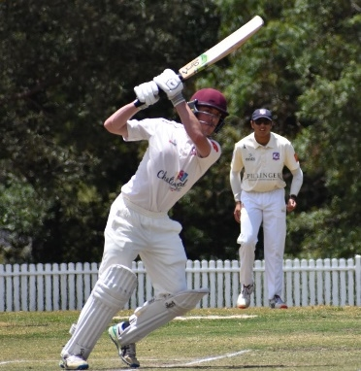
Overall it was a good season for the team, only losing 3 games in the regular season and making the finals. There were some great individual performances across the season and in particular our top order which was outstanding for the first half of the season. This allowed our bowling unit to get into a groove and look to take wickets without having to worry too much about containing runs. Pleasingly, we always looked to play positive cricket and this was for the most part, reflected in our results.
Jack Woods
Stand out batsmen were:
- Jaeden Douglas 435 runs @ 54.38 HS 80
- Jack Woods 380 runs @ 47.5 HS 102 N/O
- Miles Farrell 285 runs @ 71.25 HS 117

Notable mention to Bailey Foster (147) and Miles Lambert (112) for their 264 run opening partnership against UNSW, simply outstanding!

Stand out bowlers were:
- Taj Nicholson 23 wickets @ 16.78 BB 5/52
- Oscar Turner 17 wickets @ 17.53 BB 5/53
- Tom Gohl 10 wickets @ 20 BB 2/19

Notable mention to Jack Woods with 8 wickets @ 17 BB 3/7.

Special mention to Matthew Nicholson for his invaluable counsel throughout the season, your support was greatly appreciated.

The most pleasing aspect of the season for me was the spirit and manner in which the lads played their cricket, they represented our great Club with distinction. I hope that they were able to enjoy their cricket and learn a few things along the way, it was a great privilege to be able to lead such a terrific group of young men.

I very much look forward to seeing these players move up to 5th grade and beyond, continuing to learn and improve their craft whilst representing the Stags!

BEN WOODS
SIXTH GRADE CAPTAIN

 | GORDON DCC PLAYER AVERAGES
 | SEASON 2022/23
 | METROPOLITAN CUP
Batting Averages
Player |  | Matches |  |  | Innings |  |  | Not Outs |  |  |  | H.S. | Runs |  |  | Average
Farrell, Miles |  | 7 |  |  | 6 |  |  | 2 |  |  |  | 117 | 285 |  |  | 71.25
Douglas, Jaeden |  | 11 |  |  | 10 |  |  | 2 |  |  |  | 78 | 435 |  |  | 54.38
Woods, Jack |  | 9 |  |  | 9 |  |  | 1 |  |  |  | 102 | 380 |  |  | 47.50
Richards, Tim |  | 7 |  |  | 7 |  |  | 2 |  |  |  | 53 | 162 |  |  | 32.40
Shah, Satva |  | 10 |  |  | 8 |  |  | 2 |  |  |  | 38 | 107 |  |  | 17.83
Nielsen, Justin |  | 6 |  |  | 5 |  |  | 2 |  |  |  | 6 | 8 |  |  | 2.67
Woods, Ben |  | 10 |  |  | 5 |  |  | 0 |  |  |  | 5 | 6 |  |  | 1.20
Also Batted
Foster, Bailey |  | 2 |  |  | 2 |  |  | 0 |  |  |  | 147 | 202 |  |  | 101.00
Voleti, Aditya |  | 3 |  |  | 2 |  |  | 1 |  |  |  | 66 | 94 |  |  | 94.00
Smith, Campbell |  | 1 |  |  | 1 |  |  | 0 |  |  |  | 72 | 72 |  |  | 72.00
Lambert, Milan |  | 7 |  |  | 4 |  |  | 1 |  |  |  | 112 | 130 |  |  | 43.33
Gupta, Aryan |  | 3 |  |  | 2 |  |  | 1 |  |  |  | 18 | 34 |  |  | 34.00
Gobinath, Arinath |  | 2 |  |  | 2 |  |  | 0 |  |  |  | 21 | 33 |  |  | 16.50
Brown, Mat |  | 2 |  |  | 2 |  |  | 0 |  |  |  | 24 | 32 |  |  | 16.00
Turner, Oscar |  | 8 |  |  | 3 |  |  | 0 |  |  |  | 16 | 31 |  |  | 10.33
Gohl, Tom |  | 10 |  |  | 4 |  |  | 1 |  |  |  | 13 | 27 |  |  | 9.00
Loong, Michael |  | 8 |  |  | 2 |  |  | 0 |  |  |  | 9 | 15 |  |  | 7.50
Khunmuang, Tiger |  | 7 |  |  | 4 |  |  | 1 |  |  |  | 14 | 22 |  |  | 7.33
Bansal, Manas |  | 1 |  |  | 1 |  |  | 0 |  |  |  | 7 | 7 |  |  | 7.00
Austin, Luke |  | 2 |  |  | 1 |  |  | 0 |  |  |  | 6 | 6 |  |  | 6.00
Loynes, James |  | 13 |  |  | 4 |  |  | 1 |  |  |  | 9 | 18 |  |  | 6.00
Nicholson, Taj |  | 13 |  |  | 2 |  |  | 0 |  |  |  | 2 | 2 |  |  | 1.00
Ghandi, Vivaan |  | 2 |  |  | 1 |  |  | 0 |  |  |  | 0 | 0 |  |  | 0.00
Roberts, Nate |  | 1 |  |  | 1 |  |  | 1 |  |  |  | 13 | 13 |  |  | n/a
Holland, Alex |  | 1 |  |  | 0 |  |  | 0 |  |  |  | 0 | 0 |  |  | n/a
Medford, Lucas |  | 4 |  |  | 1 |  |  | 1 |  |  |  | 0 | 0 |  |  | n/a
Robinson, Toby |  | 1 |  |  | 0 |  |  | 0 |  |  |  | 0 | 0 |  |  | n/a
Stanwell, Nick |  | 2 |  |  | 0 |  |  | 0 |  |  |  | 0 | 0 |  |  | n/a
Patselis, James |  | 1 |  |  | 1 |  |  | 1 |  |  |  | 0 | 0 |  |  | n/a
Adams, Mack |  | 1 |  |  | 0 |  |  | 0 |  |  |  | 0 | 0 |  |  | n/a

Best Batting Performances
Player |  | Score |  | Round |  | Opponent
Foster, Bailey |  | 147 |  | 7 |  | University of NSW
Farrell, Miles |  | 117* |  | 2 |  | Randwick Petersham Gold
Lambert, Milan |  | 112* |  | 7 |  | University of NSW
Woods, Jack |  | 102* |  | 4 |  | Warringah
Farrell, Miles |  | 100* |  | 10 |  | Randwick Petersham Green
Best Partnerships
Batsmen |  |  | Runs |  | Wkt |  | Opponent
Foster, Bailey - Lambert, Milan |  |  | 264 |  | 1st |  | University of NSW
Woods, Jack - Richards Tim |  |  | 150 |  | 2nd |  | Warringah
Woods, Jack - Douglas, Jaeden |  |  | 131 |  | 3rd |  | Sydney University Gold
Farrell, Miles - Woods, Jack |  |  | 119 |  | 1st |  | Randwick Petersham Green
Foster, Bailey - Voleti, Aditya |  |  | 102 |  | 1st |  | North West Sydney Gold
Bowling Averages
Player | Overs | Mdns |  | Runs |  | Wkts |  | Average |  | Best |  |  |  | R/O
Nielsen, Justin | 40 | 17 |  | 60 |  | 5 |  | 12.00 |  | 2/7 |  |  |  | 1.50
Stanwell, Nick | 22 | 5 |  | 82 |  | 5 |  | 16.40 |  | 3/30 |  |  |  | 3.73
Nicholson, Taj | 131 | 19 |  | 386 |  | 23 |  | 16.78 |  | 5/52 |  |  |  | 2.95
Woods, Jack | 50 | 8 |  | 136 |  | 8 |  | 17.00 |  | 3/12 |  |  |  | 2.72
Turner, Oscar | 99 | 8 |  | 298 |  | 17 |  | 17.53 |  | 5/53 |  |  |  | 3.01
Gohl, Tom | 86 | 21 |  | 200 |  | 10 |  | 20.00 |  | 3/35 |  |  |  | 2.33
Shah, Satva | 55 | 10 |  | 150 |  | 7 |  | 21.43 |  | 2/14 |  |  |  | 2.73
Also Bowled
Robinson, Toby | 8.1 | 1 |  | 15 |  | 4 |  | 3.75 |  | 4/15 |  |  |  | 1.85
Patselis, James | 6 | 3 |  | 16 |  | 2 |  | 8.00 |  | 2/16 |  |  |  | 2.67
Foster, Bailey | 7.3 | 0 |  | 38 |  | 3 |  | 12.67 |  | 2/13 |  |  |  | 5.21
Medford, Lucas | 21.5 | 1 |  | 62 |  | 4 |  | 15.50 |  | 2/26 |  |  |  | 2.88
Austin, Luke | 10 | 0 |  | 39 |  | 2 |  | 19.50 |  | 2/29 |  |  |  | 3.90
Bansal, Manas | 10 | 0 |  | 46 |  | 2 |  | 23.00 |  | 2/46 |  |  |  | 4.60
Lambert, Milan | 11 | 1 |  | 25 |  | 1 |  | 25.00 |  | 1/21 |  |  |  | 2.27
Gupta, Aryan | 22 | 3 |  | 52 |  | 2 |  | 26.00 |  | 1/14 |  |  |  | 2.36
Holland, Alex | 10 | 0 |  | 37 |  | 1 |  | 37.00 |  | 1/37 |  |  |  | 3.70
Roberts, Nate | 17 | 6 |  | 39 |  | 1 |  | 39.00 |  | 1/39 |  |  |  | 2.29
Woods, Ben | 17.3 | 1 |  | 89 |  | 2 |  | 44.50 |  | 2/35 |  |  |  | 5.14
Farrell, Miles | 18 | 2 |  | 52 |  | 1 |  | 52.00 |  | 1/3 |  |  |  | 2.89
Ghandi, Vivaan | 19 | 1 |  | 57 |  | 1 |  | 57.00 |  | 1/57 |  |  |  | 3.00
Loong, Michael | 9 | 0 |  | 39 |  | 0 |  | n/a |  | n/a |  |  |  | 4.33
Khunmuang, Tiger | 4 | 0 |  | 26 |  | 0 |  | n/a |  | n/a |  |  |  | 6.50
Brown, Mat | 4 | 0 |  | 11 |  | 0 |  | n/a |  | n/a |  |  |  | 2.75
Adams, Mack | 5.3 | 3 |  | 4 |  | 0 |  | n/a |  | n/a |  |  |  | 0.75
Smith, Campbell | 7 | 1 |  | 22 |  | 0 |  | n/a |  | n/a |  |  |  | 3.14
Best Bowling Performances
Player | Overs | Runs |  | Wkts |  | Round |  |  | Opponent
Nicholson, Taj | 14 | 52 |  | 5 |  | 13 |  |  | Blacktown Mounties Black
Turner, Oscar | 17 | 53 |  | 5 |  | 15 |  |  | Sydney University Blue
Player | Overs | Runs |  | Wkts |  | Round |  |  | Opponent
Turner, Oscar | 34 | 98 |  | 5 |  | QF |  |  | Penrith
Robinson, Toby | 8.1 | 15 |  | 4 |  | 8 |  |  | Penrith

Poidevin Gray Shield Report
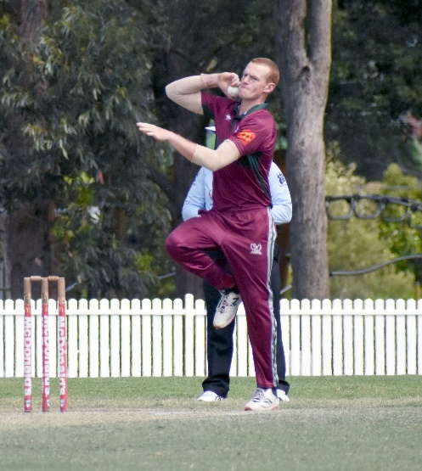
The team really wanted to bounce back after a disappointing season last year. A lot of the side was backing up having learnt some valuable lessons. There were some new additions to the squad and as we were to play more 50 over fixtures, we believed we could go deep into the competition.

It was pleasing to see the competitiveness of the side, with most games being close throughout the season and in reality we could have actually won them all (bar the Sixers conference semi-final). Highlights were the T20 vs Sydney, in which went to a super over, and the games vs Randy-Petes and UNSW which both went down to the last ball of the game.
Connor Cook

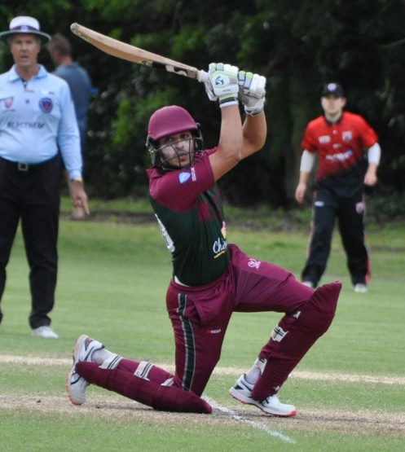
The side finished in the top 4 in the Sixers conference, emphasising we played more to our potential this season. With many of the team backing up again next season and with greater experience, the goal is to go a few steps further and win the competition.

There were some solid individual highlights throughout the season including Smit Doshi - our leading run scorer - with 68 against North Sydney. Sid Singh came into the side and showed great composure in a few crucial middle order innings scoring 43 against Eastern Suburbs and 41 against UNSW, along with picking up some handy wickets in the middle.

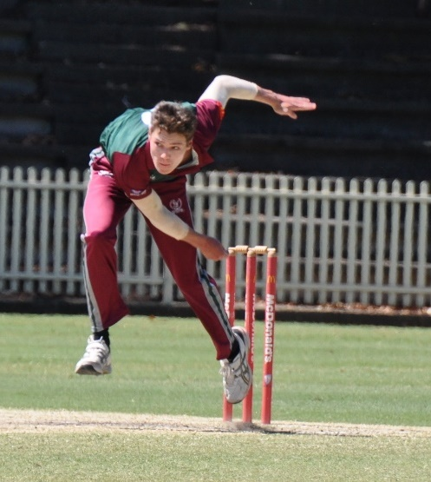
Callum Bladen was again our top bowler, with 10 wickets, highlighted by his 5-wicket haul against Easts. In typical Callum style, he only felt like bowling when he had 3 wickets to get, and the tail end came in to bat! Collectively all our bowlers contributed well in a number of games.
Smit Doshi

A highlight of the season was the super over that we played against the typically strong Sydney Cricket Club in our season opener. With the game on the line, Nick Toohey bowled the final over of the innings, restricting Sydney to only 6 runs in the final over resulting in a tie. He then took the ball again for the Super Over, landing several yorkers and taking 2-1, plus 4 leg byes and a bye, giving Sydney a total of 6 to defend. In true Jayllen style, he swung from the hip and gracefully chased down the 6 runs with 4 balls to spare.
Callum Bladen

This and both Eastern Suburbs and the UNSW wins were gritty and showed the true character of our side. It also proved to me that we as a core unit of players who have played together for a number of seasons, can go deep into the competition next year.

A massive thanks as always to Rob Carruthers, who year in and year out takes extremely good care of this team organizing everything behind the scenes to get us on the park each time we play. We all really appreciate it Rob.

Thanks to Club Coach Elliot, who took us on again this year despite his countless hours he already puts it to this club. He helps guide us all to be better individually, but most importantly to me, he guides us and highlights the importance of being a good team, which is what is going to help us win this competition.

Games:
Round 1: North Sydney 5-138 bt Gordon 127
Round 2: Gordon 8-75 and 0-7 bt Sydney 4-76 and 2-6
Round 3: Randy Petes 4-143 bt Gordon 6-139
Round 4: Gordon 216 bt Easts 138
Round 5: Gordon 6-247 bt UNSW 8-314 (Duckworth Lewis)
Round 6: Manly 5-179 bt Gordon 168
Conference Semi Final: North Sydney 2-105 bt Gordon 104

CONNOR COOK
POIDEVIN GRAY CAPTAIN

 | GORDON DCC PLAYER AVERAGES
 | SEASON 2022/23
 | POIDEVIN-GRAY
Batting Averages
Player |  |  |  | Matches |  | Innings |  | Not Outs |  |  | H.S. |  |  | Runs |  |  | Average
S Singh |  |  |  | 6 |  | 6 |  | 1 |  |  | 43 |  |  | 141 |  |  | 28.20
S Doshi |  |  |  | 7 |  | 7 |  | 0 |  |  | 68 |  |  | 169 |  |  | 24.14
MA Lole |  |  |  | 6 |  | 6 |  | 2 |  |  | 24* |  |  | 79 |  |  | 19.75
C Mitchell |  |  |  | 6 |  | 6 |  | 0 |  |  | 27 |  |  | 108 |  |  | 18.00
C Cook |  |  |  | 7 |  | 7 |  | 0 |  |  | 59 |  |  | 125 |  |  | 17.86
FE Booth |  |  |  | 7 |  | 7 |  | 1 |  |  | 40 |  |  | 106 |  |  | 17.67
J Naganayagam |  |  |  | 5 |  | 5 |  | 0 |  |  | 40 |  |  | 77 |  |  | 15.40
T Kennedy |  |  |  | 6 |  | 6 |  | 0 |  |  | 40 |  |  | 78 |  |  | 13.00
L Callanan |  |  |  | 5 |  | 4 |  | 3 |  |  | 4* |  |  | 7 |  |  | 7.00
C Bladen |  |  |  | 7 |  | 5 |  | 0 |  |  | 9 |  |  | 18 |  |  | 3.60
N Clarke |  |  |  | 5 |  | 3 |  | 0 |  |  | 4 |  |  | 6 |  |  | 2.00
Also Batted
T Siede |  |  |  | 1 |  | 1 |  | 0 |  |  | 24 |  |  | 24 |  |  | 24.00
JA Gillard |  |  |  | 2 |  | 2 |  | 1 |  |  | 11* |  |  | 14 |  |  | 14.00
S Schembri-Green |  |  |  | 1 |  | 1 |  | 0 |  |  | 13 |  |  | 13 |  |  | 13.00
NV Toohey |  |  |  | 3 |  | 2 |  | 1 |  |  | 7* |  |  | 12 |  |  | 12.00
D Ranjan |  |  |  | 1 |  | 1 |  | 0 |  |  | 8 |  |  | 8 |  |  | 8.00
T Stacy |  |  |  | 2 |  | 1 |  | 1 |  |  | 14* |  |  | 14 |  |  | n/a
Bowling Averages
Player |  | Overs |  | Mdns |  | Runs |  | Wkts |  |  | Average |  |  | Best |  |  | R/O
NV Toohey |  | 11 |  | 0 |  | 84 |  | 6 |  |  | 14.00 |  |  | 2-22 |  |  | 7.64
C Bladen |  | 36 |  | 3 |  | 169 |  | 10 |  |  | 16.90 |  |  | 5-26 |  |  | 4.69
MA Lole |  | 30 |  | 0 |  | 169 |  | 6 |  |  | 28.17 |  |  | 3-23 |  |  | 5.63
S Doshi |  | 21.3 |  | 1 |  | 127 |  | 4 |  |  | 31.75 |  |  | 2-2 |  |  | 5.91
S Singh |  | 20 |  | 0 |  | 130 |  | 4 |  |  | 32.50 |  |  | 3-61 |  |  | 6.50
C Cook |  | 31 |  | 0 |  | 202 |  | 6 |  |  | 33.67 |  |  | 3-30 |  |  | 6.52
Also Bowled
L Callanan |  | 15 |  | 1 |  | 108 |  | 1 |  |  | 108.00 |  |  | 1-14 |  |  | 7.20
D Ranjan |  | 5 |  | 0 |  | 19 |  | 0 |  |  | - |  |  | 0-19 |  |  | 3.80
T Stacy |  | 5 |  | 0 |  | 46 |  | 0 |  |  | - |  |  | 0-20 |  |  | 9.20
J Naganayagam |  | 1 |  | 0 |  | 14 |  | 0 |  |  | - |  |  | 0-14 |  |  | 14.00
Best Bowling Performances
Player |  | Overs |  | Runs |  | Wkts |  | Round |  |  | Opponent
C Bladen |  | 10 |  | 26 |  | 5 |  | 4 |  |  | Eastern Suburbs

A.W. Green Shield Report

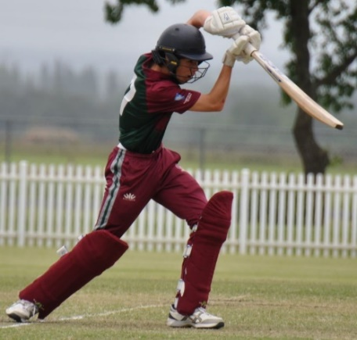
This was a season of great anticipation and high expectation for our Green Shield team after having had two seasons disrupted due to COVID-19 and La Niña. It turned out to be one of the most exciting Green Shield campaigns for Gordon in recent memory with all three results possible on the last ball of the match in three of the seven games played. Absolutely thrilling wins against Easts, Fairfield and St George and a couple of heart-breaking losses to North Sydney and Northern District.

The team played every game with lots of passion and a determination to keep fighting until the very last ball. This young team’s strength of character, maturity and love of the game enabled them to ride the highs and lows of a tough season. After a couple of early losses in close games, the team hit their stride and finished strong winning their last two games and qualifying for the finals. Unfortunately the much-anticipated Quarter Final clash against top ranked Mosman was abandoned due to rain without a ball being bowled. It was a disappointing end to what was otherwise a very exciting and captivating season.
Zack Winslow (Captain)

Bob Thomas and the selectors had once again performed a fantastic job in assembling a very talented group of young cricketers led by Zack Winslow. It was a well-balanced team with a good mix of experienced and new players. The team had three players returning for their third season of Green Shield cricket (Ben Hocking, Will Sutton and Zack Winslow). We also had two outstanding country players join the team (Jaylen Johnston from Central Coast and Rory McLean from North Coast). Four of the team members were in the NSW Metropolitan State Squads (Toby Robinson, Campbell Smith, Will Sutton and Zack Winslow). There were also several all-rounders, providing excellent depth in batting, bowling and wicket keeping. The depth of our bowling attack proved to be important as we lost our senior quicks (Aryan Gupta, Ben Hocking and Justin Nielsen) to injury at various times during the competition.

Nick Miller and Matt Wright coached the team for a third season and did a terrific job mentoring the boys and generously sharing their time and skills to help develop the team. Nick and Matt brought a wealth of cricketing experience and worked well with the boys to build a strong sense of team spirit. Their training sessions were well planned and executed. They also organised several practice matches against quality opposition to get the boys ready for the rigours of a tough season.

The Green Shield team was well supported throughout the season by the club. Many Gordon officials attended the cap presentation at Chatswood Oval by President Michael Cant. We also had several club officials assist with the numerous tasks that needed to be performed behind the scenes to keep the competition running smoothly. A number of senior players from the club regularly attended the games to encourage and support the team during the season. This was very much welcomed by the boys and is a testament to the club’s culture and values.

Tony Wilson once again captured a fantastic set of match day photos throughout the tournament which will help bring back fond memories of the Greenies experience in years to come. Tony also did a great job keeping the club supporters informed with regular match reports via email and Facebook. I would also like to acknowledge the efforts of Bob Thomas. In addition to selecting the team, Bob ensured everything was in place for the start of the season and was always willing to assist in any way needed to support the team. Gordon is very fortunate to have Bob as the Director of Junior Development where he combines his cricket expertise with his extraordinary passion for supporting and developing the young players at the club.

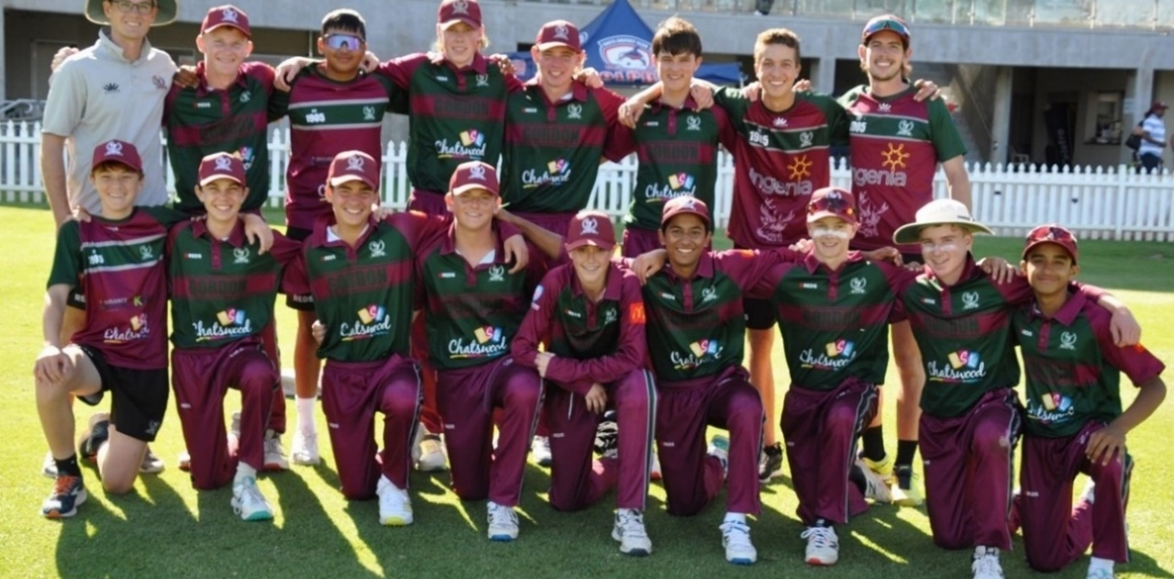
Finally, a huge thank you to the wonderful parent group who supported the boys so well and pitched in to help with scoring, covers duty, the team lunches and all the other tasks that needed to be completed in preparation for the games.
Green Shield Team
Front Row (L-R): Finn O’Farrell, Campbell Smith, Lucas Medford, Toby Robinson, Rory McLean, Zack Winslow (Captain), Jaylen Johnston, Will Sutton, Vivaan Gandhi
Back Row (L-R): Nick Miller (Coach), Ben Hocking, Aryan Gupta, Oscar Patterson, Jaeden Douglas, Tom Fuzes, Justin Nielsen, Matt Wright (Coach)

ROUND 1 VS UTS NORTH SYDNEY AT BEAUCHAMP OVAL
UTS North Sydney 5/268 (50 overs)
Oscar Patterson 2-55 (8 overs), Zack Winslow 1-40 (10 overs), Tom Fuzes 1-54 (9 overs)
Defeated Gordon 6/265 (50 overs)
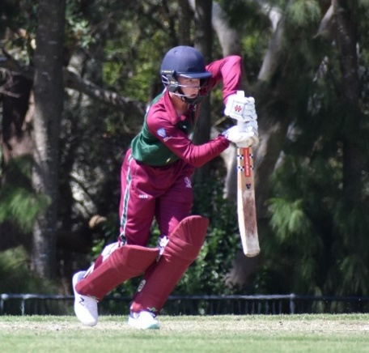
Will Sutton 102 (155), Jaeden Douglas 65* (46), Rory McLean 45 (66)
The season kicked off with the first game against UTS North Sydney which went down to the wire. North Sydney set us an impressive target of 268 in their 50 overs. Our openers started well but struggled to keep the scoreboard moving at the required rate. At 5/135 in the 33rd over we were in trouble. A brilliant fight back led by Jaeden Douglas, 65 off 46 balls, with steady support from Will Sutton and Rory McLean, helped us almost chase down the North Sydney total, falling just 4 runs short of what would have been a fantastic win.
Will Sutton

ROUND 2 VS SYDNEY AT DRUMMOYNE OVAL
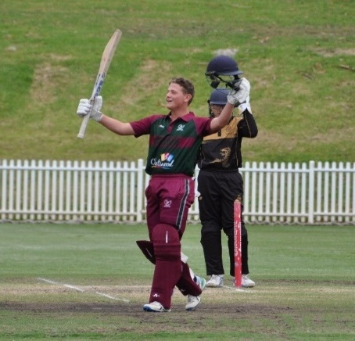
Sydney 9/184 (50 overs)
Toby Robinson 3-25 (9 overs), Oscar Patterson 2-27 (8 overs), Justin Nielsen 2-43 (9 overs), Aryan Gupta 0-9 (5 Overs)
Defeated by Gordon 0/185 (33.1 overs)
Toby Robinson 113* (108), Will Sutton 54* (91)

The team bounced back from their first-round loss to score a huge win against Sydney Cricket Club. A fine opening spell by Justin Nielsen and Aryan Gupta got us off to a good start. Oscar Patterson and Toby Robinson bowled well to pick up the key wickets and restrict Sydney to a modest score on a good batting wicket. Needing 185 to win, we scored the required runs in the 33rd over without losing a wicket. A quick century by Toby Robinson at better than a run a ball and another solid performance from Will Sutton ensured our campaign was back on track.
Toby Robinson

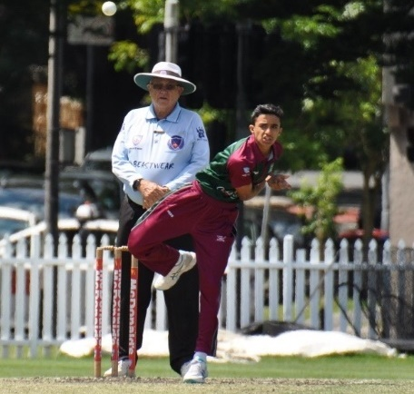
ROUND 3 VS RANDWICK-PETERSHAM AT CHATSWOOD OVAL
Gordon 140 (33 overs)
Rory McLean 41 (50), Toby Robinson 22 (45), Aryan Gupta 19 (34), Jaylen Johnston 18 (22)
Defeated by Randwick Petersham 7/141 (44 overs)
Vivaan Gandhi 5-23 (10 overs), Jaylen Johnston 1-14 (10 overs), Zack Winslow 1-37 (10 overs)

Randwick’s spinners bowled well on a turning track to dismiss us for 140. Rory McLean’s contribution with the bat gave our bowlers a fighting chance. The low total was always going to be hard to defend on a fast outfield at Chatswood Oval but the team refused to give in and put pressure on Randwick to make it a close contest. Vivaan Gandhi produced a magnificent spell of leg spin bowling to claim 5 wickets and reduce Randwick to 7-99. Jaylen Johnston, Zack Winslow and Toby Robinson bowled economically but could not break their stubborn eighth-wicket partnership and victory slipped out of our grasp.
Vivaan Gandhi

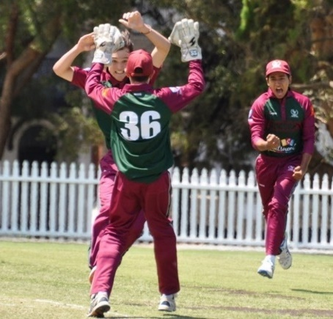
ROUND 4 VS EASTERN SUBURBS AT WAVERLEY OVAL
Gordon 5/235 (50 overs)
Will Sutton 88 (161), Rory McLean 59 (57), Toby Robinson 38 (59)
Defeated Eastern Suburbs 234 (50 overs)
Oscar Patterson 3-33 (8 overs), Ben Hocking 1-21 (6 overs), Vivaan Gandhi 1-36 (10 overs), Tom Fuzes 1-41 (5 overs), Zack Winslow 1-52 (10 overs)

The game against Eastern Suburbs produced some of the best cricket from both teams in a high scoring game at Waverley Oval. Half centuries from Rory McLean and Will Sutton helped us post a very competitive score. The bowlers did well to keep us in the contest, with Oscar Patterson picking up 3 wickets. Our fielders also stepped up, taking several great catches and creating two run outs. The game remained on a knife-edge until Gordon won the game on the last ball of the match. Easts were unable to get the 2 runs they needed off the final ball for a tie. This was certainly a game that will be remembered by all who were present for a long time.
Celebrating last ball win against Easts

ROUND 5 VS NORTHERN DISTRICT AT BEAUCHAMP OVAL
Gordon 137 (47.3 overs)
Toby Robinson 42 (98), Zack Winslow 26 (71), Rory McLean 24 (38)
Defeated by Northern District 9/138 (50 overs)
Oscar Patterson 3-40 (10 overs), Ben Hocking 1-8 (6 overs), Jaylen Johnston 1-15 (7 overs), Vivaan Gandhi 1-19 (8 overs), Aryan Gupta 1-27 (7 overs), Zack Winslow 0-17 (10 overs)

We missed an opportunity to capitalise on a good start by our openers as the middle and lower order collapsed to be bowled out for 137. The team had to bowl and field at their best to give them a chance and they certainly did both. A superb opening spell by Oscar Patterson, combined with two of the best catches of the season by Jaylen Johnston and Zack Winslow, reduced Northern District to 3/22 and brought Gordon right back into the game. From there it was a mighty arm wrestle as both teams fought desperately to win this important match in the run up to the finals. The bowlers maintained a great line and length not giving the batsmen many opportunities to score. The fielding was exceptional as the boys threw themselves at everything producing a couple of spectacular run outs. The pendulum swung back and forth till the final ball of the match. Northern District needed 2 runs to win with their last pair at the crease and they managed to get home on the last ball as a run out opportunity was missed. It was the best match of the season as both teams were tested to the limits and the supporters were kept on the edge of their seats. On this day cricket won and neither team deserved to lose. Another game that will stay with the boys for years to come.

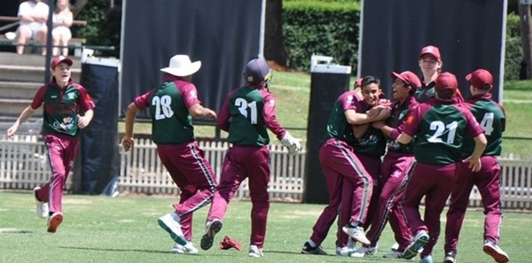
Team celebrating a wicket at Chatswood Oval
ROUND 6 VS FAIRFIELD-LIVERPOOL AT BEAUCHAMP OVAL
Fairfield-Liverpool 105 (43.4 overs)
Zack Winslow 3-19 (10 overs), Jaylen Johnston 3-23 (5.4 overs), Tom Fuzes 1-4 (4 overs), Ben Hocking 1-11 (5 overs), Campbell Smith 1-18 (10 overs)
Defeated by Gordon 7/106 (28.3 overs)
Rory McLean 48 (58), Jayden Douglas 12 (21), Lucas Medford 10 (19)

All our bowlers performed well to dismiss Fairfield for 105 with both Zack Winslow and Jaylen Johnston taking 3 wickets. It should have been a comfortable victory but the theme of close games this season continued as we started to lose wickets in search of that elusive bonus point to make up for the loss against Northern District. Another quality batting performance by Rory McLean ensured we won the game and picked up the bonus point to keep our finals hope alive.

ROUND 7 VS ST GEORGE AT HURSTVILLE OVAL
Gordon 7/196 (50 overs)
Aryan Gupta 63* (103), Jaylen Johnston 39 (35), Rory McLean 38 (45), Toby Robinson 19 (43),
Zack Winslow 16 (50)
Defeated St George 9/189 (50 overs)
Aryan Gupta 2-21 (4 overs), Jaylen Johnston 2-29 (10 overs), Ben Hocking 1-21 (7 overs), Justin Nielsen 1-30 (10 overs), Tom Fuzes 1-46 (10 overs), Justin Nielsen 0-11 (6 overs)

Needing a win to qualify for the finals, we were up against last year’s premiership winners St George. Both teams had a mixed season leading up to the final game of the preliminary rounds and both required a win to progress. Gordon started well and posted a competitive total, anchored by Aryan Gupta and well supported by Rory McLean and Jaylen Johnston. Once again, the boys played with a lot of energy and passion as they attempted to contain a strong St George batting line up. The bowling was good, fielding outstanding as both teams fought hard and emotions started to bubble up. It was soon clear that the team who could handle the pressure was going to prevail as the game headed towards another nail-biting finish. After a couple of brilliant tumbling catches in the deep by Jaeden Douglas and a couple more by Rory McLean behind the stumps as well as two direct hit runouts, we won by 7 runs in another thriller to make it to the finals.

QUARTER FINAL VS MOSMAN AT ALLAN BORDER OVAL
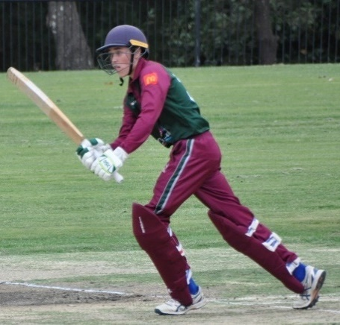
It was meant to be the clash of the season as both teams looked forward to playing against their mates for bragging rights on the North Shore. Unfortunately, due to persistent rain, the Quarter Final was eventually declared a washout and abandoned without play, ending our opportunity to compete for a place in the Semi Final. Several of the players from this year will return to compete next year and from what we saw of them this year, the future of Gordon Green Shield Cricket is bright.

Congratulations to Rory McLean who was selected in the Green Shield Merit XII for 2022-2023 as a result of his excellent batting performance across the season. Rory scored an aggregate of 255 runs at an average of 42.50 with a high score of 59.
Rory McLean

Well done to the team on their performance this season. They did a marvellous job representing Gordon, never giving up and finishing strong to make the finals. They will have many fond memories and friendships from their Greenies days that will last a lifetime.

JEFF WINSLOW
MANAGER

 |  |  |  | GORDON DCC PLAYER AVERAGES
 |  |  |  | SEASON 2022/23
 |  |  |  | GREEN SHIELD
Batting Averages
Player |  |  | Matches |  |  |  | Innings |  |  | Not Outs |  |  |  |  |  | H.S. |  |  | Runs |  |  |  | Average
W Sutton |  |  | 6 |  |  |  | 6 |  |  | 2 |  |  |  |  |  | 102 |  |  | 250 |  |  |  | 62.50
T Robinson |  |  | 7 |  |  |  | 7 |  |  | 2 |  |  |  |  |  | 113* |  |  | 245 |  |  |  | 49.00
R McLean |  |  | 7 |  |  |  | 6 |  |  | 0 |  |  |  |  |  | 59 |  |  | 255 |  |  |  | 42.50
A Gupta |  |  | 7 |  |  |  | 5 |  |  | 1 |  |  |  |  |  | 63* |  |  | 93 |  |  |  | 23.25
J Douglas |  |  | 7 |  |  |  | 6 |  |  | 2 |  |  |  |  |  | 65* |  |  | 81 |  |  |  | 20.25
C Smith |  |  | 5 |  |  |  | 3 |  |  | 2 |  |  |  |  |  | 10* |  |  | 19 |  |  |  | 19.00
Z Winslow |  |  | 7 |  |  |  | 6 |  |  | 1 |  |  |  |  |  | 26 |  |  | 68 |  |  |  | 13.60
J Johnston |  |  | 7 |  |  |  | 6 |  |  | 0 |  |  |  |  |  | 39 |  |  | 71 |  |  |  | 11.83
L Medford |  |  | 5 |  |  |  | 3 |  |  | 0 |  |  |  |  |  | 10 |  |  | 10 |  |  |  | 3.33
O Patterson |  |  | 5 |  |  |  | 3 |  |  | 0 |  |  |  |  |  | 3 |  |  | 9 |  |  |  | 3.00
Also Batted
V Gandhi |  |  | 7 |  |  |  | 2 |  |  | 1 |  |  |  |  |  | 6 |  |  | 8 |  |  |  | 8.00
J Nielsen |  |  | 6 |  |  |  | 2 |  |  | 0 |  |  |  |  |  | 9 |  |  | 9 |  |  |  | 4.50
F O'Farrell |  |  | 1 |  |  |  | 1 |  |  | 0 |  |  |  |  |  | 2 |  |  | 2 |  |  |  | 2.00
T Fuzes |  |  | 5 |  |  |  | 0 |  |  | 0 |  |  |  |  |  | 0 |  |  | 0 |  |  |  | -
B Hocking |  |  | 7 |  |  |  | 0 |  |  | 0 |  |  |  |  |  | 0 |  |  | 0 |  |  |  | -
Best Batting Performances
Player |  |  |  |  |  | Score |  |  |  |  | Round |  |  | Opponent
T Robinson |  |  |  |  |  | 113* |  |  |  |  | 2 |  |  | Sydney
W Sutton |  |  |  |  |  | 102 |  |  |  |  | 1 |  |  | UTS North Sydney
Best Partnerships
Batsmen |  |  |  |  |  | Runs |  |  |  |  | Wkt |  |  | Opponent
T Robinson - W Sutton |  |  |  |  |  | 185* |  |  |  |  | 1st |  |  | Sydney
W Sutton - J Douglas |  |  |  |  |  | 119 |  |  |  |  | 6th |  |  | UTS North Sydney
W Sutton - R McLean |  |  |  |  |  | 114 |  |  |  |  | 2nd |  |  | Eastern Suburbs
Bowling Averages
Player |  | Overs |  |  | Mdns |  |  | Runs |  |  |  | Wkts |  |  |  |  | Average |  |  |  | Best |  |  |  | R/O
V Gandhi |  | 30 |  |  | 4 |  |  | 94 |  |  |  | 7 |  |  |  |  | 13.43 |  |  |  | 5-23 |  |  |  | 3.13
O Patterson |  | 34 |  |  | 0 |  |  | 155 |  |  |  | 10 |  |  |  |  | 15.50 |  |  |  | 3-33 |  |  |  | 4.56
B Hocking |  | 25 |  |  | 5 |  |  | 69 |  |  |  | 4 |  |  |  |  | 17.25 |  |  |  | 1-8 |  |  |  | 2.76
T Robinson |  | 18 |  |  | 0 |  |  | 55 |  |  |  | 3 |  |  |  |  | 18.33 |  |  |  | 3-25 |  |  |  | 3.06
J Johnston |  | 47.4 |  |  | 8 |  |  | 151 |  |  |  | 7 |  |  |  |  | 21.57 |  |  |  | 3-23 |  |  |  | 3.17
T Fuzes |  | 32 |  |  | 5 |  |  | 161 |  |  |  | 5 |  |  |  |  | 32.20 |  |  |  | 1-4 |  |  |  | 5.03
J Nielsen |  | 28 |  |  | 4 |  |  | 108 |  |  |  | 3 |  |  |  |  | 36.00 |  |  |  | 2-43 |  |  |  | 3.86
A Gupta |  | 26 |  |  | 2 |  |  | 108 |  |  |  | 3 |  |  |  |  | 36.00 |  |  |  | 2-21 |  |  |  | 4.15
Z Winslow |  | 65 |  |  | 7 |  |  | 230 |  |  |  | 6 |  |  |  |  | 38.33 |  |  |  | 3-19 |  |  |  | 3.54
Also Bowled
C Smith |  | 28 |  |  | 2 |  |  | 85 |  |  |  | 1 |  |  |  |  | 85.00 |  |  |  | 1-18 |  |  |  | 3.04
L Medford |  | 4 |  |  | 0 |  |  | 19 |  |  |  | 0 |  |  |  |  | - |  |  |  | 0-7 |  |  |  | 4.75
Best Bowling Performances
Player |  |  |  | Overs |  | Runs |  |  |  |  | Wkts |  |  | Round |  |  |  | Opponent
V Gandhi |  |  |  | 10 |  | 23 |  |  |  |  | 5 |  |  | 3.00 |  |  |  | Randwick-Petersham

Career Records of Current Players
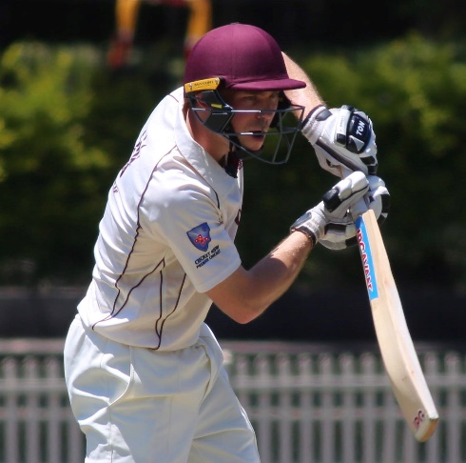
Below please find the career records of the current grade players in season 2022-2023. Please note minimums of 900 runs and 50 wickets.

The interesting part of the statistics for the season is that Dave Monaghan reached 3000 runs and 250 wickets for the club over 12 seasons. Also Tym Crawford reached 5000 runs in both first grade and all grades and Axel Cahlin moved to over 5000 runs in all grades. While Adam Cubbage only played a few matches he reached 15 seasons with the club.
Tym Crawford

BATTING
(Minimum of 900 runs in All Grades including T20 matches)

 |  |  |  | FIRST GRADE |  |  |  | ALL GRADES
 | Number of
 | Seasons |  | Completed |  |  |  | Completed
 | Played |  | Innings |  | Runs | Average | Innings |  |  | Runs | Average
Nick Andreou | 7 |  | - |  | - | - | 68 |  | 1911 |  | 28.1
Jamie Bekis | 7 |  | 34 |  | 452 | 13.29 | 101 |  | 2683 |  | 26.56
Felix Booth | 4 |  |  |  |  |  | 38 |  | 1122 |  | 29.53
Taj Brar | 3 |  | 46 |  | 1378 | 29.96 | 47 |  | 1403 |  | 29.85
Stephen Bristow | 8 |  | - |  | - | - | 73 |  | 1848 |  | 25.32
Stuart Bromley | 10 |  | - |  | - | - | 73 |  | 1761 |  | 24.12
Axel Cahlin | 9 |  | 117 |  | 3946 | 33.73 | 158 |  | 5234 |  | 33.13
Tym Crawford | 9 |  | 160 |  | 5322 | 33.26 | 164 |  | 5569 |  | 33.06
Adam Cubbage | 15 |  |  |  |  |  | 131 |  | 2848 |  | 21.74
Tom Carruthers | 7 |  | - |  | - | - | 66 |  | 1605 |  | 24.32
Michael Fletcher | 6 |  | 2 |  | 0 | - | 67 |  | 1824 |  | 27.22
Jayden Gray | 5 |  |  |  |  |  | 49 |  | 950 |  | 19.39
Rahul Krishna | 6 |  |  |  |  |  | 69 |  | 1524 |  | 22.09
Charles Mitchell | 3 |  | 7 |  | 131 | 18.71 | 30 |  | 912 |  | 30.40
Dave Monaghan | 12 |  |  |  |  |  | 124 |  | 3125 |  | 25.20
Jay Naganayagam | 6 |  |  |  |  |  | 49 |  | 1249 |  | 25.49
Scott O'Brien | 9 |  | 33 |  | 498 | 15.09 | 89 |  | 2262 |  | 25.49
Ryan Tullia | 8 |  | 4 |  | 73 | 18.25 | 87 |  | 2606 |  | 29.95
Fraser Wilson | 4 |  |  |  |  |  | 39 |  | 932 |  | 23.90
Matt Wright | 7 |  | 38 |  | 589 | 15.50 | 84 |  | 1810 |  | 21.55

BOWLING
(Minimum of 50 Wickets in All Grades including T20 Matches)
 |  |  | FIRST GRADE |  |  |  |  |  |  |  | ALL GRADES
 | Number of
 | Seasons
 | Played | Wickets |  | Runs |  | Average |  |  | Wickets |  |  | Runs |  | Average
Callum Bladen | 4 | 35 |  | 930 |  | 26.27 |  |  | 85 |  |  | 2,007 |  | 23.61
Stephen Bristow | 8 | - |  | - |  | - |  |  | 65 |  |  | 1064 |  | 16.37
Lachlan Burrows | 5 | - |  | - |  | - |  |  | 72 |  |  | 1,431 |  | 19.88
Connor Cook | 3 | 32 |  | 952 |  | 29.75 |  |  | 52 |  |  | 1,498 |  | 28.81
Tym Crawford | 9 | 77 |  | 2126 |  | 40.60 |  |  | 80 |  |  | 3,203 |  | 40.04
Prahlad Iyer | 5 | - |  | - |  | - |  |  | 74 |  |  | 1,646 |  | 22.24
Matt Keevers | 10 | - |  | - |  | - |  |  | 189 |  |  | 3,592 |  | 19.01
Nick Miller | 10 | 4 |  | 96 |  | 24.00 |  |  | 124 |  |  | 2,767 |  | 22.31
Dave Monaghan | 11 | - |  | - |  | - |  |  | 261 |  |  | 4,346 |  | 16.65
Scott O'Brien | 9 | 60 |  | 1959 |  | 32.65 |  |  | 184 |  |  | 4,890 |  | 26.58
Ashwin Premkumar | 4 | 40 |  | 1204 |  | 30.1 |  |  | 82 |  |  | 2,083 |  | 25.40
Simon Read | 5 | - |  | - |  | - |  |  | 104 |  |  | 1,846 |  | 17.75
Hayden Robertson | 4 |  |  |  |  |  |  |  | 76 |  |  | 1379 |  | 18.14
Jackson Saggers | 4 | 65 |  | 1516 |  | 23.32 |  |  | 98 |  |  | 2318 |  | 23.65
Tom Stacy | 3 |  |  |  |  |  |  |  | 60 |  |  | 1247 |  | 20.78
Quincy Titterton | 3 | 76 |  | 2019 |  | 26.57 |  |  | 86 |  |  | 2285 |  | 26.57
Matthew Wright | 7 | 48 |  | 1580 |  | 32.92 |  |  | 138 |  |  | 3640 |  | 26.38

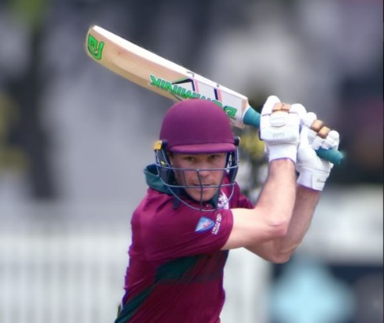
Club Records

The following club records are an abridged version of the full record set. This is available on the website www.gordoncricket.com.

One interesting change to the records was Tym Crawford moving into the top 10 of run scorers for the club and moving ahead of President Michael Cant.
Tym Crawford
TEAM AVERAGE AND AGGREGATE RECORDS

Aggregate and Average Records for a Season (Minimum of 300 runs and 30 wickets)

FIRST GRADE
Batting: | Aggregate: | - Cahlin | 971 | 2017-18
Batting: | Average: | C.J. Tozer (491) | 122.75 | 1920-21
Bowling: | Most Wickets: | R. Guy | 91 | 1967-68
Bowling: | Average: | C. Kelleway (41) | 9.65 | 1927-28

SECOND GRADE
Batting: | Aggregate: | C. Eccles | 734 | 2010-11
Batting: | Average: | J. Claridge | 113 | 2019-20
Bowling: | Most Wickets: | J. Prowse | 125 | 1942-43
Bowling: | Average: | J. Prowse (125) | 7.63 | 1942-43

THIRD GRADE
Batting: | Aggregate: | M. Kelly | 774 | 2006-07
Batting: | Average: | R. Radley (360) | 90.00 | 1990-91
Bowling: | Most Wickets: | R. Ellsmore | 78 | 1922-23
Bowling: | Average: | K. Ryan (33) | 5.97 | 1946-47

FOURTH GRADE
Batting: | Aggregate: | W. Dellow | 645 | 1974-75
Batting: | Average: | W. Quigley (423) | 70.50 | 1974-75
Bowling: | Most Wickets: | C. Alderdice | 85 | 1957-58
Bowling: | Average: | G. Elkan (55) | 7.18 | 1959-60

FIFTH GRADE
Batting: | Aggregate: | J. Shattock | 663 | 1970-71
Batting: | Average: | S. Blockley (352) | 88.00 | 1969-70
Bowling: | Most Wickets: | M. Todd | 59 | 2011-12
Bowling: | Average: | M. Todd (59) | 8.22 | 2011-12

CLUB AGGREGATE RECORDS
 |  |  |  |  |  | Career |  | Completed Innings |  | Runs |  | Average
 | BATTING – FIRST GRADE – over 3,000 runs
1 |  |  | Sid Carroll |  | 1939-66 |  | 320 |  | 11,322 |  | 35.38
2 |  |  | Charlie Macartney |  | 1905-34 |  | 166 |  | 7,984 |  | 48.10
3 |  |  | James Packman |  | 2000-14 |  | 233 |  | 6,705 |  | 28.78
4 |  |  | Jack Potter |  | 1936-60 |  | 229 |  | 6,211 |  | 27.12
5 |  |  | Steve Colley |  | 2008-20 |  | 200 |  | 5,968 |  | 29.94
6 |  |  | Marshall Rosen |  | 1965-80 |  | 166 |  | 5,936 |  | 35.76
7 |  |  | Frank Fordham |  | 1925-45 |  | 181 |  | 5,528 |  | 30.54
8 |  |  | Harry Evans |  | 2008-20 |  | 134 |  | 5,503 |  | 41.07
9 |  |  | Tym Crawford |  | 2013-23 |  | 160 |  | 5,322 |  | 33.26
10 |  |  | Michael Cant |  | 1987-97 |  | 155 |  | 5,285 |  | 34.10
11 |  |  | Warwick Murray |  | 1963-77 |  | 180 |  | 5,011 |  | 27.84
12 |  |  | Phil Emery |  | 1982-99 |  | 157 |  | 4,794 |  | 30.54
13 |  |  | Cameron Eccles |  | 2008-20 |  | 161 |  | 4,377 |  | 27.19
14 |  |  | Brian Taber |  | 1956-78 |  | 175 |  | 4,368 |  | 24.96
15 |  |  | Axel Cahlin |  | 2014-23 |  | 117 |  | 3,946 |  | 33.73
16 |  |  | Brian Thompson |  | 1958-76 |  | 169 |  | 3,882 |  | 22.97
17 |  |  | Reece Bombas |  | 2006-16 |  | 149 |  | 3,825 |  | 25.67
18 |  |  | Kurt Morrison |  | 1992-04 |  | 178 |  | 3,646 |  | 20.48
19 |  |  | Elliot Richtor |  | 2009-19 |  | 117 |  | 3,570 |  | 30.51
20 |  |  | Ray Boyce |  | 1913-36 |  | 116 |  | 3,502 |  | 30.19
21 |  |  | Charles Kelleway |  | 1922-34 |  | 75 |  | 3,441 |  | 45.88
22 |  |  | Michael Falk |  | 1972-86 |  | 152 |  | 3,263 |  | 21.47
23 |  |  | Ginty Lush |  | 1940-49 |  | 98 |  | 3,119 |  | 31.83

 |  |  |  |  | Career |  | Completed Innings |  | Runs |  | Average
BATTING – ALL GRADES – over 5,000 runs
1 |  |  | Bob Lowing | 1940-82 |  | 407 |  | 12,681 |  | 31.16
2 |  |  | Sid Carroll | 1939-67 |  | 327 |  | 11,694 |  | 35.76
3 |  |  | Damon Livermore | 1992-22 |  | 332 |  | 10,049 |  | 30.27
4 |  |  | James Packman | 1996-14 |  | 295 |  | 8,661 |  | 29.36
5 |  |  | Bas Sheidow | 1932-67 |  | 314 |  | 8,387 |  | 26.71
6 |  |  | Charlie Macartney | 1905-34 |  | 166 |  | 7,984 |  | 48.10
7 |  |  | Frank Fordham | 1922-45 |  | 256 |  | 7,833 |  | 30.60
8 |  |  | Mitchell Kleem | 2002-20 |  | 280 |  | 7,652 |  | 27.33
9 |  |  | Anthony Sherman | 1993-16 |  | 307 |  | 7,547 |  | 24.58
10 |  |  | Steve Colley | 2006-22 |  | 244 |  | 7,513 |  | 30.79
11 |  |  | Jack Potter | 1934-61 |  | 274 |  | 7,362 |  | 26.87
12 |  |  | Col Ashton | 1943-73 |  | 333 |  | 7,323 |  | 21.99
13 |  |  | Marshall Rosen | 1960-80 |  | 203 |  | 7,028 |  | 34.62
14 |  |  | Harry Evans | 2006-20 |  | 177 |  | 7,027 |  | 39.70
15 |  |  | Harry Watts | 1914-43 |  | 269 |  | 6,917 |  | 25.71
16 |  |  | Cuthbert Berenger | 1975-01 |  | 292 |  | 6,747 |  | 23.11
17 |  |  | Jack Quigley | 1941-68 |  | 231 |  | 6,394 |  | 27.68
18 |  |  | Elliot Richtor | 2005-22 |  | 198 |  | 6,316 |  | 31.90
19 |  |  | Brian Thompson | 1957-77 |  | 266 |  | 6,214 |  | 23.36
20 |  |  | Michael Cant | 1987-02 |  | 180 |  | 6,209 |  | 34.49
21 |  |  | Cameron Eccles | 2007-21 |  | 213 |  | 6,136 |  | 28.81
22 |  |  | Sid Trumper | 1909-43 |  | 237 |  | 6,116 |  | 25.81
23 |  |  | Ed Howitt | 1989-22 |  | 246 |  | 5,908 |  | 24.02
24 |  |  | Jock Shea | 1932-52 |  | 251 |  | 5,896 |  | 23.49
25 |  |  | John Morrison | 1949-70 |  | 265 |  | 5,800 |  | 21.89
26 |  |  | Warwick Murray | 1963-89 |  | 222 |  | 5,739 |  | 25.85
27 |  |  | Graham King | 1949-82 |  | 342 |  | 5,645 |  | 16.51
28 |  |  | Tym Crawford | 2013-23 |  | 164 |  | 5,569 |  | 33.96
29 |  |  | Michael Falk | 1969-15 |  | 242 |  | 5,511 |  | 22.77
30 |  |  | Matt Kelly | 1989-11 |  | 175 |  | 5,452 |  | 31.15
31 |  |  | Jim Baker | 1956-81 |  | 262 |  | 5,396 |  | 20.60
32 |  |  | Harry Crow | 1941-61 |  | 262 |  | 5,344 |  | 20.40
33 |  |  | Reece Bombas | 2004-16 |  | 195 |  | 5,341 |  | 27.39
34 |  |  | Phil Emery | 1982-99 |  | 162 |  | 5,056 |  | 31.21
35 |  |  | Keith McDonald | 1950-67 |  | 208 |  | 5,000 |  | 24.04

BOWLING - FIRST GRADE - over 200 wickets
 |  |  |  |  |  |  |  |  | Career |  |  | Wickets |  |  |  | Runs |  |  |  |  | Average
1 |  | Dick Guy | 1957-75 | 786 | 12,927 | 16.45
2 |  | Charlie Macartney | 1905-34 | 569 | 8,266 | 14.53
3 |  | Reg Giddey | 1946-60 | 452 | 9,451 | 20.91
4 |  | Norval Campbell | 1925-38 | 400 | 8,516 | 21.29
5 |  | Richard Stobo | 1983-94 | 396 | 8,388 | 21.18
6 |  | Phil Antman | 1973-85 | 351 | 7,435 | 21.18
7 |  | Bert Shortland | 1906-20 | 325 | 7,318 | 22.52
8 |  | Bob Hynes | 1934-46 | 300 | 5,602 | 18.67
9 |  | Dylan Connell | 2000-11 | 294 | 7,274 | 24.74
10 |  | Kurt Morrison | 1992-04 | 275 | 8,185 | 29.76
11 |  | Barry Thompson | 1966-76 | 294 | 6,389 | 21.73
12 |  | John Todd | 1968-79 | 260 | 5,928 | 22.80
13 |  | Matt Nicholson | 1992-09 | 228 | 4,009 | 17.58
14 |  | Brian Bell | 1950-63 | 227 | 5,032 | 22.17
15 |  | Percy Dive | 1915-25 | 224 | 4,479 | 20.00
16 |  | Wally Wilson | 1932-48 | 228 | 4,427 | 19.42
17 |  | Charles Kelleway | 1922-34 | 220 | 4,151 | 18.87
18 |  | James Kennedy | 2008-18 | 221 | 5,783 | 26.17

BOWLING - ALL GRADES -over 300 wickets
 |  |  |  |  |  |  |  |  | Career |  |  |  | Wickets |  |  |  |  | Runs |  |  |  | Average
 | 1 |  |  |  |  | Graham King |  | 1949-82 |  |  | 1,122 |  |  |  | 16,222 |  |  |  | 14.46
 | 2 |  |  |  |  | Jack Prowse |  | 1926-51 |  |  | 1,105 |  |  |  | 14,726 |  |  |  | 13.33
 | 3 |  |  |  |  | Dick Guy |  | 1953-76 |  |  | 999 |  |  |  | 16,359 |  |  |  | 16.38
 | 4 |  |  |  |  | Col Alderdice |  | 1940-73 |  |  | 872 |  |  |  | 13,051 |  |  |  | 14.97
 | 5 |  |  |  |  | Allan Poole |  | 1969-91 |  |  | 592 |  |  |  | 10,846 |  |  |  | 18.32
 | 6 |  |  |  |  | Richard Stobo |  | 1981-10 |  |  | 577 |  |  |  | 11,431 |  |  |  | 19.81
 | 7 |  |  |  |  | Charlie Macartney |  | 1905-34 |  |  | 569 |  |  |  | 8,266 |  |  |  | 14.53
 | 8 |  |  |  |  | Ed Howitt |  | 1989-22 |  |  | 557 |  |  |  | 12,437 |  |  |  | 22.33
 | 9 |  |  |  |  | Col Ashton |  | 1943-73 |  |  | 535 |  |  |  | 8,606 |  |  |  | 16.09
 | 10 |  |  |  |  | Phil Bovey |  | 1955-77 |  |  | 530 |  |  |  | 7,598 |  |  |  | 14.34
 | 11 |  |  |  |  | Matt Todd |  | 1992-16 |  |  | 514 |  |  |  | 11,756 |  |  |  | 22.87
 | 12 |  |  |  |  | Reg Giddey |  | 1946-60 |  |  | 469 |  |  |  | 9,690 |  |  |  | 20.66
 | 13 |  |  |  |  | Andy McElroy |  | 1971-86 |  |  | 453 |  |  |  | 7,542 |  |  |  | 16.65
 | 14 |  |  |  |  | Norval Campbell |  | 1924-38 |  |  | 415 |  |  |  | 8,835 |  |  |  | 21.29
 | 15 |  |  |  |  | Gerry Elkan |  | 1957-77 |  |  | 402 |  |  |  | 5,792 |  |  |  | 14.41
 | 16 |  |  |  |  | Phil Antman |  | 1972-85 |  |  | 401 |  |  |  | 8,326 |  |  |  | 20.76
 | 17 |  |  |  |  | Allen Walsh |  | 1964-80 |  |  | 389 |  |  |  | 6,311 |  |  |  | 16.22
 | 18 |  |  |  |  | Kurt Morrison |  | 1989-04 |  |  | 379 |  |  |  | 10,776 |  |  |  | 28.43
 | 19 |  |  |  |  | Bob Hynes |  | 1929-46 |  |  | 370 |  |  |  | 7,014 |  |  |  | 18.96
 | 20 |  |  |  |  | Bert Shortland |  | 1906-20 |  |  | 364 |  |  |  | 7,968 |  |  |  | 21.89
 | 21 |  |  |  |  | Dylan Connell |  | 2000-16 |  |  | 360 |  |  |  | 8,894 |  |  |  | 24.71
 | 22 |  |  |  |  | Tony Wilson |  | 1961-74 |  |  | 359 |  |  |  | 7,512 |  |  |  | 20.92
 | 23 |  |  |  |  | Barry Thompson |  | 1961-76 |  |  | 344 |  |  |  | 7,372 |  |  |  | 21.43
 | 24 |  |  |  |  | Chris McMurray |  | 1968-77 |  |  | 336 |  |  |  | 4,876 |  |  |  | 14.51
 | 25 |  |  |  |  | Geoff Hickman |  | 1981-96 |  |  | 332 |  |  |  | 7,454 |  |  |  | 22.45
 | 26 |  |  |  |  | Peter Murphy |  | 1981-97 |  |  | 324 |  |  |  | 6,274 |  |  |  | 19.36
 | 27 |  |  |  |  | Bill Hendricks |  | 1981-99 |  |  | 320 |  |  |  | 6,120 |  |  |  | 19.13
 | 28 |  |  |  |  | Barry Eastment |  | 1948-64 |  |  | 315 |  |  |  | 5,884 |  |  |  | 18.68
 | 29 |  |  |  |  | Adair Durie |  | 2001-14 |  |  | 314 |  |  |  | 5,915 |  |  |  | 18.84
 | 30 |  |  |  |  | Rupert Ellsmore |  | 1910-27 |  |  | 310 |  |  |  | 4,790 |  |  |  | 15.45
 | 31 |  |  |  |  | John Todd |  | 1968-79 |  |  | 310 |  |  |  | 6,823 |  |  |  | 22.01
 | 32 |  |  |  |  | Syd Smith |  | 1916-26 |  |  | 307 |  |  |  | 3,861 |  |  |  | 12.58
 | 33 |  |  |  |  | James Kennedy |  | 2004-18 |  |  | 303 |  |  |  | 7,670 |  |  |  | 25.31
 | 34 |  |  |  |  | Geoff Schwartzkoff |  | 1955-77 |  |  | 301 |  |  |  | 6,195 |  |  |  | 20.58
 |  |  | 35 |  |  | Steve Kavanagh |  |  |  | 1970-93 |  |  |  | 300 |  |  | 5,401 |  |  | 18.00

PARTNERSHIP RECORDS
PARTNERSHIPS OVER 200
 | Runs |  | Grade |  | Wicket |  | Season | Players
1 |  | 326* |  | 3rd |  | 1 | 1986-87 | M. O’Neill – P. Emery
2 |  | 284 |  | 2nd |  | 2 | 2009-10 | S. Colley – H. Evans
3 |  | 279 |  | 3rd |  | 1 | 1934-35 | F. Cummins – F. Fordham
4 |  | 273* |  | 6th |  | 1 | 1989-90 | S. Day – K. Roberts
5 |  | 268 |  | 3rd |  | 2 | 1998-99 | G. Tullia – N. Cutler
6 |  | 266 |  | 2nd |  | 5 | 2016-17 | Ryan Tullia – Tom Hamblin
7 |  | 263 |  | 1st |  | 1 | 1921-22 | Joe Taylor – A.G. Moyes
8 |  | 263* |  | 2nd |  | 1 | 1990-91 | M. Cant – P. Emery
9 |  | 261 |  | 1st |  | 1 | 1973-74 | J. Cattlin – I. Davis
10  11 |  | 261*  259 |  | 3rd  1st |  | 2  4 | 2022-23  1962-63 | L. Bhabra – T. Siede  J. Bendon – D. Lewarne
12 |  | 256 |  | 5th |  | 2 | 2000-01 | J. Packman – E. Howitt
13 |  | 253 |  | 1st |  | 2 | 1945-46 | J. Quigley – B. Sheidow
14 |  | 244* |  | 3rd |  | 4 | 1977-78 | D. Quigley – P. Smith
15 |  | 244 |  | 2nd |  | 2 | 2006-07 | B. Rasool – S. Hinton
16 |  | 243 |  | 2nd |  | 1 | 1925-26 | N. Phillips – C. Macartney
17 |  | 239 |  | 4th |  | 1 | 2014-15 | H. Evans – E. Richtor
18 |  | 239 |  | 1st |  | 3 | 1976-77 | C. Berenger – M. Berman
19 |  | 236 |  | 4th |  | 4 | 2010-11 | K. Colley – A. Crosland
20 |  | 235* |  | 4th |  | 2 | 2005-06 | R. Hokin – D. Livermore
21 |  | 231 |  | 3rd |  | 2 | 2001-02 | G. Lipshitz – A. Sherman
22 |  | 230 |  | 3rd |  | 4 | 2003-04 | N. Barrett – M. Makepeace
23 |  | 227 |  | 1st |  | 2 | 2006-07 | B. Rasool – D. Livermore
24 |  | 226 |  | 2nd |  | 4 | 2005-06 | J. Cashman – J.O’Neill-Fuller
25 |  | 224 |  | 3rd |  | 2 | 1935-36 | N. Carr – F. Leonard
26 |  | 223 |  | 3rd |  | 1 | 2022-23 | J.N. James- T.A. Crawford
27 |  | 220 |  | 5th |  | 1 | 1922-23 | R. Boyce – G. Chapman
28 |  | 219 |  | 5th |  | 4 | 2018-19 | S.Bromley – M.Chauhan
29 |  | 219 |  | 3rd |  | 2 | 2019-20 | J.Bekis – J. Claridge
30 |  | 218* |  | 7th |  | 1 | 1919-20 | E.A. Dwyer – A. Diamond
31 |  | 218 |  | 5th |  | 1 | 1925-26 | N. Phillips – E. Frendin
32 |  | 217* |  | 7th |  | 4 | 2003-04 | R. Campbell – S. Lin
33 |  | 216 |  | 3rd |  | 1 | 1986-87 | M. O’Neill – P. Emery
34 |  | 213 |  | 4th |  | 1 | 2011-12 | R Bombas – H Evans
35 |  | 208 |  | 4th |  | 5 | 2008-09 | K. Colley – H. Carmichael
36 |  | 206* |  | 3rd |  | 5 | 2006-07 | S. Sajdeh – B. Marvell
37 |  | 206 |  | 2nd |  | 2 | 1948-49 | J. Quigley – J. Shea
38 |  | 206 |  | 3rd |  | 1 | 2013-14 | D. Livermore – H. Evans
39 |  | 204 |  | 5th |  | 2 | 2013-14 | B. Rosen – J. Colley
40 |  | 204 |  | 3rd |  | 1 | 1920-21 | Joe Taylor – C. Hosking
41 |  | 204 |  | 3rd |  | 1 | 1929-30 | C. Macartney – J. Taylor
42 |  | 204 |  | 4th |  | 3 | 2010-11 | H. Turner – T. Tait
43 |  | 203 |  | 8th |  | 1 | 1913-14 | C. Macartney – G.E. Jordan
44 |  | 203 |  | 2nd |  | 2 | 1964-65 | J. Cattlin – H. Tebbutt
45 |  | 202 |  | 1st |  | 4 | 1984-85 | G. Death – C. Gray
46 |  | 202 |  | 5th |  | 2 | 1988-89 | P. Gregson – K. Roberts
47 |  | 202 |  | 5th |  | 2 | 2006-07 | J. Cashman – M. Michael

PARTNERSHIP RECORDS FOR EACH WICKET
*Denotes unbroken Partnership

ALL GRADES
Runs | Gd | Wicket | Season
263 | 1 | 1st | 1921-22 | Joe Taylor – A.G. Moyes
284 | 2 | 2nd | 2009-10 | S. Colley – H. Evans
326* | 1 | 3rd | 1986-87 | M. O’Neill – P. Emery
239 | 1 | 4th | 2014-15 | H. Evans – E. Richtor
256 | 2 | 5th | 2000-01 | J. Packman – E. Howitt
273* | 1 | 6th | 1989-90 | S. Day – K. Roberts
218* | 1 | 7th | 1919-20 | E.A. Dwyer – A. Diamond
203 | 1 | 8th | 1913-14 | C. Macartney – G.E. Jordan
136 | 1 | 9th | 1932-33 | C. Brown – K. Frazer
128 | 1 | 10th | 2016-17 | M. Crane – M. Junk

FIRST GRADE
Runs | Wicket | Season
263 | 1st | 1921-22 | Joe Taylor – A.G. Moyes
263* | 2nd | 1990-91 | M. Cant – P. Emery
326* | 3rd | 1986-87 | M. O’Neill – P. Emery
239 | 4th | 2014-15 | H. Evans – E. Richtor
220 | 5th | 1922-23 | G. Chapman – R. Boyce
273* | 6th | 1989-90 | S. Day – K. Roberts
218* | 7th | 1919-20 | E.A. Dwyer – A. Diamond
203 | 8th | 1913-14 | C. Macartney – G.E. Jordan
136 | 9th | 1932-33 | C. Brown – K. Frazer
128 | 10th | 2016-17 | M. Crane – M. Junk
SECOND GRADE
Runs | Wicket | Season
253 | 1st | 1945-46 | J. Quigley – B. Sheidow
284 | 2nd | 2009-10 | S. Colley - H. Evans
268 | 3rd | 1998-99 | G. Tullia – N. Cutler
235* | 4th | 2005-06 | R. Hokin – D. Livermore
256 | 5th | 2000-01 | J. Packman – E. Howitt
182 | 6th | 2017-18 | M. Newman – M. Roberts
145 | 7th | 1990-91 | M. Danckert – S. Hutton
163 | 8th | 1961-62 | J. Haines – B. McKinnon
117 | 9th | 1967-68 | J. Cattlin – C. Leadle
94 | 10th | 2002-03 | - Boorer – A. Parry-Okeden

THIRD GRADE
Runs | Wicket | Season
239 | 1st | 1976-77 | C. Berenger – M. Berman
261* | 2nd | 2022-23 | L. Bhabra – T. Siede
187 | 3rd | 2003-04 | N. Barrett – J. Cashman
204 | 4th | 2010-11 | H. Turner – T. Tait
181 | 5th | 2008-09 | D. Livermore – H. Angus
167 | 6th | 1960-61 | J. Morrison – C. Stevens
191 | 7th | 1955-56 | B. King – G. Steward
162 | 8th | 2005-06 | J. Hosking – M. Wiese
126 | 9th | 2017-18 | M.Roberts – C de Kretzer
89 | 10th | 1949-50 | J. Pelquest – S. Anson

FOURTH GRADE
Runs | Wicket | Season
259 | 1st | 1962-63 | J. Bendon – D. Lewarne
181 | 2nd | 1970-71 | R. Hawtree – S. Kavanagh
244* | 3rd | 1977-78 | D. Quigley – P. Smith
236 | 4th | 2010-11 | K. Colley – A. Crosland
219 | 5th | 2018-19 | S.Bromley – M. Chauhan
155 | 6th | 1982-83 | S. Kavanagh – D. Laundry
217* | 7th | 2003-04 | R. Campbell – S. Lin
169 | 8th | 2013-14 | A. Crossland – A. Wright
103 | 9th | 1999-00 | S. Selva – T. Hopkins
127 | 10th | 2015-16 | S. Lin – B. Leighton
FIFTH GRADE
Runs | Wicket | Season
158 | 1st | 1985-86 | S. Roberts – D. Shepherd
266 | 2nd | 2016-17 | R. Tullia – T. Hamblin
206* | 3rd | 2006-07 | S. Sajdeh – B. Marvel
208 | 4th | 2008-09 | K. Colley – H. Carmichael
185 | 5th | 1990-91 | C. Berenger – A. Swan
136 | 6th | 1993-94 | M. Hall – G. Carroll
138* | 7th | 1999-00 | N. Barrett – A. Edington
134 | 8th | 1992-93 | M. Hall – C. Rosen
91 | 9th | 2016-17 | D. Monaghan – S. Watts
80 | 10th | 2011-12 | D. Monaghan – M. Todd

POIDEVIN-GRAY SHIELD
Runs | Wicket | Season
226 | 1st | 2020-21 | A.Niranjan – L. Barnsley
233 | 2nd | 2008-09 | S. Colley – R. Bombas
151 | 3rd | 1991-92 | A. Gilchrist – P. McLean
225 | 4th | 2019-20 | J. Claridge – N. Doyle
126 | 5th | 1995-96 | J. Moss – P. Crocker
97 | 6th | 2004-05 | J. Cashman – S. Hinton
86 | 7th | 1967-68 | P. Horwitz – R. Ireland
129 | 8th | 2007-08 | N. Cheadle – W. Sweeney
85 | 9th | 1960-61 | P. Johnson – G. Elkan
52 | 10th | 1987-88 | M. Taber – S. Hutton
AW GREEN SHIELD
Runs | Wicket | Season
241 | 1st | 2008-09 | J. Liddle – J. Avendano
165 | 2nd | 2007-08 | T. Lamont – A. Shaw
187 | 3rd | 1959-60 | P. Johnson – J. Haines
158 | 4th | 1955-56 | F. Munro – G. Schwartzkoff
143 | 5th | 1951-52 | K. Eastwood – G. Doherty
129 | 6th | 1951-52 | K. Eastwood – S. Everett
105 | 7th | 1948-49 | K. Leggett – K. Eastwood
79 | 8th | 1999-00 | A. Quinliven – J. Benson
73 | 9th | 2002-03 | W. Sweeney – P. Crawford
50 | 10th | 1966-67 | A. Falk – D. Fellows

SCORES OF 200 OR MORE

FIRST GRADE
C.G. Macartney | 227 | 1913-14 | N.E. Phillips |  |  | 202 |  | 1925-26
C.G. Macartney | 224* | 1906-07 | J.G. Lush |  |  | 201* |  | 1947-48
A.G. Moyes | 218 | 1921-22 | M.D. O’Neill |  |  | 200* |  | 1986-87
C.J. Tozer | 211 | 1920-21

SECOND GRADE
B. Rasool | 236* | 2006-07 |  | B. Rasool | 201* |  | 2006-07
J. Packman | 204 | 2000-01 |  | J. Quigley | 200 |  | 1958-59
W. Dunn | 203* | 1915-16 |  | A. Sherman | 200* |  | 2001-02
W. Gerdes | 201* | 1925-26 | D. Thomson |  |  | 200 |  | 2017-18

THIRD GRADE
A.E. Carroll | 228* | 1906-07 | F. Matthews |  |  | 210 |  | 1918-19
C. Diamond | 225 | 1938-39

JUNIOR GRADE
H. Davis | 206 | 1933-34 | J. Lawrence |  | 201* |  |  | 1936-37

AW GREEN SHIELD
K. Eastwood | 320 | 1951-52 | T. Lamont |  | 212* |  |  | 2007-08

700 RUNS OR MORE IN A SEASON

FIRST GRADE

C.G. Macartney | 715 |  |  | 1913-14 |  | C. Simmons |  | 711 |  | 2005-06
C.G. Macartney | 824 |  |  | 1914-15 |  | C. Simmons |  | 864 |  | 2006-07
J.M. Taylor | 779 |  |  | 1929-30 |  | J. Packman |  | 772 |  | 2006-07
J.G. Lush | 775 |  |  | 1941-42 |  | C. Simmons |  | 958 |  | 2007-08
C. Solomon | 717 |  |  | 1942-43 |  | C. Eccles |  | 743 |  | 2014-15
J. Minter | 721 |  |  | 1947-48 |  | E. Richtor |  | 787 |  | 2016-17
S. Carroll | 723 |  |  | 1948-49 |  | A. Cahlin |  | 971 |  | 2017-18
S. Carroll | 724 |  |  | 1955-56 |  | S. Colley |  | 795 |  | 2017-18
M. Rosen | 814 |  |  | 1977-78 |  | H. Evans |  | 785 |  | 2017-18
M. Cant | 756 |  |  | 1991-92 |  | H. Evans |  | 842 |  | 2018-19
R. Soper | 751 |  |  | 1997-98 |  | T. Crawford |  | 750 |  | 2019-20
C. Fryar | 772 |  |  | 2002-03 |  | T.Crawford |  | 808 |  | 2020-21
J. Packman |  | 730 | 2002-03 |  | A.Cahlin |  | 912 |  | 2022-23
J. Packman |  | 710 | 2004-05

600 RUNS OR MORE IN A SEASON (Lower grades)
SECOND GRADE  F. Brand | 715 | 1916-17 | A. Sherman | 604 |  |  | 2001-02
B. Brodie | 630 | 1918-19 | S. Colley |  | 614 |  |  | 2008-09
J. Shea | 633 | 1941-42 | H. Evans |  |  | 623 |  | 2009-10
J. Calder | 628 | 1984-85 | C. Eccles |  |  | 734 |  | 2010-11

THIRD GRADE
F. Matthews | 630 |  | 1918-19 | R. Lowing |  |  |  |  | 654 |  | 1969-70
S. Butcher | 621 |  | 1923-24 | M. Kelly |  |  |  |  | 774 |  | 2006-07
R. Lowing | 694 |  | 1966-67 | B. Rosen |  |  |  |  | 692 |  | 2008-09
R. Lowing | 606 |  | 1968-69
FOURTH GRADE
W. Dellow | 645 | 1974-75 |  |  | M. Reynolds |  |  | 637 |  | 2003-04

FIFTH GRADE
J. Shattock | 663 | 1970-71
COLTS TEAM
H. Davies | 803 | 1933-34 | A. Brown |  | 644 | 1944-45
L. Lawrence | 674 | 1936-37 | H. Hedstrom |  | 649 | 1945-46
C. Roy | 753 | 1937-38 | C. Ashton |  | 645 | 1951-52
C. Roy | 626 | 1938-39 | R. Chadwick |  | 703 | 1964-65
C. Roy | 718 | 1939-40 | M. Reynolds |  | 700 | 1983-84
B. Fulford | 611 | 1942-43 | F. Duncan |  | 630 | 1983-84
A. Brown | 608 | 1942-43

CITY AND SUBURBAN TEAMS (VETS TEAMS)
C. Mayo | 825 | 1913-14 | B. McDowell |  |  | 650 | 1935-36
R. Rodgers | 955 | 1923-24 | R. McDowell |  | 665 |  | 1937-38
R. Rodgers | 847 | 1924-25 | B. Smith |  | 795 |  | 1939-40
O.S. Smith | 733 | 1925-26 | R. McDowell |  | 631 |  | 1939-40
R. Rodgers | 610 | 1925-26 | C. Coltman |  | 642 |  | 1954-55
R. Rodgers | 817 | 1926-27 | J. Quigley |  | 980 |  | 1964-65
R. Rodgers | 1013 | 1927-28 | J. Quigley |  | 601 |  | 1965-66
R. McDowell | 682 | 1934-35

VARIOUS GRADES
 | 1ST G | 2ND G | 3RD G | 4TH G | 5TH G | TOTAL | Season
W. Baker |  | 503 | 215 |  |  | 718 | 1923-24
W. Vaughan | 296 | 326 |  |  |  | 622 | 1928-29
F. Tranor |  | 35 | 581 |  |  | 616 | 1945-46
C. Ashton | 381 | 296 |  |  |  | 677 | 1953-54
A. Scott |  | 285 | 420 |  |  | 705 | 1953-54
R. Lowing | 156 | 509 |  |  |  | 665 | 1957-58
J. Shattock |  | 153 | 299 | 148 |  | 600 | 1971-72
D. Quigley |  | 351 | 142 | 162 |  | 655 | 1974-75
W. Quigley |  | 7 | 93 | 423 | 166 | 689 | 1974-75
C. Berenger |  | 78 | 412 | 129 |  | 619 | 1976-77
R. McGregor | 573 | 154 |  |  |  | 727 | 1982-83
M. Kelly |  | 108 | 511 |  |  | 619 | 1991-92
J. Moss | 378 | 232 |  |  |  | 610 | 1995-96
M. Rayner | 192 | 427 |  |  |  | 619 | 1996-97
M. O’Rourke | 597 |  | 13 |  |  | 610 | 1996-97
R. Radley | 280 | 329 |  |  |  | 609 | 1999-00
A. Sherman | 15 | 604 |  |  |  | 619 | 2001-02
D. Goldsmith |  | 160 | 458 |  |  | 618 | 2002-03
M. Makepeace | 6 | 318 | 183 | 146 |  | 653 | 2003-04
J. Cashman |  |  | 231 | 264 | 114 | 609 | 2003-04
R. Hokin | 272 | 328 |  |  |  | 600 | 2004-05
J. O’Neill-Fuller | 385 | 241 |  |  |  | 626 | 2005-06
B. Rasool | 116 | 535 |  |  |  | 651 | 2006-07
A. Sherman |  |  | 515 | 101 |  | 616 | 2006-07
M. Kleem |  |  | 49 | 559 |  | 608 | 2006-07
B. Rosen |  | 8 | 692 |  |  | 700 | 2008-09
C. Eccles | 458 | 100 | 105 |  |  | 663 | 2008-09
S. Colley | 6 | 614 | 19 |  |  | 639 | 2008-09
D. Livermore |  |  | 543 | 92 |  | 635 | 2008-09
B. Garratt | 93 | 513 |  |  |  | 606 | 2008-09
H. Evans | 103 | 623 |  |  |  | 726 | 2009-10
N. Dowsley |  | 18 | 485 |  | 102 | 605 | 2009-10
S. O’Brien | 13 | 633 |  |  |  | 646 | 2016-17
R. Klemt | 170 | 473 |  |  |  | 643 | 2017-18
M. Fletcher |  | 180 | 448 |  |  | 628 | 2020-21

PLAYERS WHO HAVE TAKEN 50 OR MORE WICKETS IN A SEASON

FIRST GRADE

C.G. Macartney |  |  | 51 |  |  |  | 1910-11
B. Shortland |  |  | 51 |  |  |  | 1912-13
P.W. Dive |  |  | 56 |  |  |  | 1915-16
B. Shortland |  |  | 53 |  |  |  | 1917-18
S.C. Freeman |  |  | 51 |  |  |  | 1918-19
A.C. Lawrie |  |  | 58 |  |  |  | 1922-23
P.W. Dive |  |  | 54 |  |  |  | 1923-24
J.N. Campbell |  |  | 55 |  |  |  | 1930-31
J.N. Campbell |  |  | 55 |  |  |  | 1932-33
W. Wilson |  |  | 60 |  |  |  |  | 1943-44
D. McDonald |  |  |  | 55 |  |  |  |  | 1958-59
R. Guy |  |  |  | 56 |  |  |  |  |  | 1961-62
R. Guy |  | 67 |  |  |  | 1964-65
R. Guy |  | 57 |  |  |  | 1966-67
R. Guy |  | 91 |  |  |  | 1967-68
R. Guy |  | 58 |  |  |  | 1968-69
R. Guy |  | 57 |  |  |  | 1970-71
R. Guy |  | 60 |  |  |  | 1971-72
Barry Thompson | 54 |  |  |  | 1974-75
R. Stobo | 64 |  |  |  | 1990-91
A. Hunter | 51 |  |  |  | 1981-82
R. Giddey | 50 |  |  |  | 1949-50
M. Crane | 51 |  |  |  | 2016-17

SECOND GRADE

 | F. Brand |  | 66 |  |  |  | 1917-18
 | S. Clarke |  |  | 54 |  | 1918-19
 | H.F. Watson |  |  | 52 |  | 1918-19
 | S. Fuller |  |  | 51 |  | 1922-23
 | S. Francis |  |  | 80 |  | 1923-24
 | T. Stenning |  |  | 50 |  | 1925-26
 | T. Stenning |  |  | 64 |  | 1926-27
 | R. Anderson |  |  | 50 |  | 1932-33
 | J. Prowse |  |  | 50 |  | 1933-34
 | J. Prowse |  |  | 52 |  | 1935-36
J. Prowse |  | 51 |  |  | 1940-41
H. Crow |  | 61 |  |  | 1941-42
J. Prowse |  | 53 |  |  | 1941-42
J. Prowse |  | 125 |  |  | 1942-43
J. Prowse |  | 74 |  |  | 1944-45
J. Prowse |  | 52 |  |  | 1945-46
J. Prowse |  | 66 |  |  | 1946-47
J. Prowse |  | 50 |  |  | 1948-49
A. Poole |  | 60 |  |  | 1974-75

THIRD GRADE
H.J. Emms 68 1910-11 D. Duncan 50 1941-42
G.R. Dettman 52 1910-11 J. Sutherland 58 1942-43
L. Parkin 65 1914-15 B. Lobb 62 1943-44
W.T. Forster 73 1920-21 D. Cochrane 58 1944-45
C.M. Geddes 56 1921-22 C. Ashton 54 1952-53
R. Ellsmore 78 1922-23 C. Alderdice 50 1959-60
S. Smith Jnr 62 1923-24 J. Ogden 59 1965-66
S. Smith Jnr 65 1924-25 G. King 63 1966-67
P. Bates 50 1926-27 G. King 61 1970-71
J. Minogue 60 1929-30 G. King 64 1971-72
K. Anderson 50 1929-30

FOURTH GRADE
R. Guy | 60 | 1954-55 | C. Ashton | 50 | 1966-67
C. Alderdice | 84 | 1957-58 | P. Bovey | 50 | 1971-72
W. McDonald | 57 | 1957-58 | P. Bovey | 50 | 1973-74
C. Alderdice | 77 | 1958-59 | A. Walsh | 50 | 1974-75
G. Elkan | 55 | 1959-60 | G. King | 53 | 1979-80
G. King | 55 | 1961-62 | G. King | 51 | 1981-82
K. Jones | 53 | 1964-65

FIFTH GRADE
A. Adair | 51 | 1969-70 |  |  | M. Todd |  | 59 |  | 2011-12
S. Kavanagh | 57 | 1973-74

SHIRE TEAMS
J.N. Campbell | 51 | 1924-25 |  | R. Murray | 52 | 1937-38
A.M. Sargeant | 50 | 1932-33 |  | B. Lobb | 50 | 1946-47
E. Harding | 54 | 1933-34 |  | B. Lobb | 63 | 1947-48
D. Cochrane | 84 | 1934-35 |  | P. Bovey | 50 | 1968-69
D. Cochrane | 84 | 1936-37 |  | A. Walsh | 50 | 1968-69

COLTS TEAM

D. Cochrane | 54 | 1928-29 | J. Clarke | 56 | 1952-53
K. Oldry | 68 | 1930-31 | B. Lobb | 58 | 1959-60
G. Wilson | 86 | 1936-37 | B. Lobb | 51 | 1960-61
R. Carroll | 71 | 1936-37 | B. Lobb | 50 | 1961-62
S. McPherson | 55 | 1937-38 | W. Havercroft | 50 | 1961-62
R. Carroll | 50 | 1937-38 | W. Havercroft | 53 | 1962-63
B. Lobb | 72 | 1939-40 | H. Strath | 56 | 1966-67
D. Evans | 66 | 1941-42 | R. Wildes | 53 | 1974-75
J. McGrath | 58 | 1943-44 | G. Sadler | 57 | 1982-83
J. Roarty | 53 | 1943-44 | B. Peden | 52 | 1982-83
A. Martin | 54 | 1949-50 | A. Kemeny | 51 | 1984-85
A. Martin | 57 | 1951-52 | G. Sadler | 50 | 1986-87
J. Clarke | 51 | 1951-52

CITY and SUBURBAN TEAM (VETS TEAMS)
G. Gerdes | 54 | 1913-14 | H. Poll | 57 | 1933-34
S.M. Clarke | 71 | 1914-15 | L. Debus | 61 | 1934-35
W. Langley | 64 | 1918-19 | B. McDowell | 67 | 1935-36
R. Ellsmore | 59 | 1924-25 | J. McDowell | 62 | 1935-36
R. Ellsmore | 74 | 1925-26 | B. Smith | 56 | 1937-38
R. Ellsmore | 54 | 1926-27 | J. McDowell | 51 | 1937-38
R. Rodgers | 50 | 1927-28 | B. Smith | 61 | 1938-39
G.R. Dettmann | 64 | 1929-30 | H. Barnby | 60 | 1939-40
L. Debus | 73 | 1930-31 | T. Gatty | 65 | 1964-65
R. Rodgers | 59 | 1932-33 | T. Gatty | 60 | 1967-68
L. Debus | 75 | 1933-34

VARIOUS GRADES
1ST G 2ND G 3RD G 4TH G 5TH G TOT Season
T.W. Forster 7 46 53 1918-19
R. Ellsmore 34 16 50 1923-24
T. Stenning 4 50 54 1925-26
P. Bates 2 50 52 1926-27
J. Prowse 18 35 53 1927-28
R. Anderson 50 5 55 1932-33
J. Prowse 18 50 68 1933-34
G. Thame 7 48 55 1935-36
J. Godwin 35 15 50 1936-37
G. Thame 5 49 54 1939-40
H. Crow 3 61 64 1941-42
C. Alderdice 48 12 60 1946-47
G. Wearne 31 23 54 1947-48
C. Alderdice 27 30 57 1948-49
R. Werner 8 3 42 53 1950-51
B. Eastment 16 39 55 1952-53
C. Alderdice 17 35 52 1953-54
M. Goodridge 25 25 50 1953-54
F. Ward 1 24 26 51 1956-57
B. Eastment 9 37 9 55 1959-60
A. Wilson 15 37 52 1963-64
J. Todd 14 44 58 1968-69
A. McElroy 33 18 51 1971-72
G. Mackie 1 49 50 1971-72
C. McMurray 6 44 50 1971-72
G. King 45 1 9 55 1973-75
G. Elkan 5 37 8 50 1973-74
C. Peiffer 26 29 55 1974-75
G. King 10 41 51 1974-75
H. Chapman 33 18 51 1974-75
D. Fenton 17 36 53 1977-78
A. Hunter 51 16 67 1981-82
A. Poole 3 49 52 1981-82
A. Durie 7 45 52 2010-11

WICKET-KEEPING - MOST DISMISSALS
FIRST GRADE
I. Beverley | Stumped 13 | Caught 34 | Total 47 | 2008-09

OTHER GRADES
G. Verco | Stumped 9 | Caught 44 | Total 53 | 1974-75

PLAYERS WHO HAVE SCORED A CENTURY AND TAKEN 10 WKTS IN A MATCH
D. Tutton 112 Runs 5/38 and 6/46 5th Grade 1967-68

PLAYERS WHO HAVE TAKEN 10 WKTS IN AN INNINGS
T.W. Forster 10/18 3rd Grade 1920-21
D. Horsfield 10/26 3rd Grade 1962-63
T. Gatty 10/54 City & Suburban 1969-70

OTHER ITEMS

HIGHEST SCORE 1ST XI
7 for 571 in 220 minutes | v | University | 1941-42

HIGHEST INDIVIDUAL SCORE
K. Eastwood | 320 | A.W. Green Shield XI | 1951-52
GORDON’S REPRESENTATIVE PLAYERS - IN TEST MATCHES

While a Gordon Member | After Playing for Gordon | Before Playing with Gordon
Charlie Macartney | Ken Eastwood | Frank Iredale
Vic Trumper (*) | Matt Nicholson | Morrie Sievers
Johnny Taylor | Adam Gilchrist | Sid Barnes
Charles Kelleway (*) | Mason Crane (**) | Barry Knight (**)
Bert Oldfield (*) | Matthew Parkinson (**) | Graeme Watson
Ray Robinson |  | Scott Styris (***)
Neil Harvey (*) |  | Daniel Flynn (***)
Brian Taber
Ian Davis
Trevor Chappell | 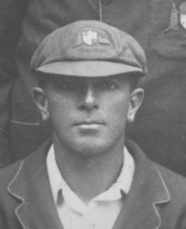
Phil Emery
Beau Casson

* Also a Test Representative before becoming a member of Gordon
** Played Test cricket for England
*** Played Test cricket for New Zealand

IN FIRST CLASS AND ONE DAY INTERNATIONAL MATCHES

While a Member of Gordon

Charlie Macartney | Norman Fox | Ian Davis
Robert Hickson (*) | Harold McQuirk | Graeme Watson (*)
Tom Hartigan | Bert Watson | Trevor Chappell (*)
Vic Trumper (*) | Ray Robinson | Mark O’Neill (*)
Bert Shortland | LC (Bob) Hynes | Phil Emery
Claude Tozer (*) | Sid Carroll | Richard Stobo
Johnny Taylor (*) | JG (Ginty) Lush | Matt Nicholson (*)
Charles Kelleway (*) | Jack Pettiford | James Packman
Bert Oldfield (*) | Sid Barnes (*) | Craig Simmons (*)
Norbert Phillips (*) | Neil Harvey (*) | Beau Casson (*)
Percy Dive | Dick Guy | Chad Soper (**)
George Chapman | Brian Taber | Charlie Stobo
Norval Campbell  Don Harkness | Marshall Rosen | Mason Crane (*)

* Also a first-class representative before becoming a member of Gordon
** Played First Class and One Day International cricket for Papua New Guinea

After Playing for Gordon

Harry Savage | Tony Steele | Adam Gilchrist
Ray Boyce | Stuart Webster | Greg Hayne
Roy Loder | Allan Anderson | Jon Moss
Fred Edwards | Michael Cox | Will Smith (***)
Tom Parsonage | Russell McCool | Josh Poysden (***)
Ken Eastwood | John Davison | Ron Harvey
Kevin Roberts | Matthew Parkinson (*)
Before Playing for Gordon
Frank Iredale | Douglas Reid | Paul Romaines (***)
Gother Clarke | G.A. (Goldie) Thomas | David Thomas (***)
Gordon Black | Frank Cummins | Hugh Wilson (***)
Keith McPhillamy | Sam Everett | Bill Snowden (***)
EL (Gar) Waddy | Ben Salmon | Jon Wileman
Frank Devenish-Meares | Cyril Solomon | Dean Cosker (***)
Dan Gee | Morrie Sievers | Anurag Singh (***)
Harold Cranney | Jim Minter | Alun Evans (***)
GS (Jimmy) Down | Bill Englefield | Rod Tucker
John Flynn | Peter Trethewey | Scott Styris (**)
Austin Diamond | Geoff Forsaith | Daniel Flynn (**)
Joe Taylor | Barry Knight (*) | Mark Atkinson
EA (Chappie) Dwyer | Ross Collins | Matthew Parkinson (***)
Percival Penman | David Rathie | Mason Crane (***)
AG (Johnnie) Moyes | Bill Hendricks (#)
* For England
** For New Zealand
*** For English County Teams
# For South Africa Provinces

MEMBERS WHO HAVE PLAYED IN NEW SOUTH WALES 2ND XI OR COLTS/FUTURES LEAGUE

Adlam W  Andrews B.F.  Antman P.  Bel, B.  Bombas R.  Bray J.  Cahlin A  Campbell J.N.  Cant M.  Carroll S.  Casson B  Colley S.  Cox M. | Davison J  Dive P.  Eastment B.  Eastwood K.  Emery P.  Evans G.  Evans H.  Fisher J.  Gilchrist A.  Guy R.  Hynes L.C.  Kennedy J.  Knight A. | Lush J.G.  McCool R.  McDonald B  McLean P.  Munro F.  Murray W.A.  Nicholson M.  O’Neill M.D.  O’Rourke M.  Packman J  Roberts K.  Robinson R.H.  Rosen M. | Simmons C  Smith D  Soper R  Stobo C  Stobo R.  Taber H.B.  Thomas R.  Vaughan W.  Cahlin A
AUSTRALIAN INSTITUTE OF SPORT CRICKET ACADEMY GRADUATES

1991 - Adlam W. 1992 - Roberts K. 1995 - Nicholson M.

1992 - Gilchrist A. 1993 - Davison J. 1996 - Nicholson M.

MEMBERS WHO HAVE REPRESENTED AUSTRALIA IN INTERNATIONAL YOUTH CRICKET

Adlam W. Gilchrist A. Roberts K. Nicholson M.

MANAGER, AUSTRALIAN XI

1921 - S. Smith 1926 – S. Smith

OFFICE BEARERS

SEASON | YEARS | PRESIDENT | SECRETARY | TREASURER
1905-06 | 1 | R. Black | R. Hickson | E. Brooks
1906-09 | 3 | R. Black | T. Hartigan | E. Brooks
1909-10 | 1 | R. Black | T. Hartigan | T. Butler
1910-15 | 5 | R. Black | T. Hartigan | W. Renshaw
1915-16 | 1 | R. Black | T. Hartigan | W. Renshaw & F. Grace
1916-17 | 1 | R. Black | D. Campbell & S. Smith | G. Martin
1917-21 | 4 | R. Black | S. Smith | G. Martin
1921-22 | 1 | R. Black | S. Smith | P. Dive
1922-25 | 3 | R. Black | W. Gerdes | S. Smith
1925-26 | 1 | R. Black | W. Gerdes & A. Moyes | S. Smith & H. Hinton
1926-27 | 1 | R. Black | A. Moyes | H. Hinton
1927-28 | 1 | R. Black | A. Moyes & K. Dorhauer | H. Hinton
1928-30 | 2 | R. Gordon | K. Dorhauer | H. Hinton
1930-35 | 5 | R. Gordon | P. Harrison | H. Hinton
1935-40 | 5 | F. Petrie | P. Harrison | H. Hinton
1940-47 | 7 | J. Bales | P. Harrison | H. Hinton
1947-51 | 4 | J. Bales | P. Harrison | W. Govers
1951-55 | 4 | J. Bales | P. Harrison | R. Barnes
1955-56 | 1 | L. Evans | G. King | R. Barnes
1956-60 | 4 | L. Evans | B. Sheidow | R. Barnes
1960-66 | 6 | P. Harrison | B. Sheidow | R. Barnes
1966-68 | 2 | P. Harrison | B. Sheidow | J. Horsfield
1968-69 | 1 | P. Harrison & H. Crow | B. Sheidow | L. Wilson
1969-70 | 1 | H. Crow | B. Sheidow | L. Wilson
1970-77 | 7 | H. Crow | B. Sheidow | K. McDonald
1977-78 | 1 | R. Guy | L. Wilson | K. McDonald
1978-82 | 4 | R. Guy | J. Baker | K. McDonald
1982-83 | 1 | B.C. Sheidow | G. Mackie & W.A. Murray | K. McDonald
1983-86 | 3 | B.C. Sheidow | W.A. Murray | K. McDonald
1986-88 | 2 | W.A. Murray | A. K. Poole | K. McDonald
1988-89 | 1 | W.A. Murray | A.K. Poole & W.A. Murray | K. McDonald
1989-90 | 1 | W.A. Murray | J. Cameron & G. Hickman | K. McDonald
1990-92 | 2 | P. Davison | G. Hickman | K. McDonald
1992-96 | 4 | P. Davison | W. Hendricks | K. McDonald
1996-00 | 4 | B. Strang | W. Hendricks | K. Crocker
2000-03 | 3 | I.C. Carroll | A.J. Falk | K. Crocker
2003-05 | 2 | I.C. Carroll | A.J. Falk | J. Edington
2005-07 | 2 | I.C. Carroll | A.J. Falk | I. Packman
2007-13 | 6 | A.J. Falk | R.J.W. Cattlin | I. Packman
2013-14 | 1 | A.J. Falk | R.J.W. Cattlin | H. Turner
2014-15 | 1 | A.J. Falk | R.J.W. Cattlin | G. Hickman
2015-21 | 6 | G. Hickman | R.J.W. Cattlin | G. Keevers
2021-22 | 1 | M.Cant | R.J.W. Cattlin | G. Keevers
2022-23 | 1 | M.Cant | A.J. Falk | G. Keevers

NSW Premier Cricket Sponsors 2022-2023

